

**Movie Theater**

Software Requirements Specification

Version 1.2

**Hanoi, Jan 2020**

**Approval Page**

|  |  |
| --- | --- |
| **Prepared by :** | Signature: |
| Business Analyst |  |
|  | Date: |
|  | / / |
| **Reviewed by :** | Signature: |
| Business Analyst |  |
|  | Date: |
|  | / / |
| **Supported by:** | Signature: |
|  |  |
|  | Date: |
|  | / / |
| **Approved by :** | Signature: |
|  |  |
|  | Date: |
|  | / / |

**Revision History**

|  |  |  |  |
| --- | --- | --- | --- |
| **Date** | **Version** | **Author** | **Change Description** |
| 15/01/2025 | 1.0 | Ngo Quang Huy | Initial draft |
| 18/01/2025 | 1.1 | Ngo Quang Huy | Update version |
| 25/3/2025 | 1.2 | Ngo Quang Huy | Comprehensive update |
|  |  |  |  |
|  |  |  |  |
|  |  |  |  |

**TABLE OF CONTENTS**

1. Introduction 5
   1. **Purpose 5**
   2. **In scope 6**
2. Overview 6
   1. **Actors 6**
   2. **Use Case Diagram 6**
3. Functional Description 7
   1. Functional Requirements 8
      1. Log in 8
      2. Register account 9
         1. Register account 10
         2. Edit member accounts 12
         3. View member list 15
      3. Account management of the user 17
         1. The user – Booked ticket management 17
         2. The user – View history of score adding/using 18
         3. Movie list – Search of the user 20
      4. Booking ticket of the user 21
         1. Book ticket – Select movie and showtime 21
         2. Booking ticket – Selecting seat 23
         3. Booking ticket – Confirm booking ticket 25
         4. Booking ticket – Ticket information 26
      5. Ticket selling management 27
         1. Ticket selling management – Select movie and showtime 28
         2. Ticket selling management – Selecting seat 30
         3. Ticket selling management – Confirm ticket 32
         4. Ticket selling management – Ticket information 35
      6. Ticket booking management 36
         1. Ticket booking management – Search 36
         2. Ticket booking management – Booking list 37
         3. Ticket booking management – Confirm booking 38
         4. Ticket booking management – Information of converting into ticket 40
      7. Employee management 41
         1. Employee management – View employee list 41
         2. Employee management – Add employee 43
         3. Employee management – Edit employee 45
         4. Employee management – Delete employee 47
      8. Cinema room management 49
         1. Cinema room management – Display list of cinema rooms 49
         2. Cinema room management – Cinema room detail 51
      9. Movie management 52
         1. Movie management – View movie list 52
         2. Movie management – Add movie 54
         3. Movie management – Edit movie information 56
         4. Movie management – Delete movie 58
      10. Promotion management 58
          1. Promotion management – View promotion list 59
          2. Promotion management – Add promotion 60
          3. Promotion management – Edit promotion 61
          4. Promotion management – Delete promotion 63
   2. Detailed Non-Functional Requirements 64
      1. Logical Structure of the Data 64
      2. Security 66
      3. Performance 66

# Introduction

## Purpose

The management system allows to easily perform the functions of the movie theater operation management, especially ticket selling of employees and ticket booking of the users. The biggest goal of the system is to improve the performance of employees, minimize the time to conduct ticket selling with each customer, facilitate booking, increase sales, minimize manpower and make the movie theater more competitive compared with other movie theaters.

The system has user authorization function, so that:

* For users who are customers - not members: can view movie list, view promotions, view ticket prices, view showtimes, register an account, log in.
* For users who are customers - members: the same as customers who are not members, besides, they can book tickets, manage accounts ...
* For users who are employees: view and search members, manage movies, ticket selling, ticket booking, and promotion.
* For users who are shop owners or managers: in addition to the functions of management employee, they can use statistical functions, manage employees, members, cinema rooms...

## In scope

In the movie theatre scope, for learning Mock project, create basic premise for next projects.

# Overview

## Actors

The following table describes actors of the movie theatre management system.

|  |  |  |
| --- | --- | --- |
| **Actor** | | **Description** |
| Admin | | Actor has the highest right in the system, admin can add, edit,  delete all modules in the system. |
| Employee | | Employees who operate directly in the system can manage ticket selling, booking and search for members. |
| Customer | Not member | Operate directly in the user system, with functions: view movie list, view promotions, view ticket price, showtime, and register  accounts |
| Member | Operate functions of customers – not members, besides,  member customers can book tickets, manage accounts and manage ticket booking. |

## Use Case Diagram

The diagram below provides an overview of the function as well as actors of the users

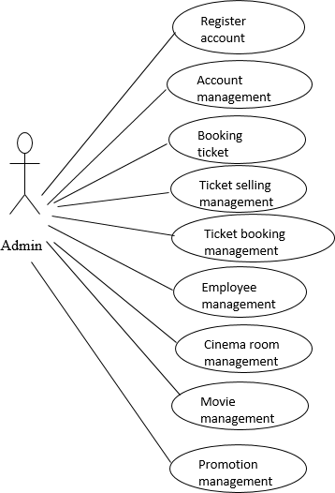

# Functional Description

## Functional Requirements

### Authentication & Authorization

##### **3.1.1.1 Log In Account**

**Users must be authenticated with the provided account and password to access the system.**

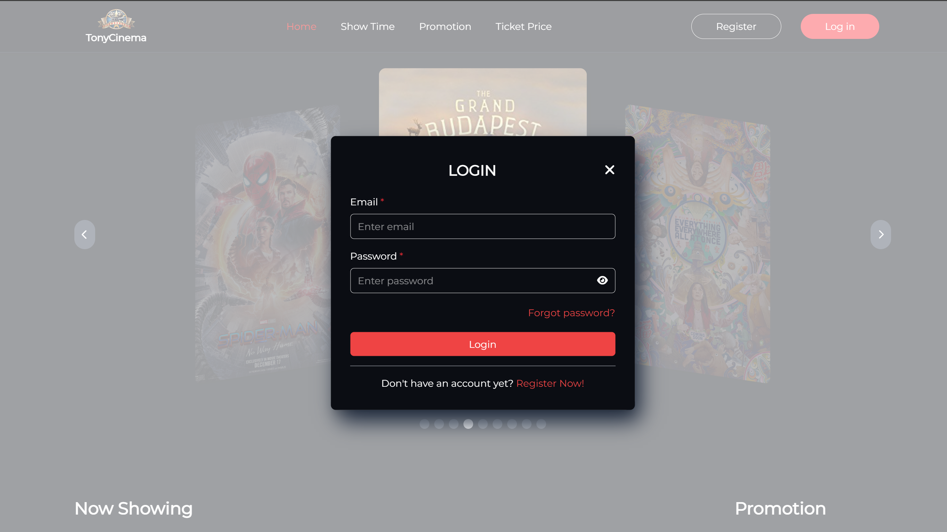

The system provides a login page for users to enter their email and password. The system will verify the entered user information with the user database of the system.

If no password and email are entered, the system will display an error stating that both fields are required. If no password and email are entered, the system will display an error stating that “Email and password are required”.

If the account does not exist in the system, the system will display the message "Account does not exist." If the password is incorrect, the system will show the error "Invalid password. Try another password for the account with currentEmail." If the email is incorrect, the system will display the error "The email address you entered isn't connected to an account."

If login successfully, the system will check the assigned roles and bring users to the main screen of the application

|  |  |
| --- | --- |
| Use Case Name | Log in account |
| Use Case ID |  |
| High Level Requirement Ref |  |
| Actor | User |
| Description | This is a use case which allows the user to log in the website |
| Trigger | NA |
| Pre-condition | The user enters email and password correctly |
| Post-processing |  |

|  |  |  |  |
| --- | --- | --- | --- |
| **Item** | **Type** | **Data** | **Description** |
| Email | Textbox-  String | N/A |  |
| Password | TextBox -  String | N/A |  |
| Forgot Password | Link Button | N/A |  |
| Show/HidePassword | Icon Button | N/A |  |
| Register now! | Link Button | N/A |  |
| Login | Button | N/A |  |

|  |  |  |  |
| --- | --- | --- | --- |
| **Screen action** | | | |
| **Action name** | **Description** | **Success** | **Failure** |
| Register now! | Click Register move to Register form | N/A | N/A |
| Login now | After filling in all required fields, click this button to submit data to the database, and the system will check if the information exists truely in the database, the system will release access token and refresh token for this user whenever they log into the system | Receive tokens and be directed to the specific screen as user’s role | Wrong inputs |
| Forgot password | Click this link button to direct to the forgot password form | N/A | N/A |
| Show/Hide Password | Click this icon button to show or hide password | N/A | N/A |

##### **3.1.1.2 Register Account**

|  |  |
| --- | --- |
| Use Case Name | Register account |
| Use Case ID |  |
| High Level Requirement Ref |  |
| Actor | User |
| Description | This is a use case which allows the user to register accounts |
| Trigger | NA |
| Pre-condition | The user registers account information |
| Post-processing |  |

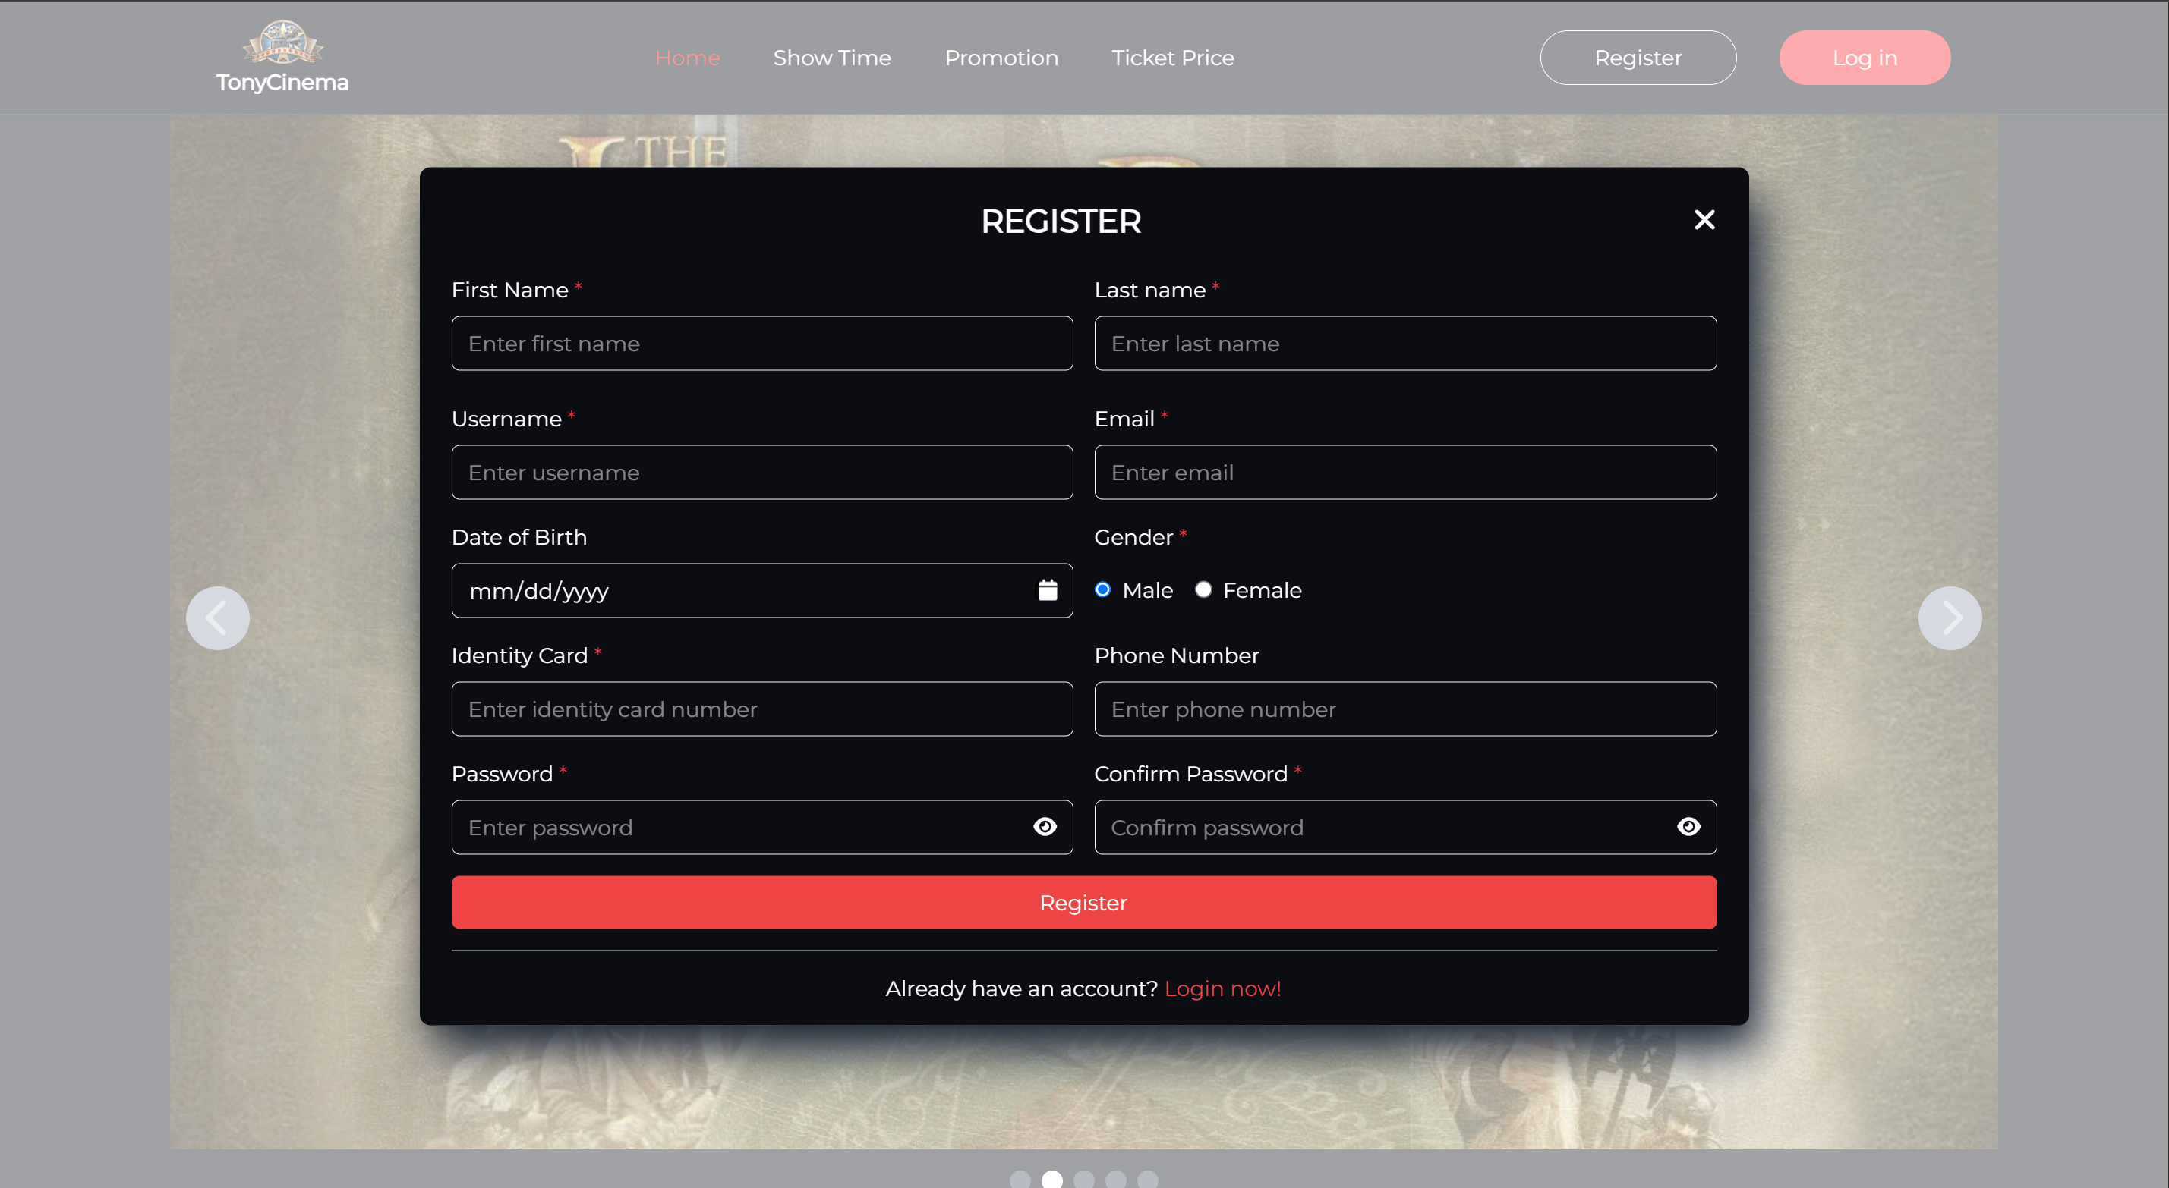

When entering existed user name or email, the system will show a message “Username already existed”/” Email already existed”

Each input field has their own unique criteria , if user fails to sign up, the specific errors will be shown immediately for them to check .

|  |  |  |  |  |
| --- | --- | --- | --- | --- |
| **Screen** | Register account | | | |
| **Description** | Register user information | | | |
| **Screen**  **Access** | The user clicks Register account | | | |
| **Screen Content** | | | | |
| **Item** | **Type** | **Data** | **Description** | |
| First name | Textbox-  String | N/A |  | |
| Last name | TextBox -  String | N/A |  | |
| Confirm  password | Textbox -  String | N/A |  | |
| Username | Textbox -  String | N/A |  | |
| Date of birth | Textbox -  String | N/A |  | |
| Gender | Radiobutton  - String | N/A |  | |
| Email | Textbox –  String | N/A |  | |
| Identity card | Texbox -  number | N/A |  | |
| Phone  number | Textbox -  Number | N/A |  | |
| Password | Textbox -  String | N/A |  | |
| Confirm password | Textbox -  String | N/A |  | |
| Show/Hide password | Icon-buttion | N/A |  | |
| Register | Button | N/A |  | |
| Login now! | Link | N/A |  | |
| **Screen action** | | | | |
| **Action name** | **Description** | | **Success** | **Failure** |
| Register | Click Register to submit data to the database to creat a new account | | Forward to login in the website | The required fields are null or they do not matched the input criteria |
| Login now! | Click this link button to direct to the login form | | N/A | N/A |

##### 3.1.1.3 Forgot Password

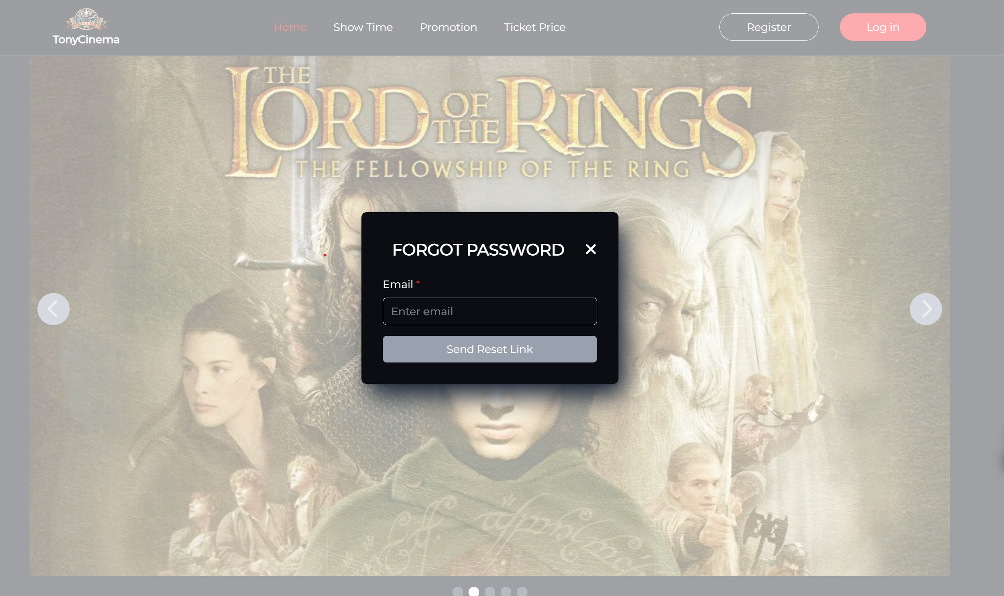

|  |  |
| --- | --- |
| Use Case Name | Forgot password |
| Use Case ID |  |
| High Level Requirement Ref |  |
| Actor | User |
| Description | This is a use case which allows the user to get an email (with a link) to reset their password then |
| Trigger | NA |
| Pre-condition | The user clicks forgot password in the Login form |
| Post-processing |  |

|  |  |  |  |
| --- | --- | --- | --- |
| **Screen** | Forgot password | | |
| **Description** | Get new password | | |
| **Screen**  **Access** | The user clicks Forgot password | | |
| **Screen Content** | | | |
| **Item** | **Type** | **Data** | **Description** |
| Email | Textbox-  String | N/A |  |
| Send Reset Link | Button | N/A |  |

|  |  |  |  |
| --- | --- | --- | --- |
| **Screen action** | | | |
| **Action name** | **Description** | **Success** | **Failure** |
| Send Reset Link | After fill in correct email, click this button and the email sender will work, | user will get an email with the notification and a link (limited 5 minutes) to access to the reset password form | Wrong email |

##### **3.1.1.4 Reset Password**

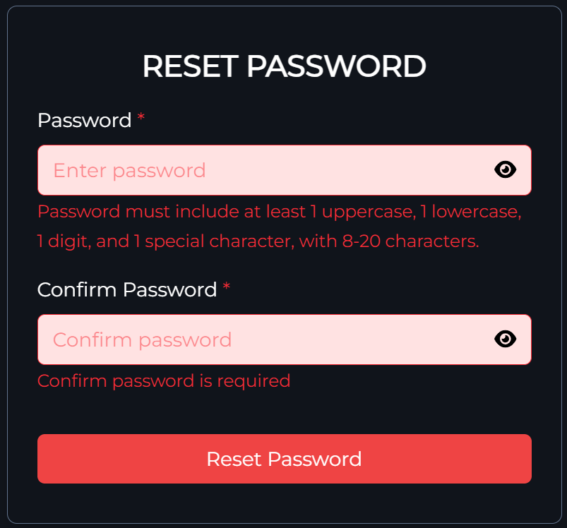

After 5 minutes receiving the mail and clicking the included link, the user cannot reset password because the token is expired and the system will show error message: “Invalid or expired token. Please request a new password reset link here”, instead, user has to click “here” to be back to the forgot password form and send reset link again to receive another new email with a link.

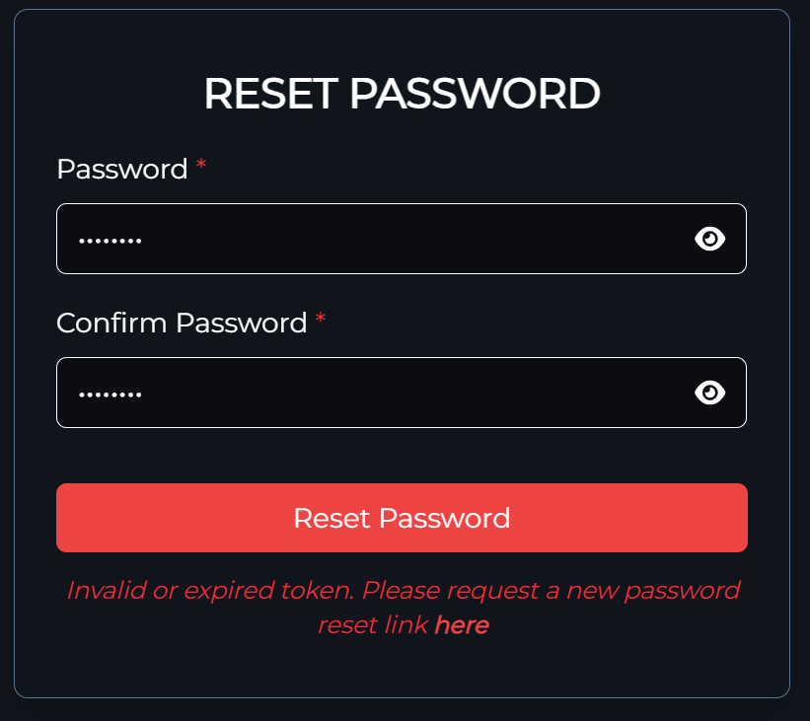

|  |  |
| --- | --- |
| Use Case Name | Reset password |
| Use Case ID |  |
| High Level Requirement Ref |  |
| Actor | User |
| Description | This is a use case which allows the user to reset current password |
| Trigger | NA |
| Pre-condition | The user clicks the link in the received email |
| Post-processing |  |

|  |  |  |  |
| --- | --- | --- | --- |
| **Screen** | Reset password | | |
| **Description** | Reset the current password | | |
| **Screen**  **Access** | The user clicks send reset link and receive an email with a link, click that link | | |
| **Screen Content** | | | |
| **Item** | **Type** | **Data** | **Description** |
| Password | Textbox-  String | N/A |  |
| Confirm password | Textbox-  String | N/A |  |
| Here | Text-link | N/A |  |
| Reset Password | Button | N/A |  |

|  |  |  |  |
| --- | --- | --- | --- |
| **Screen action** | | | |
| **Action name** | **Description** | **Success** | **Failure** |
| Reset password | After fill in new password and confirm password, click this button to reset password to new one | The system will show message “reset password successfully” and redirect to the homepage without log in, the database will update the new password | - Wrong confirm password  - The token is expired (after 5 minutes) the link in the received email will invalid |
| Here | After 5 minutes, user cannot reset password due to token expiration, click “here” to be back to the forgot password form and get another email will included link | Redo send reset link and get an email with 5-minute-link | -wrong email |

##### **3.1.1.5 Change Password**

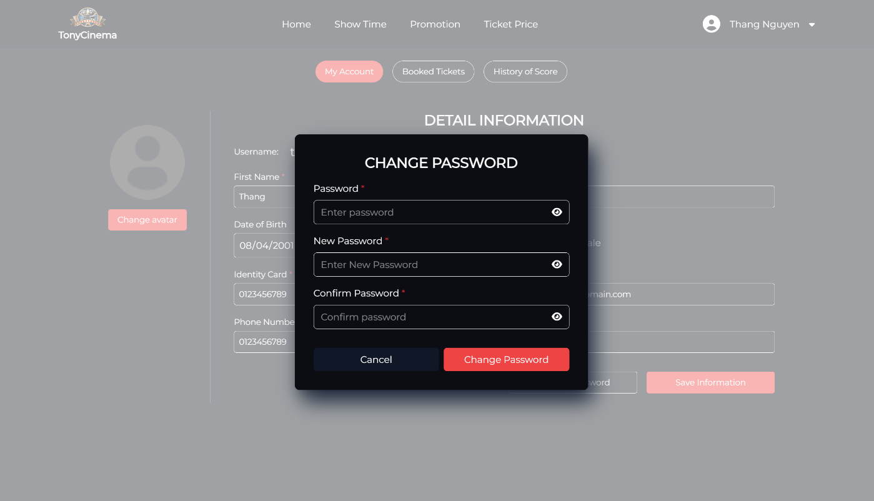

If user enters new password same as current password, the system will show message below:

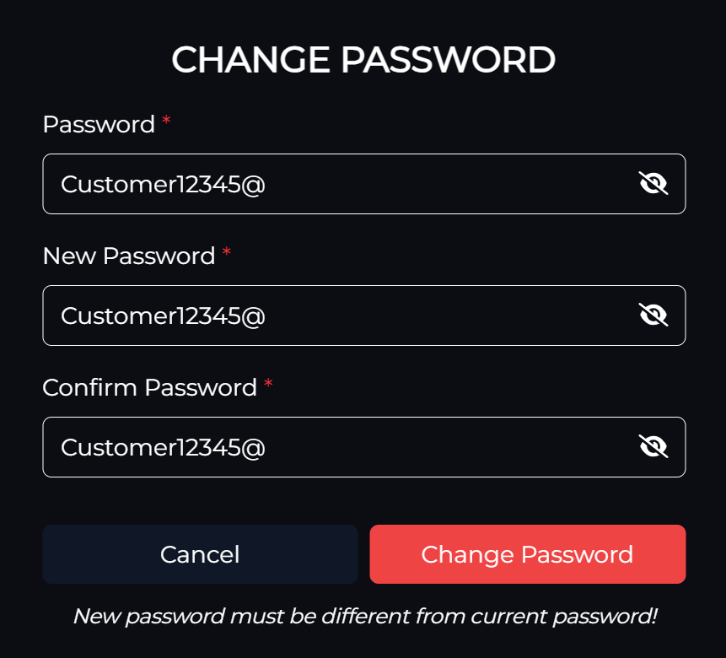

When entering wrong current password, the system will show error message: “Error changing password! Try again”

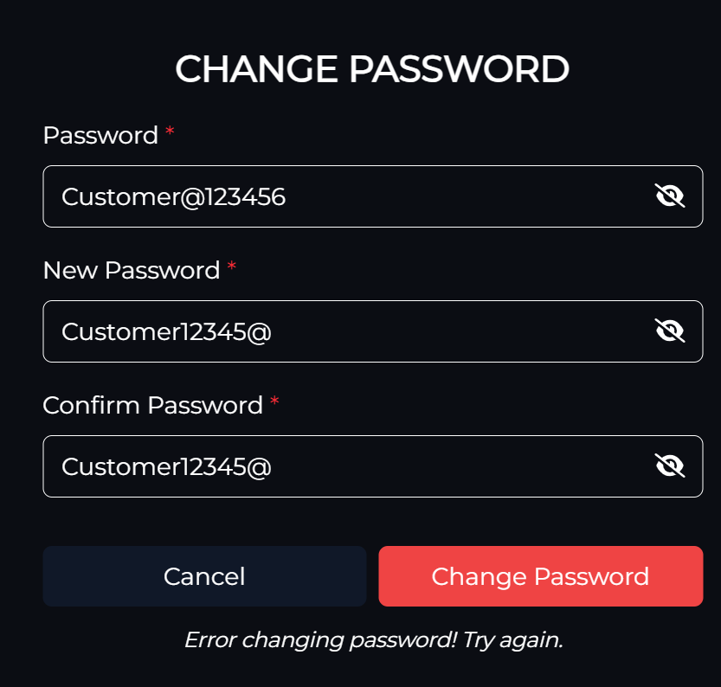

When passing all criterial of input fields and clicking “Change password”, the system will announce: “Password changed successfully”

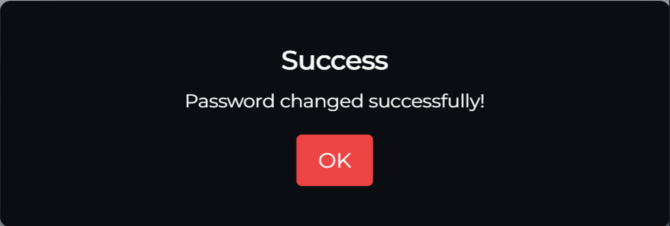

|  |  |
| --- | --- |
| Use Case Name | Change password |
| Use Case ID |  |
| High Level Requirement Ref |  |
| Actor | Customer – member |
| Description | This is a use case which allows the user to change current password |
| Trigger | NA |
| Pre-condition | Successfully registered and logged in the website. |
| Post-processing |  |

|  |  |  |  |
| --- | --- | --- | --- |
| **Screen** | Change password | | |
| **Description** | Change the current password | | |
| **Screen**  **Access** | At HomePage, the user clicks Profile and Change Password | | |
| **Screen Content** | | | |
| **Item** | **Type** | **Data** | **Description** |
| Password | Textbox-  String | N/A | Current password |
| New password | Textbox-  String | N/A |  |
| Confirm password | Textbox-  String | N/A |  |
| Change password | Button | N/A |  |
| Cancel | Button | N/A |  |

|  |  |  |  |
| --- | --- | --- | --- |
| **Screen action** | | | |
| **Action name** | **Description** | **Success** | **Failure** |
| Change password | After fill in current password, new password and confirm password, click this button to change password to new one | The system will show message “password change successfully”, the database will update the new password for user | - Wrong confirm password  - Passwords do not match the criteria  - Wrong confirm password |
| Cancel | Click cancel to close change password form | N/A | N/A |

##### **3.1.1.6 Authorization**

When user log in the system by Admin account, the system will direct him/her to the admin management UI with rights to all actions in the sidebar such as user management (including customers, employees), room management, ticket management, promotion management, movie management, …

And only Employees must be created by admins, the default password for these accounts is: “Abc@12345”, they can edit password or information themselves in the Profile in Website. Also in management page there is profile editing available but without changing password there.

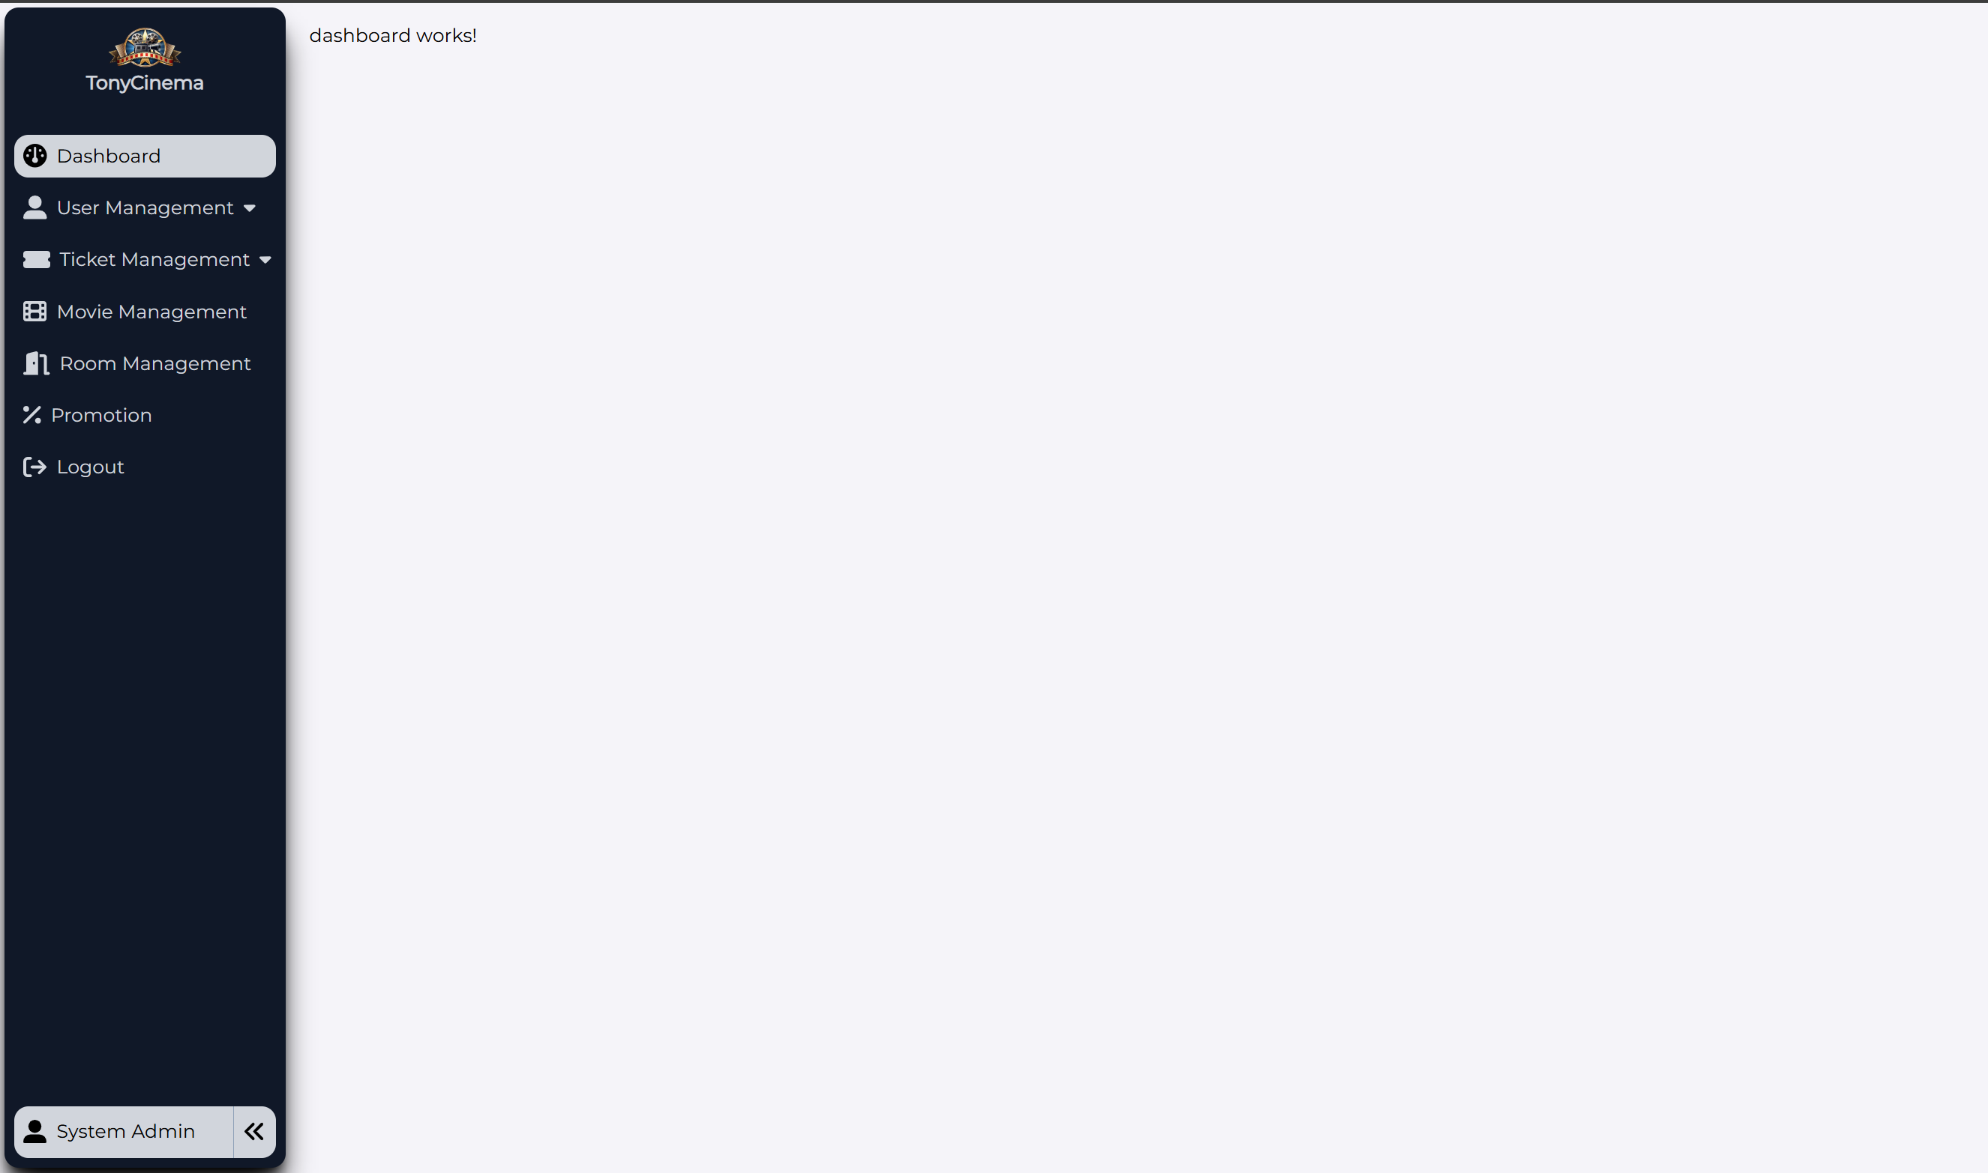

When user is with Employee account, the system will lead him/her to the employee management UI (same with admin’s) but with fewer rights to all actions in the sidebar for specific managements such as Ticket Management, Dashboard, Setting. If the employee keeps accessing the unavailable managements like user management, movie management, … the system will show a message as below: “Only available for admin users”

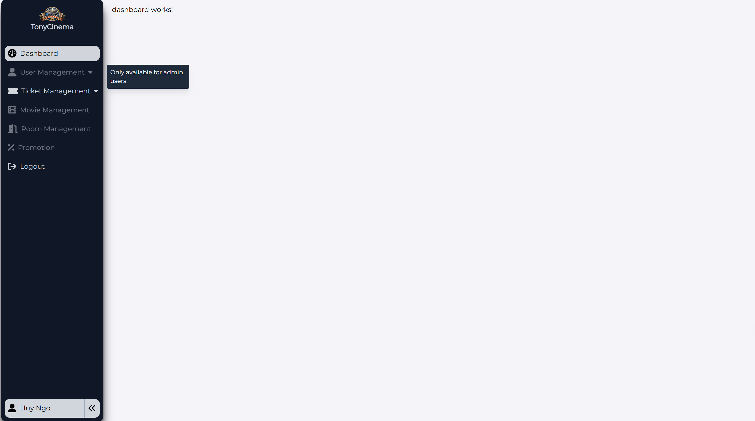

Admin and User can access to the Cinema Website by clicking on the Cinema Logo, and when being in the Cinema website, they can go back to the management page by choosing Management Page in the left corner dropdown menu

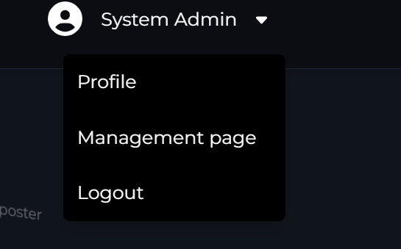

When users as customers (member or not member) log in the system, these actors have different rights to the website as mentioned in part 2.1

### Account management of the user

|  |  |
| --- | --- |
| Use Case  Name | Account management |
| Use Case ID |  |
|  |  |
| Actor | Member |
| Description | This is a use case which allows the users to update information, change avatar, change password, manage ticket booking, view details of score including added and used scores |
| Trigger | NA |
| Pre-condition | The user with registered account and logged in the website successfully |
| Post-  processing |  |

#### Edit member profile

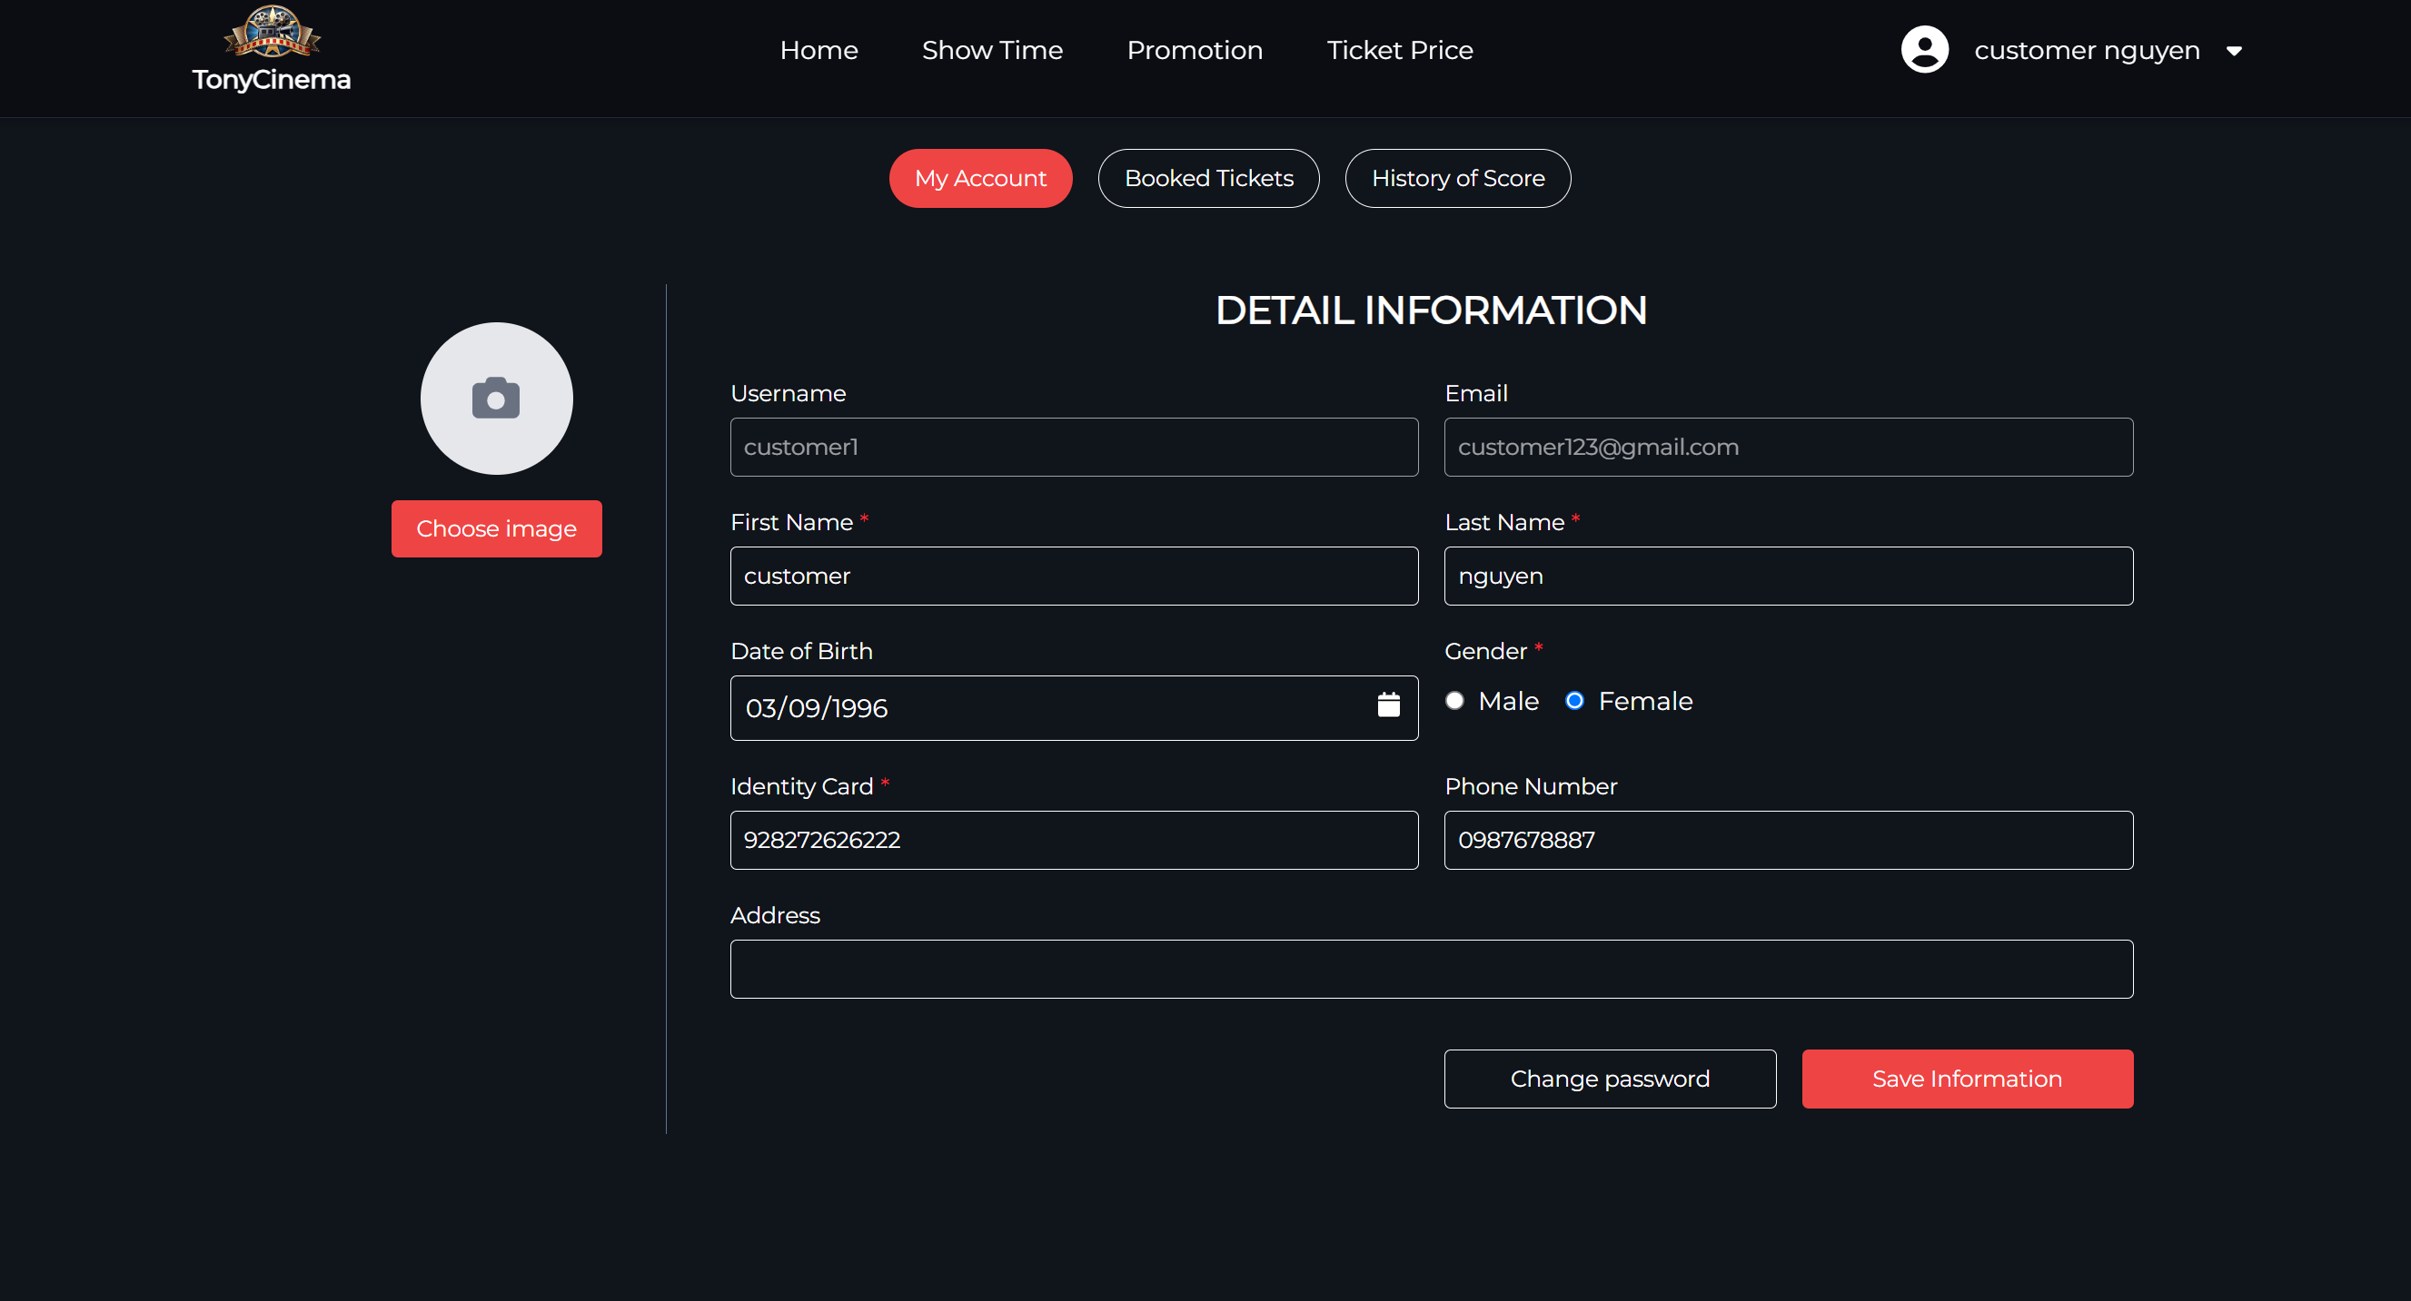

The Username and email cannot be changed, because of authentication so each input field has their own criteria, if the user fails with some fields, they will be noticed by the specific error messages below each field

After filling fields matching all criteria, and press “Save information”, there will be a pop-up showed

below:

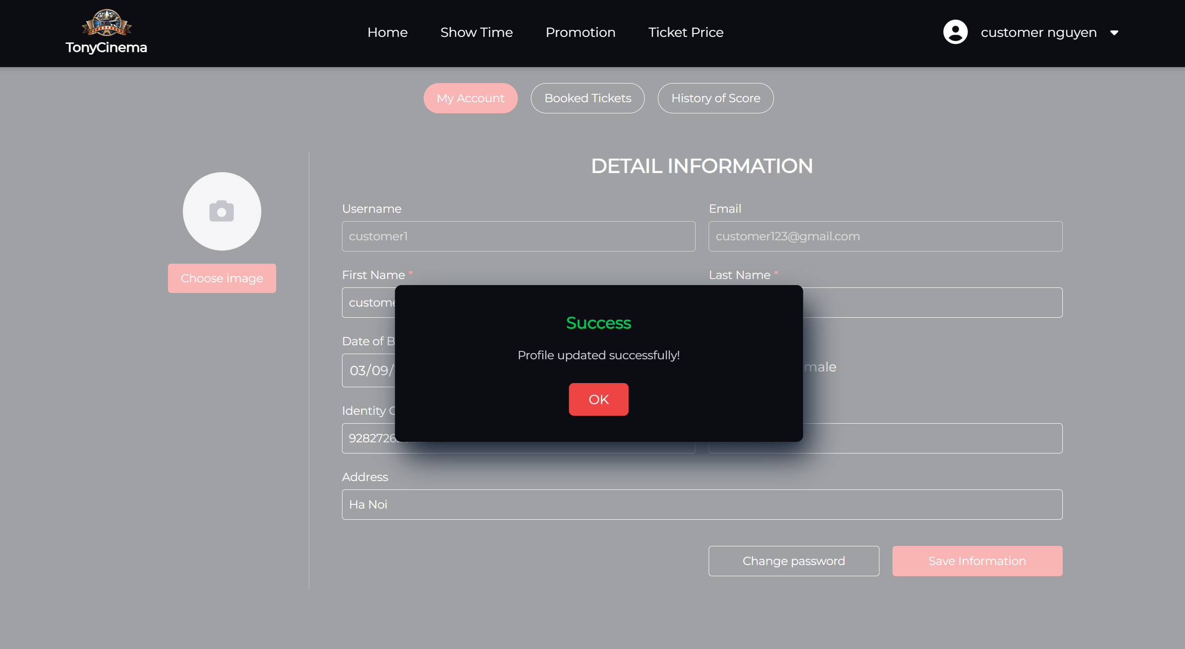

|  |  |
| --- | --- |
| **Screen** | Edit member account |
| **Description** | Display information of member whose account needs editing |
| **Screen**  **Access** | The user clicks “Profile” at the right corner dropdown |

|  |  |  |  |  |
| --- | --- | --- | --- | --- |
| **Screen Content** | | | | |
| **Action name** | **Description** | **Success** | **Failure** | |
| Full name | Textbox – string | N/A |  | |
| Username | ReadOnly | N/A |  | |
| Date of birth | Textbox – string | N/A |  | |
| Identity Card | Textbox – string | N/A |  | |
| Email | ReadOnly | N/A |  | |
| Identity card | Textbox – string | N/A |  | |
| Phone  number | Textbox – string | N/A |  | |
| Address | Textbox – string | N/A |  | |
| Choose Avatar | Button | N/A |  | |
| Change Password | Button | N/A |  | |
| Save Information | Button | N/A |  | |
| **Screen action** | | | | |
| **Action name** | **Description** | | **Success** | **Failure** |
| Choose Avatar | Click this button to open explorer to update avatar | | N/A | N/A |
| Chang Password | Click this button move to change password form | | N/A | N/A |
| Save Information | Click this button to save all the changes and send request to update newest data to the database, save all changes | | The user’s information is updated | The inputs do not match the criteria. |

#### Change Avatar

|  |  |
| --- | --- |
| **Screen** | Change avatar |
| **Description** | Display a screen for users to choose or update avatar |
| **Screen**  **Access** | The user clicks “Profile” at the right corner dropdown |

|  |  |  |  |  |
| --- | --- | --- | --- | --- |
| **Screen Content** | | | | |
| **Action name** | **Description** | **Success** | **Failure** | |
| Full name | Textbox – string | N/A |  | |
| Username | ReadOnly | N/A |  | |
| Date of birth | Textbox – string | N/A |  | |
| Identity Card | Textbox – string | N/A |  | |
| Email | ReadOnly | N/A |  | |
| Identity card | Textbox – string | N/A |  | |
| Phone  number | Textbox – string | N/A |  | |
| Address | Textbox – string | N/A |  | |
| Choose Avatar | Button | N/A |  | |
| Change Password | Button | N/A |  | |
| Save Information | Button | N/A |  | |
| **Screen action** | | | | |
| **Action name** | **Description** | | **Success** | **Failure** |
| Choose Avatar | Click this button to choose an image avatar from your computer | | The default avatar will change to perform your chosen image | N/A |
| Change Password | Click this button move to change password form | | N/A | N/A |
| Save Information | Click this button to save all the changes and send request to update newest data to the database | | The user’s information is updated | The inputs do not match the criteria. |

#### The member – View booked tickets list

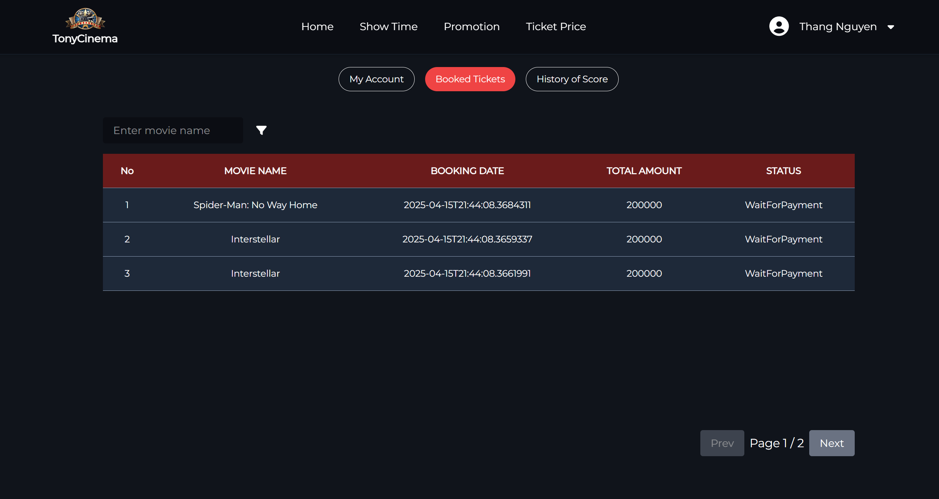

|  |  |  |  |
| --- | --- | --- | --- |
| **Screen** | Booked Tickets | | |
| **Description** | Display all booked tickets of member | | |
| **Screen**  **Access** | Member clicks “View Profile” on the dropdown at the right corner then choose “Booked tickets” | | |
| **Screen Content** | | | |
| **Item** | **Type** | **Data** | **Description** |
| No | int | N/A |  |
| Movie Name | label-  string | N/A |  |

|  |  |  |  |  |
| --- | --- | --- | --- | --- |
| Booking date | Label -  String | N/A |  | |
| Total Amount | Label -  String | N/A |  | |
| Status | Link -  String | N/A |  | |
| Filter | Icon | N/A |  | |
| **Screen Action** | | | | |
| **Action name** | **Description** | | **Success** | **Failure** |
| Filter | Click this icon, the filter form will be showed with some criteria | | N/A | N/A |

#### The member – Search booked tickets with movie name

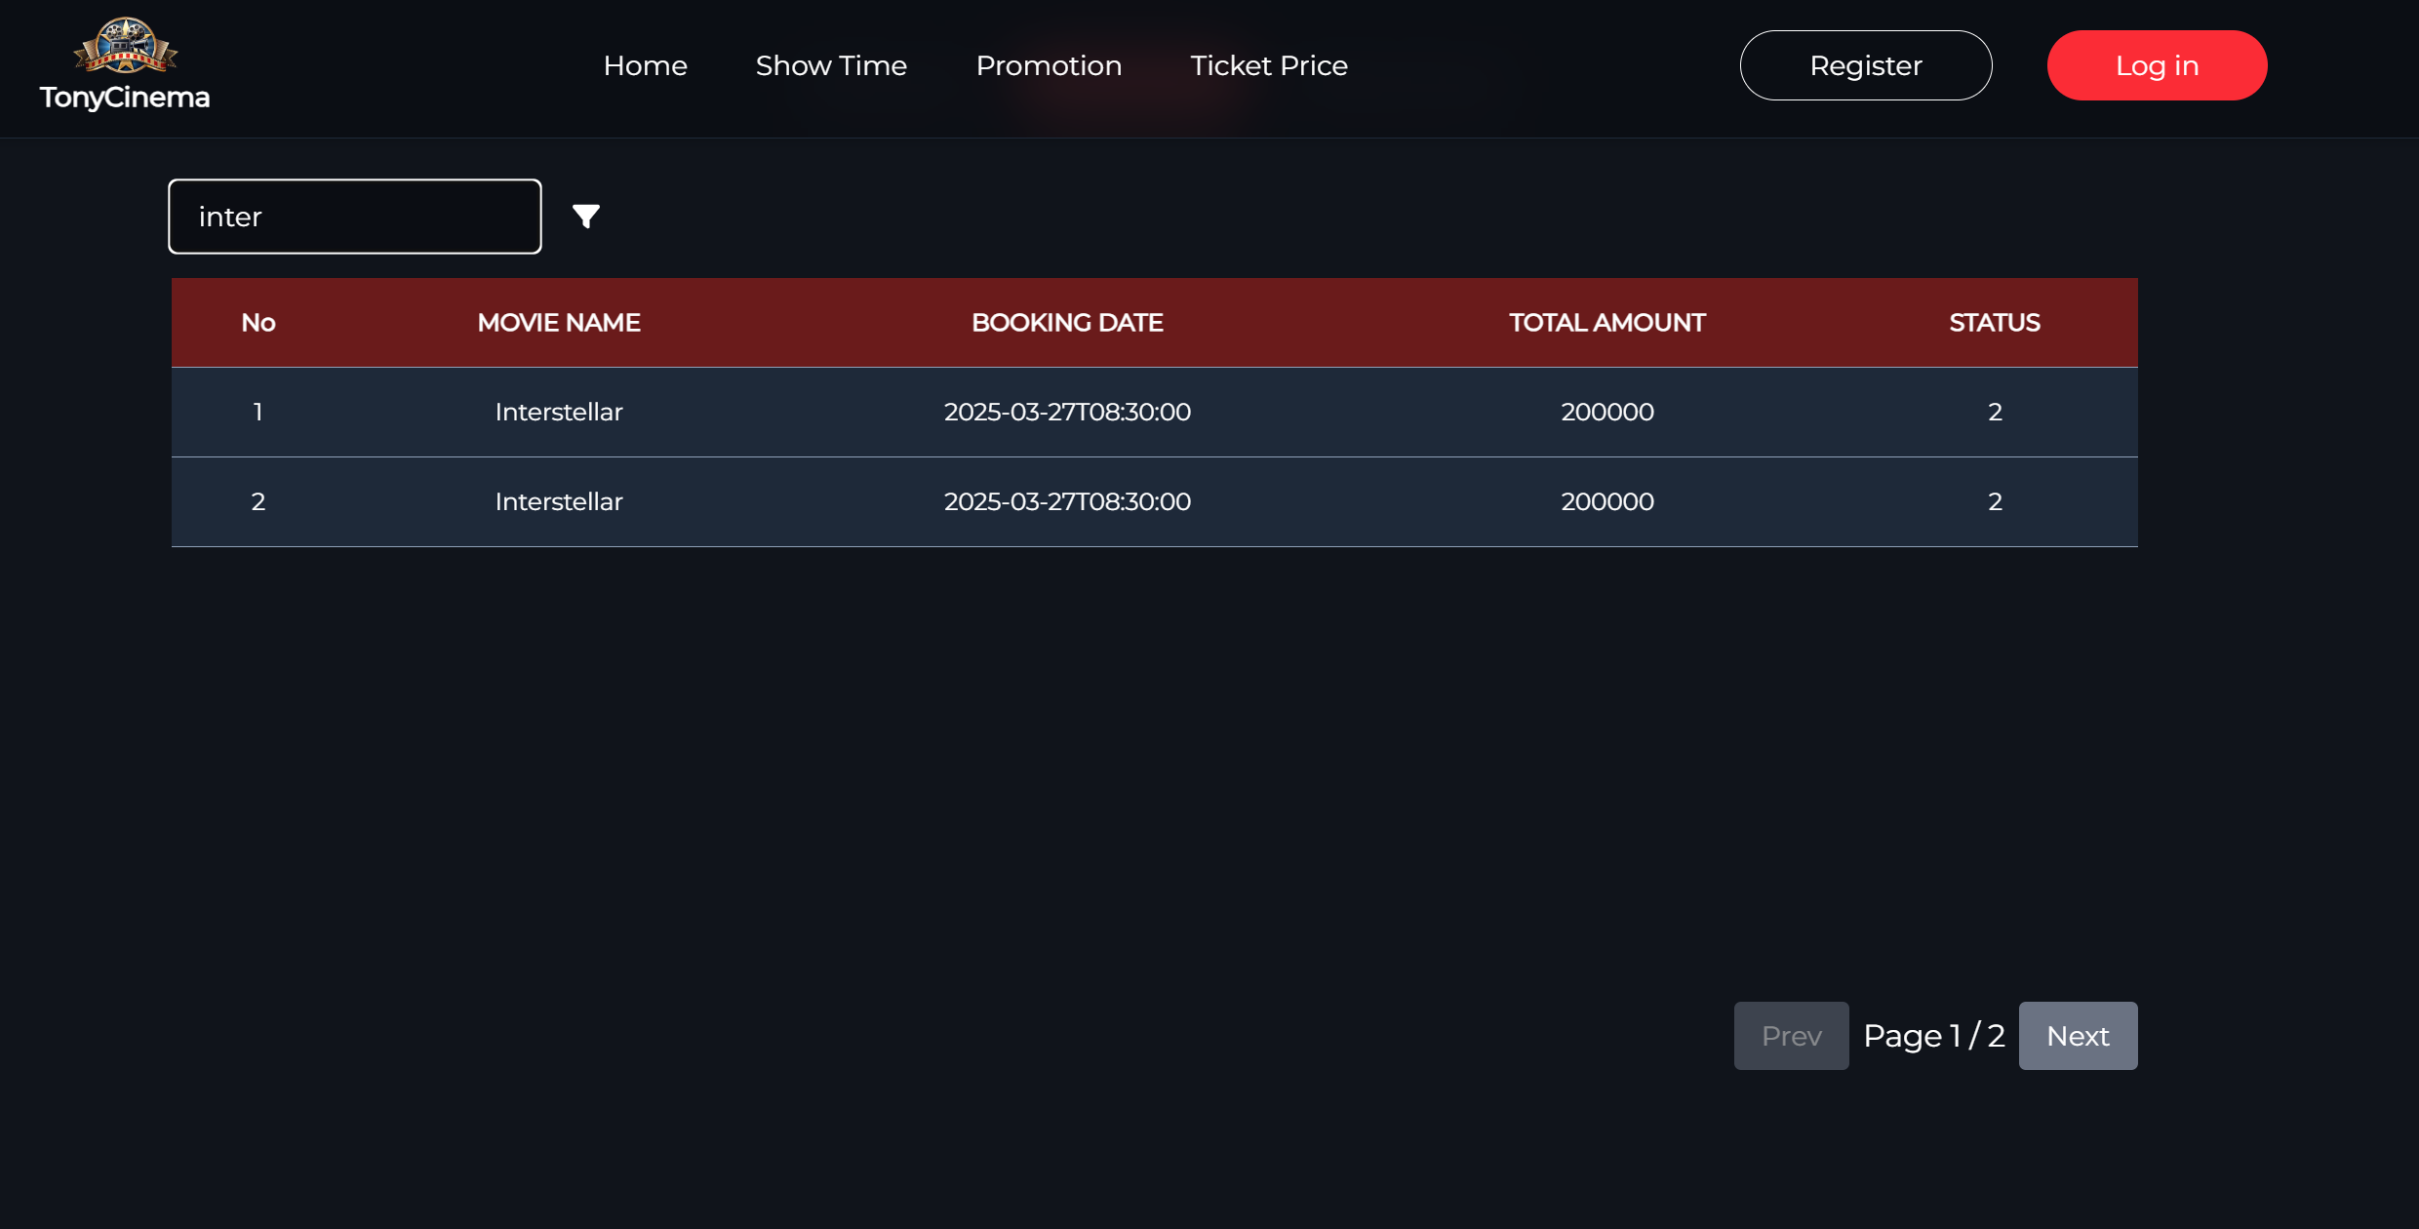

User enters the movie name to search and the below table will automatically show all the booked tickets matching the searching input

|  |  |  |  |
| --- | --- | --- | --- |
| **Screen** | Search Booked Tickets by movie name | | |
| **Description** | Display all booked tickets of member searched by movie name | | |
| **Screen**  **Access** | At “Booked Ticked” screen, the user clicks the input field and enter movie name | | |
| **Screen Content** | | | |
| **Item** | **Type** | **Data** | **Description** |
| No | int | N/A |  |
| Movie Name | label-  string | N/A |  |

|  |  |  |  |
| --- | --- | --- | --- |
| Booking date | Label -  String | N/A |  |
| Total Amount | Label -  String | N/A |  |
| Status | Link -  String | N/A |  |

#### The member – Search booked tickets with filter

#### The member – View history of score

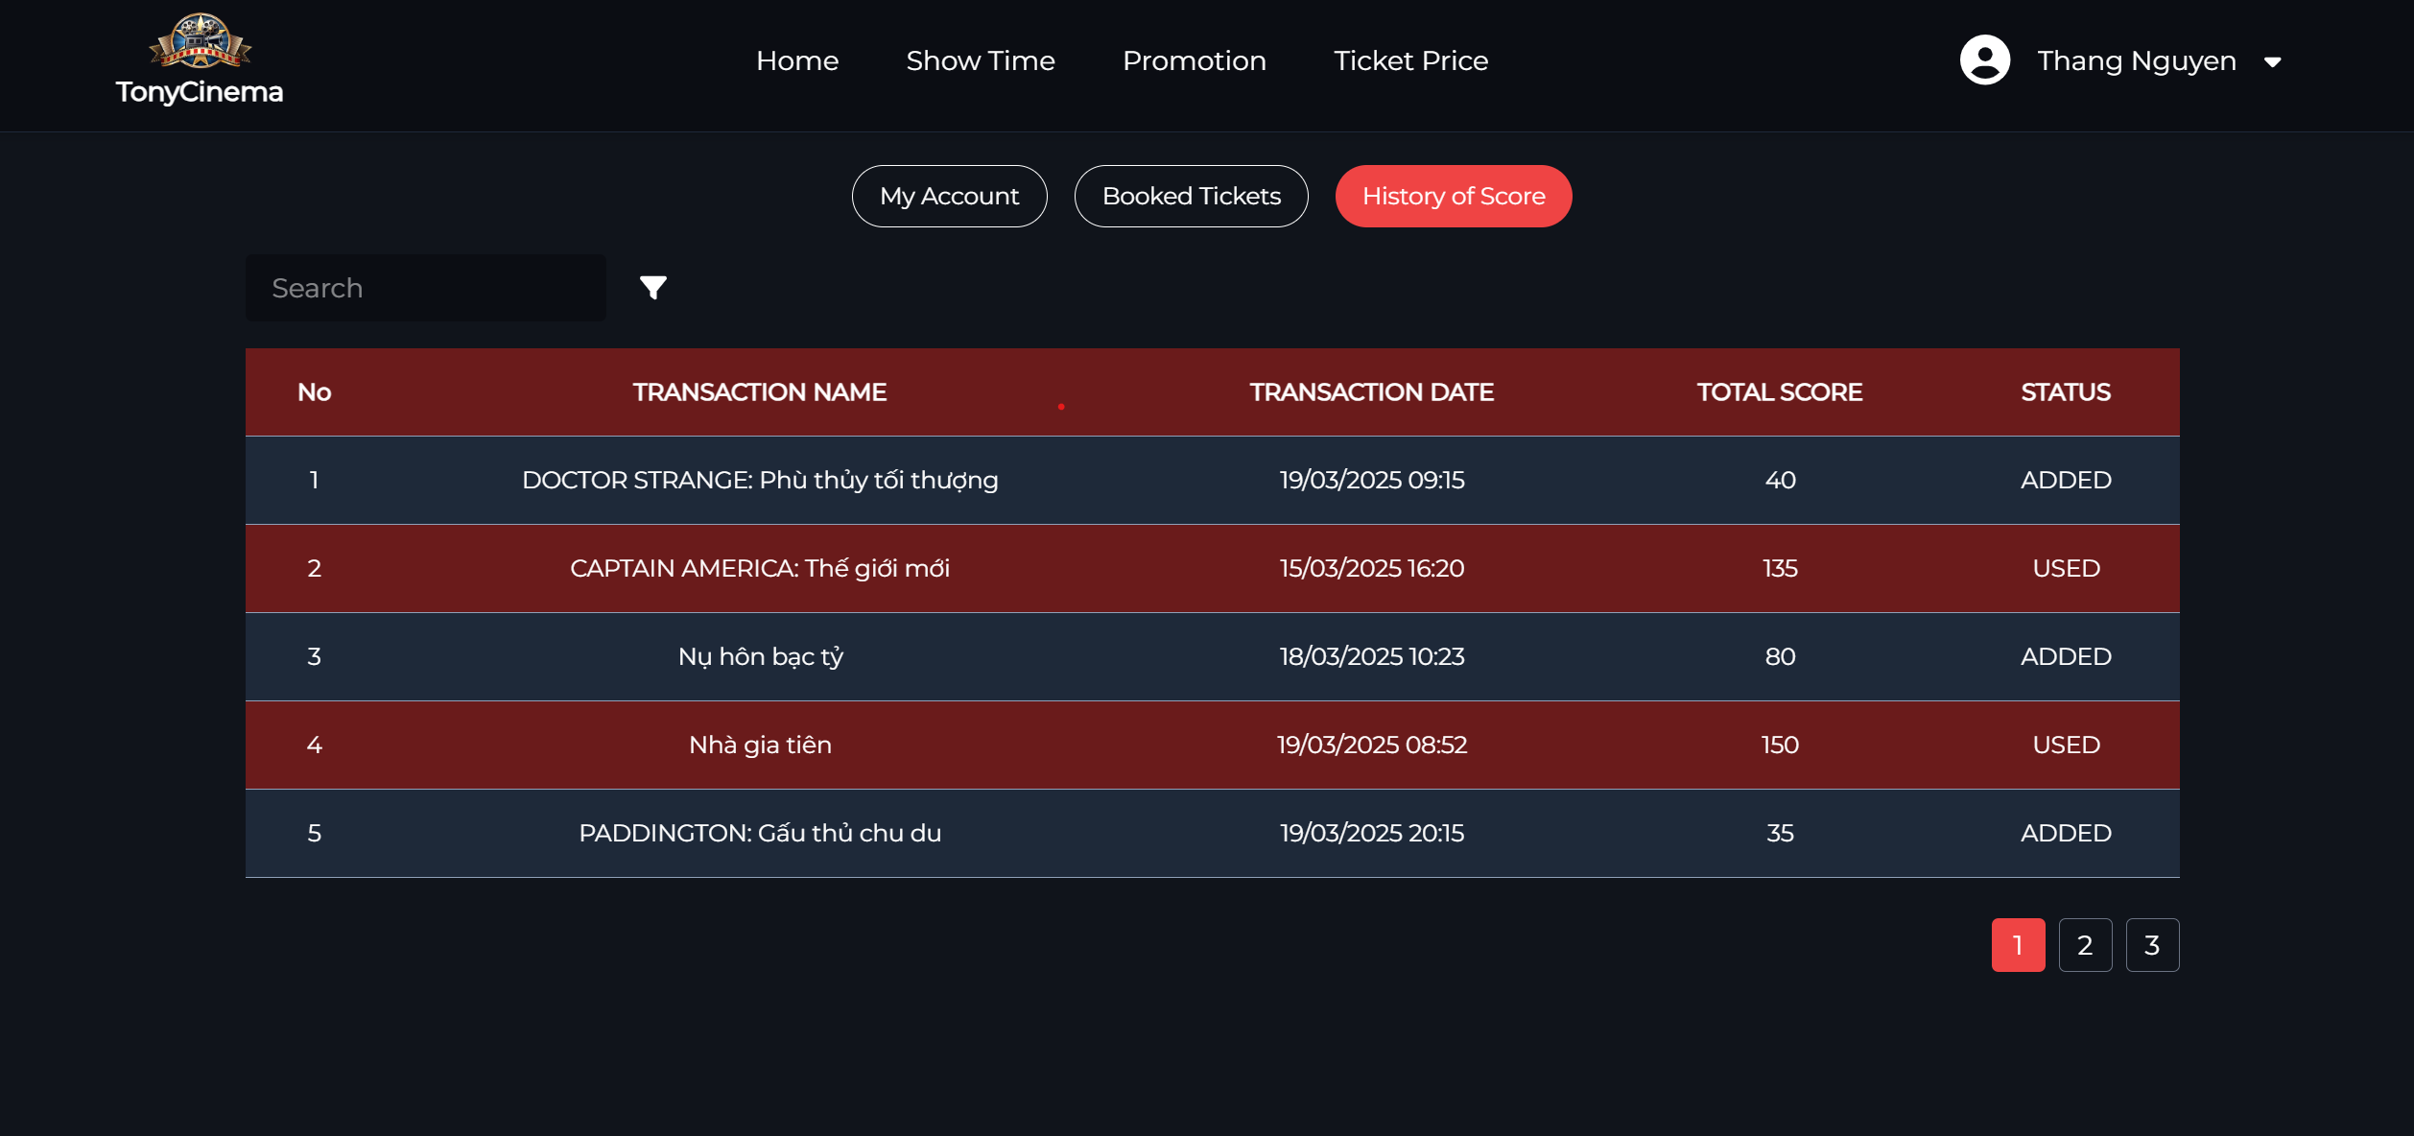

|  |  |  |  |  |
| --- | --- | --- | --- | --- |
| **Screen** | View history of score adding/using | | | |
| **Description** | Display all history of score adding/using of the current member | | | |
| **Screen**  **Access** | The member clicks account management -> History | | | |
| **Screen Content** | | | | |
| **Item** | **Type** | **Data** | **Description** | |
| From date | Date - string | N/A |  | |
| To date | Date - string | N/A |  | |
| History of  score adding | Radiobutton-  String | N/A |  | |
| History of  score using | Radiobutton-  String | N/A |  | |
| Date created | Label -  string | N/A |  | |
| Movie name | Label -  string | N/A |  | |
| Added score | Label -  string | N/A |  | |
| Account  information | Link - String | N/A |  | |
| History | Link - String | N/A |  | |
| Booked  ticket | Link - String | N/A |  | |
| Canceled  ticket | Link - String | N/A |  | |
| Log out | Button | N/A |  | |
| View score | Button | N/A |  | |
|  |  |  |  | |
| **Screen Action** | | | | |
| **Action name** | **Description** | | **Success** | **Failure** |
| Log out | Click the logout button to exit the current member account | | Back to the login screen | No event has been created for the logout  button |
| View score | Click the View score button to see the process of using or adding scores | | Displays a list of added or used  scores | No event created for ViewScore button |

#### The member – Search score with transaction name

#### The member – Search score with filters

#### Admin/Employee – View Profile/Edit Profile

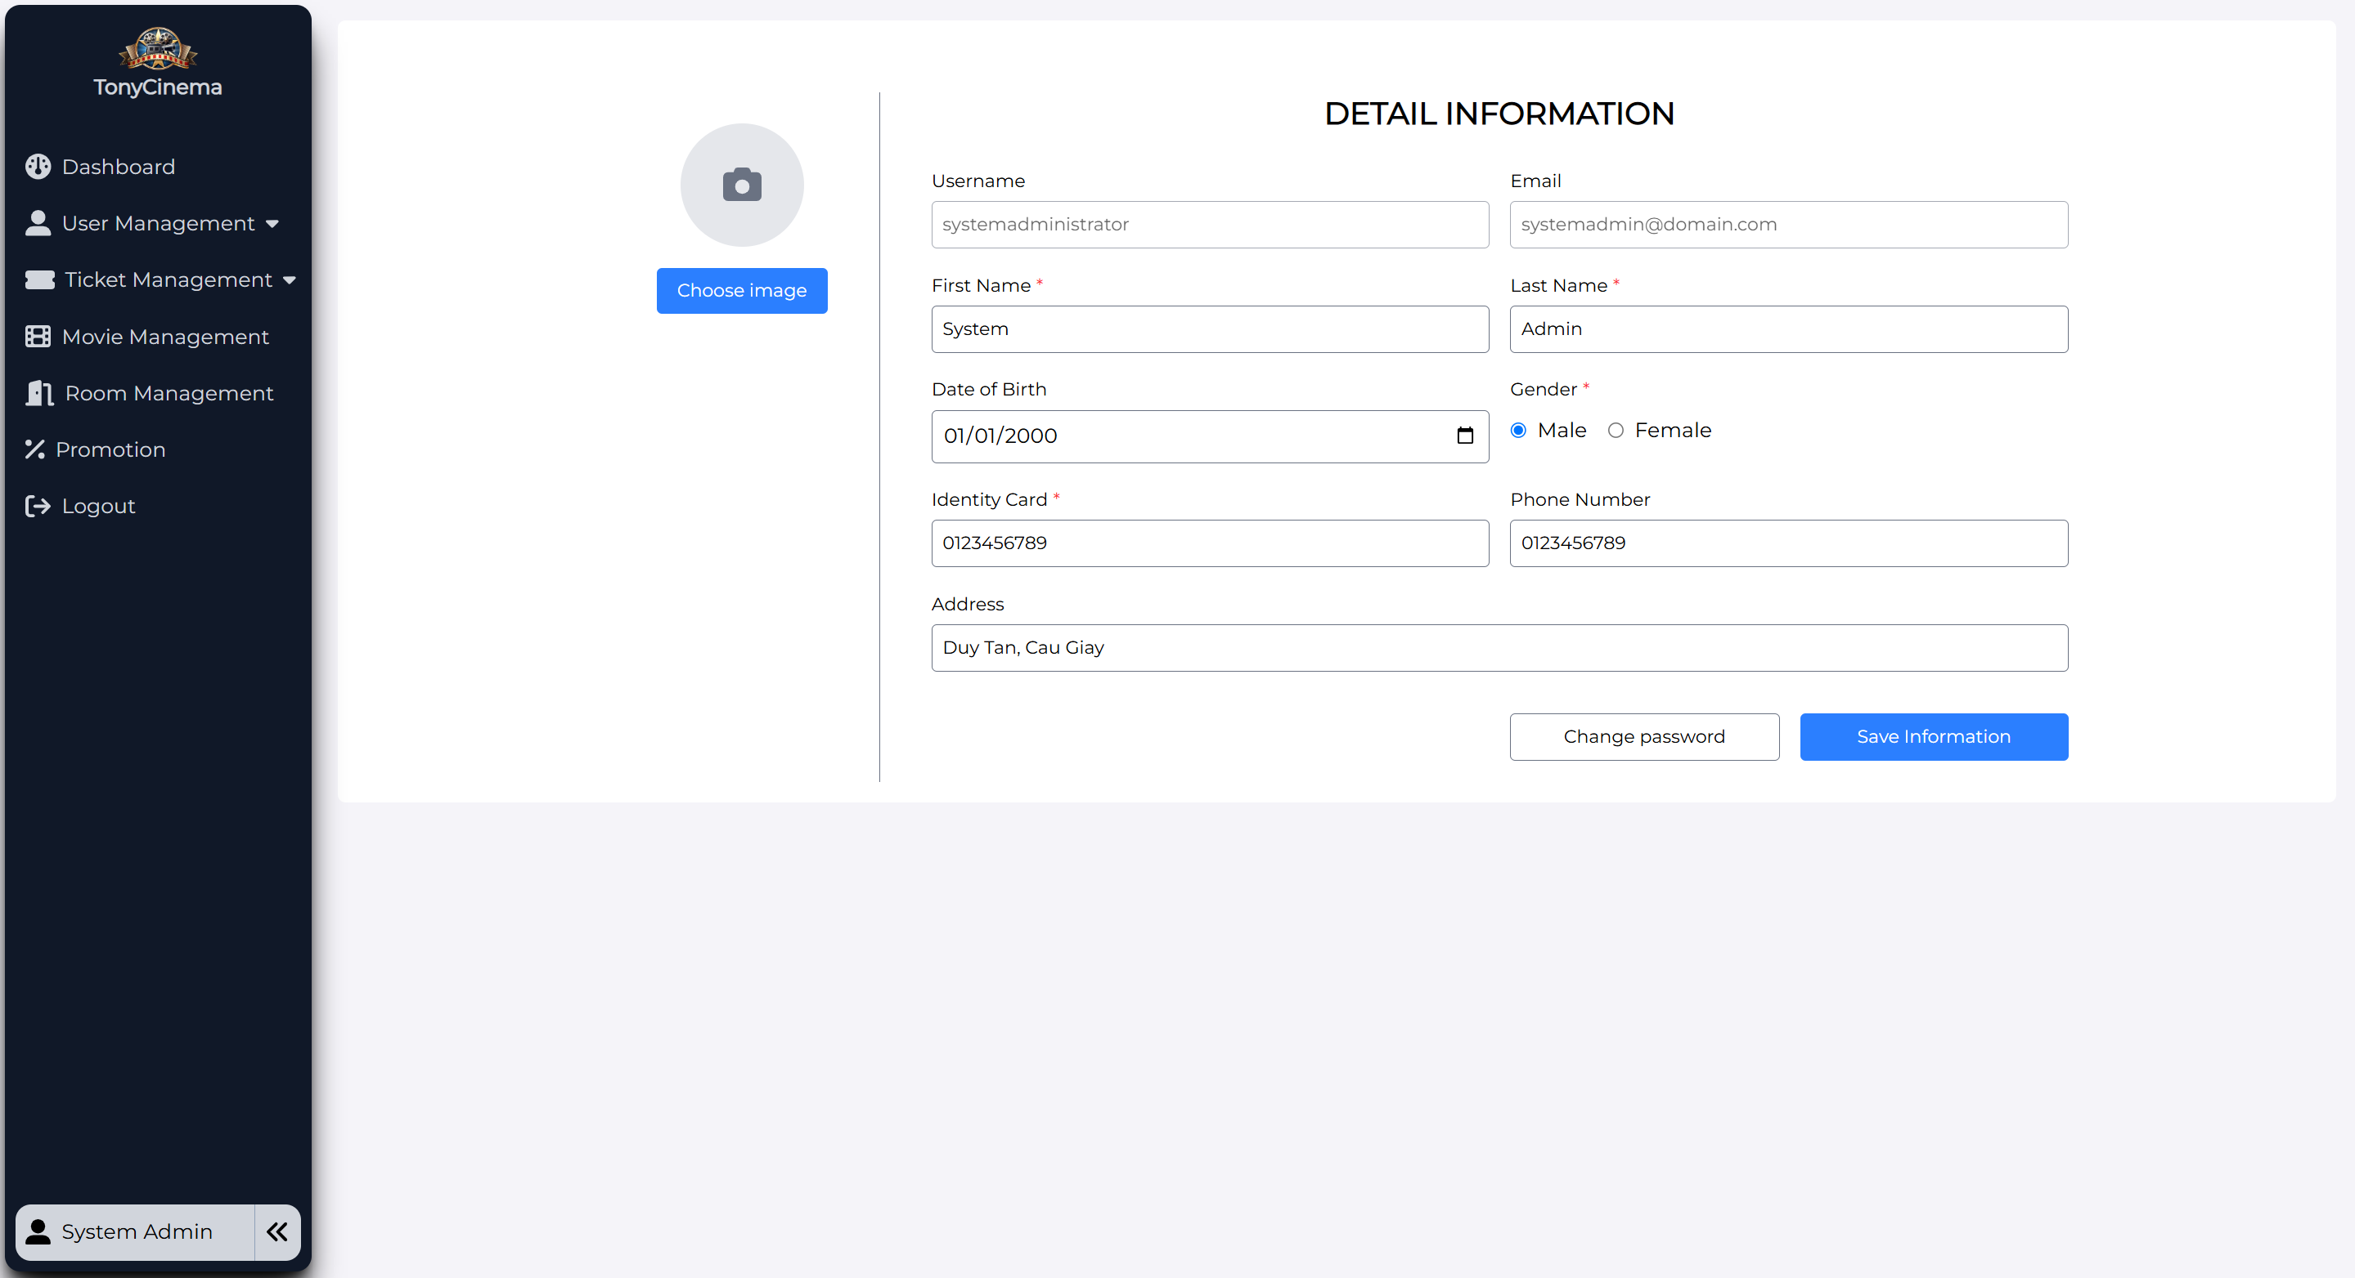

|  |  |
| --- | --- |
| **Screen** | Edit Admin/Employee account |
| **Description** | Display information of member whose account needs editing |
| **Screen**  **Access** | The admin/employee clicks the profile button at the left corner of management page |

|  |  |  |  |  |
| --- | --- | --- | --- | --- |
| **Screen Content** | | | | |
| **Action name** | **Description** | **Success** | **Failure** | |
| Full name | Textbox – string | N/A |  | |
| Username | ReadOnly | N/A |  | |
| Date of birth | Textbox – string | N/A |  | |
| Identity Card | Textbox – string | N/A |  | |
| Email | ReadOnly | N/A |  | |
| Identity card | Textbox – string | N/A |  | |
| Phone  number | Textbox – string | N/A |  | |
| Address | Textbox – string | N/A |  | |
| Choose Avatar | Button | N/A |  | |
| Change Password | Button | N/A |  | |
| Save Information | Button | N/A |  | |
| **Screen action** | | | | |
| **Action name** | **Description** | | **Success** | **Failure** |
| Choose Avatar | Click this button to open explorer to update avatar | | N/A | N/A |
| Chang Password | Click this button move to change password form | | N/A | N/A |
| Save Information | Click this button to save all the changes and send request to update newest data to the database, save all changes | | The user’s information is updated | The inputs do not match the criteria. |

### Booking ticket of the user

|  |  |
| --- | --- |
| Use Case  Name | Booking ticket |
| Use Case ID |  |
|  |  |
| Actor | Member |
| Description | This is the use case which allows users to book tickets |
| Trigger | NA |
| Pre-condition | The user logged in the website successfully |
| Post-  processing |  |

#### Book ticket – Select movie and showtime

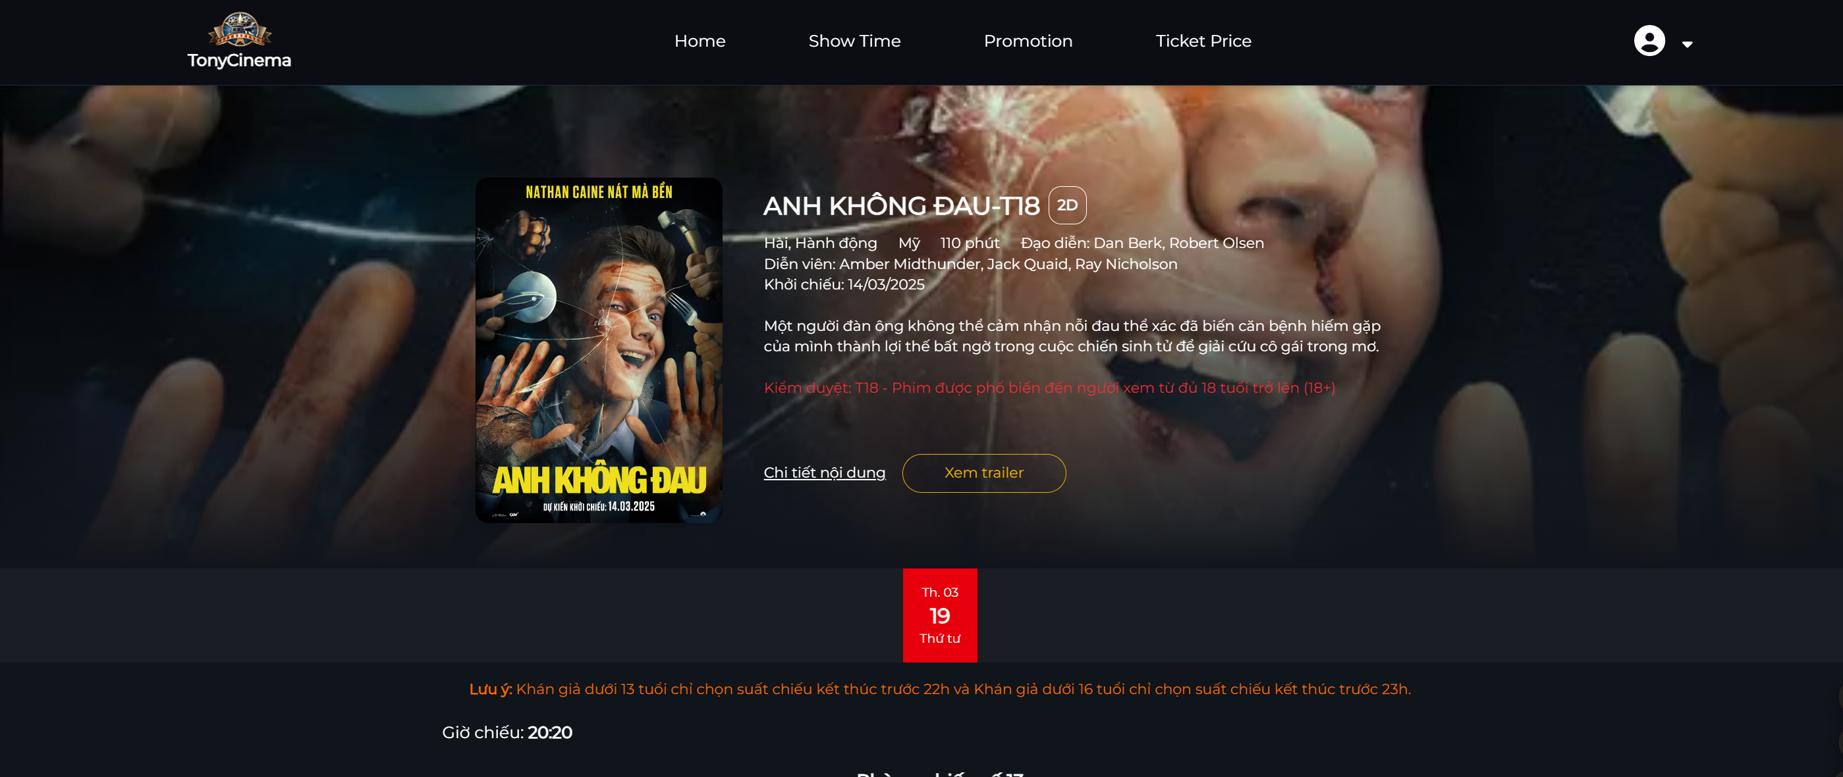

|  |  |  |  |  |
| --- | --- | --- | --- | --- |
| **Screen** | Book ticket – Select movie and showtime | | | |
| **Description** | Display the current movies and showtime | | | |
| **Screen**  **Access** | The user accesses to book ticket | | | |
| **Screen Content** | | | | |
| **Item** | **Type** | **Data** | **Description** | |
| Select movie | Combobox | N/A | Display current movies for users to  select | |
| Select date | Combobox | N/A | Display the show date of each selected movie in Select movie combobox for  users to select | |
| Select time | Combobox | N/A | Display the showtime of each movie according to the movie and the show  date for the user to select | |
| Book ticket | Button | N/A | Send movie information and  showtime, display the screen of selecting seat | |
| **Screen action** | | | | |
| **Action name** | **Description** | | **Success** | **Failure** |
| Select movie | Display all show dates for the selected movie | | Display all the show date of the selected movie in Select movie  combobox | The list of show dates is empty when no show date is found |
| Select date | Display all showtimes of selected movies | | Display all showtimes of movies according to the show date selected in Select show date  combobox | The list of schedules is empty when no show schedule is found during the day |
| Book ticket | Send ticket booking request, send movie information and showtime | | Display screen of Selecting seat | * If the movie show date has not been selected, display the message "Please select the show date" * If showtime has not been selected, display the message "Please select   showtime" |

#### Booking ticket – Selecting seat

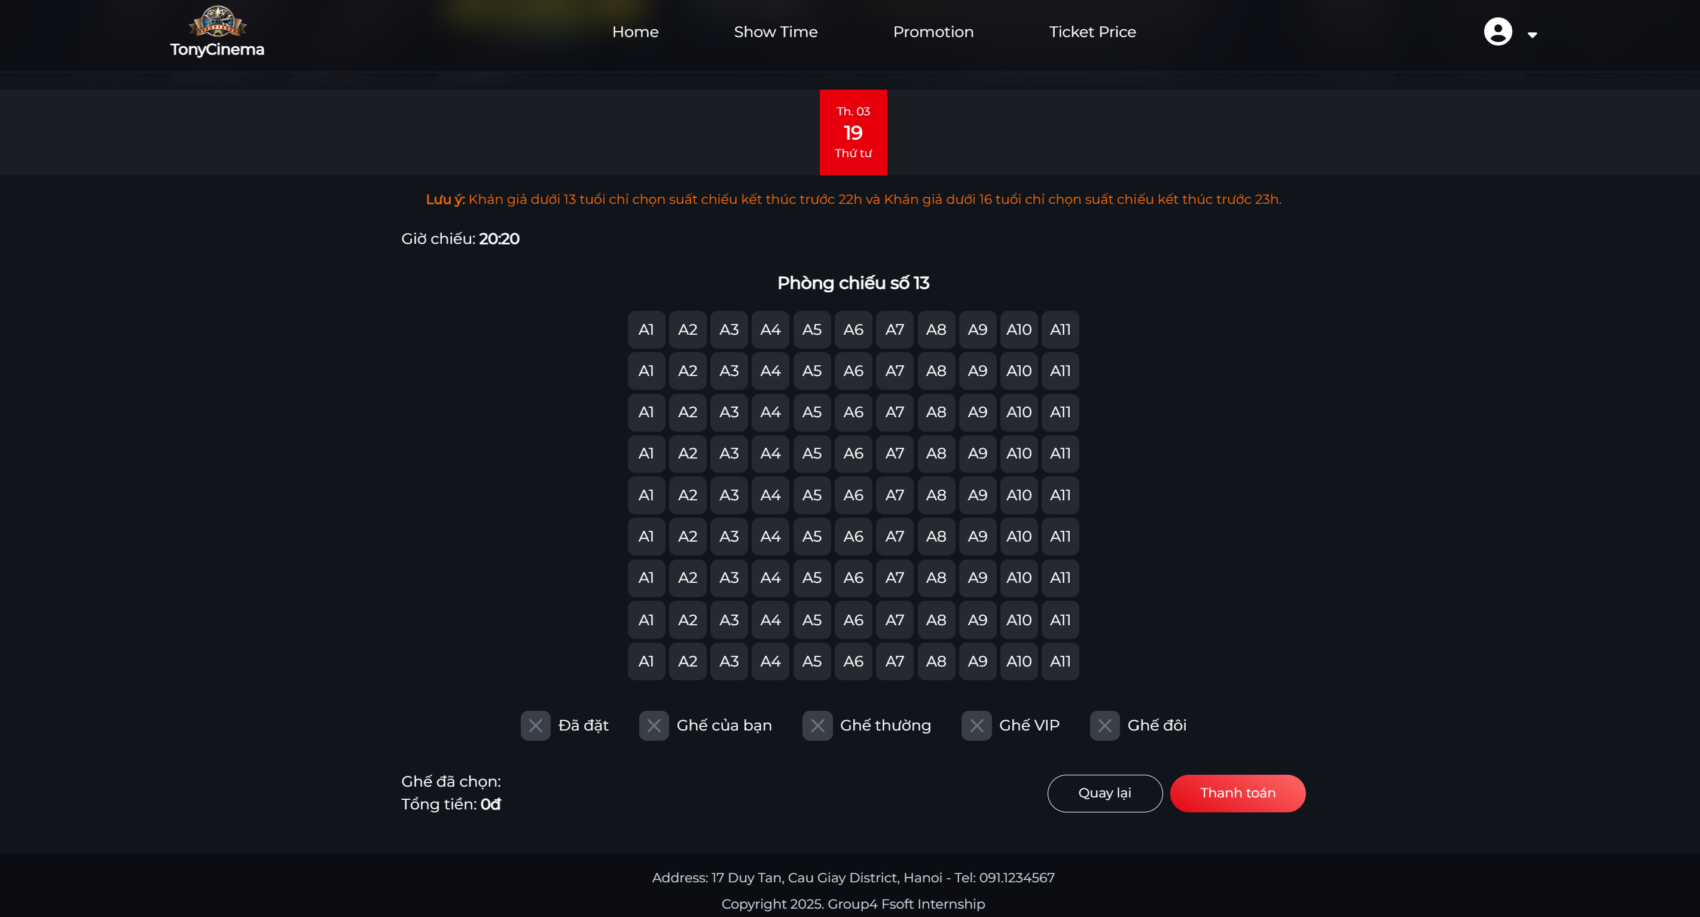

|  |  |  |  |  |
| --- | --- | --- | --- | --- |
| **Screen** | Booking ticket – Selecting seat | | | |
| **Description** | Display seat map of the movie and selected showtime | | | |
| **Screen**  **Access** | The user accesses after selecting movie and showtime | | | |
| **Screen Content** | | | | |
| **Item** | **Type** | **Data** | **Description** | |
| Select seat  quantity | Combobox | N/A | Display list of seat quantity for the  user to select | |
| Seat | CheckBox | N/A | Display seat map for the user to  choose | |
| Continue | Button | N/A | Send information of seat selection and  display the screen of ticket booking information | |
| **Screen Action** | | | | |
| **Action name** | **Description** | | **Success** | **Failure** |
| Select seat  quantity | Display list of seat quantity that  customer needs to select (0, 1, 2, …8) | | Display list of seat  quantity |  |
| Select seat | Display seat map for the customer to choose according to selected seat quantity | | When selecting the seat number as the same as selected seat quantity in combobox of Select seat quantity | If selected seat number is less than the seat quantity at the combobox, display the message "Please selecte x seat more"  - If selected seat number is more than the seat quantity at the combobox, display the message "Please select only x  seat" |

|  |  |  |  |
| --- | --- | --- | --- |
| Continue | Send ticket booking request, send seat selection information and display  booking information screen | Display Confirm booking ticket  screen |  |

#### Booking ticket – Confirm booking ticket

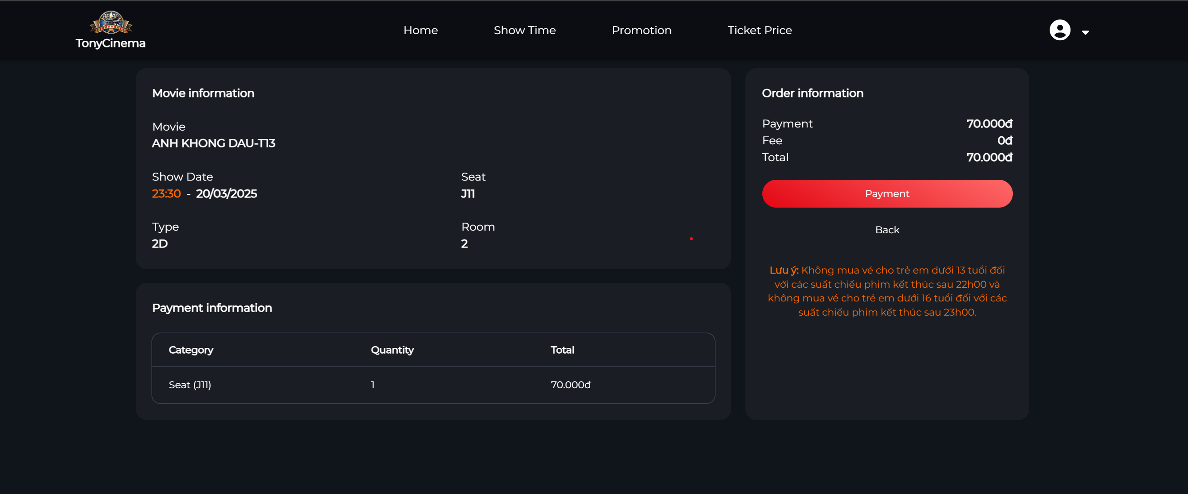

|  |  |  |  |
| --- | --- | --- | --- |
| **Screen** | Booking ticket – Confirm booking ticket | | |
| **Description** | Display all ticket booking information | | |
| **Screen**  **Access** | The user accesses after selecting seat | | |
| **Screen Content** | | | |
| **Item** | **Type** | **Data** | **Description** |
| Movie name | Label | N/A |  |
| Screen | Label | N/A |  |
| Date | Label | N/A |  |
| Time | Label | N/A |  |
| Seat | Label | N/A |  |
| Price | Label | N/A |  |

|  |  |  |  |  |
| --- | --- | --- | --- | --- |
| Total | Label | N/A |  | |
| Full name | Label | N/A |  | |
| Email | Label | N/A |  | |
| Identity card | Label | N/A |  | |
| Phone  number | Label | N/A |  | |
| Confirm booking  ticket | Button | N/A |  | |
| **Screen Action** | | | | |
| **Action name** | **Description** | | **Success** | **Failure** |
| Confirm booking  ticket | Select to send all ticket booking information | | Display screen of ticket booking  information |  |

#### Booking ticket – Ticket information

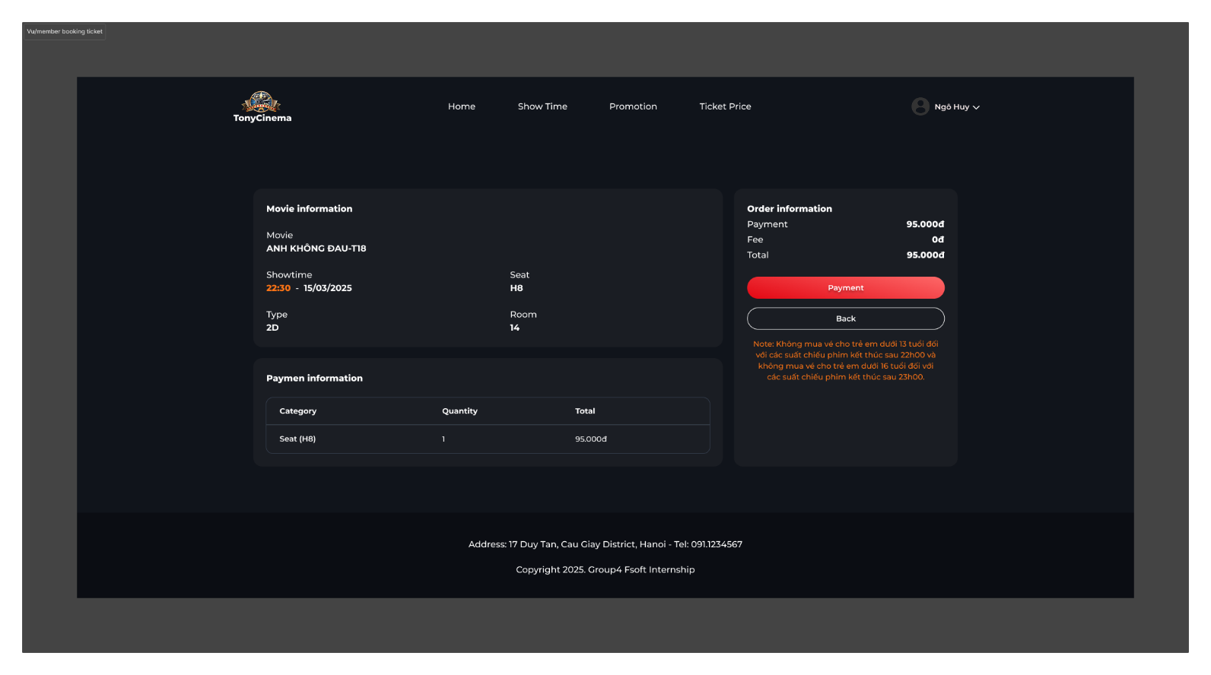

|  |  |  |  |  |
| --- | --- | --- | --- | --- |
| **Screen** | Booking ticket – Ticket information | | | |
| **Description** | Display all ticket booking information | | | |
| **Screen**  **Access** | The user accesses after seleting seat | | | |
| **Screen Content** | | | | |
| **Item** | **Type** | **Data** | **Description** | |
| Movie name | Label | N/A |  | |
| Booking ID | Label | N/A |  | |
| Screen | Label | N/A |  | |
| Date | Label | N/A |  | |
| Time | Label | N/A |  | |
| Seat | Label | N/A |  | |
| Price | Label | N/A |  | |
| Total | Label | N/A |  | |
| Full name | Label | N/A |  | |
| Email | Label | N/A |  | |
| Identity card | Label | N/A |  | |
| Phone  number | Label | N/A |  | |
| **Screen Action** | | | | |
| **Action name** | **Description** | | **Success** | **Failure** |

### Ticket selling management

|  |  |
| --- | --- |
| Use Case  Name | Ticket selling management |
| Use Case ID |  |
| High Level  Requirement Ref |  |
| Actor | Admin/Manager/Admin |
| Description | Allows the user to manage selling ticket |
| Trigger | N/A |
| Pre-condition | The actors must log in the system |
| Post-  processing |  |

#### Ticket selling management – Select movie and showtime

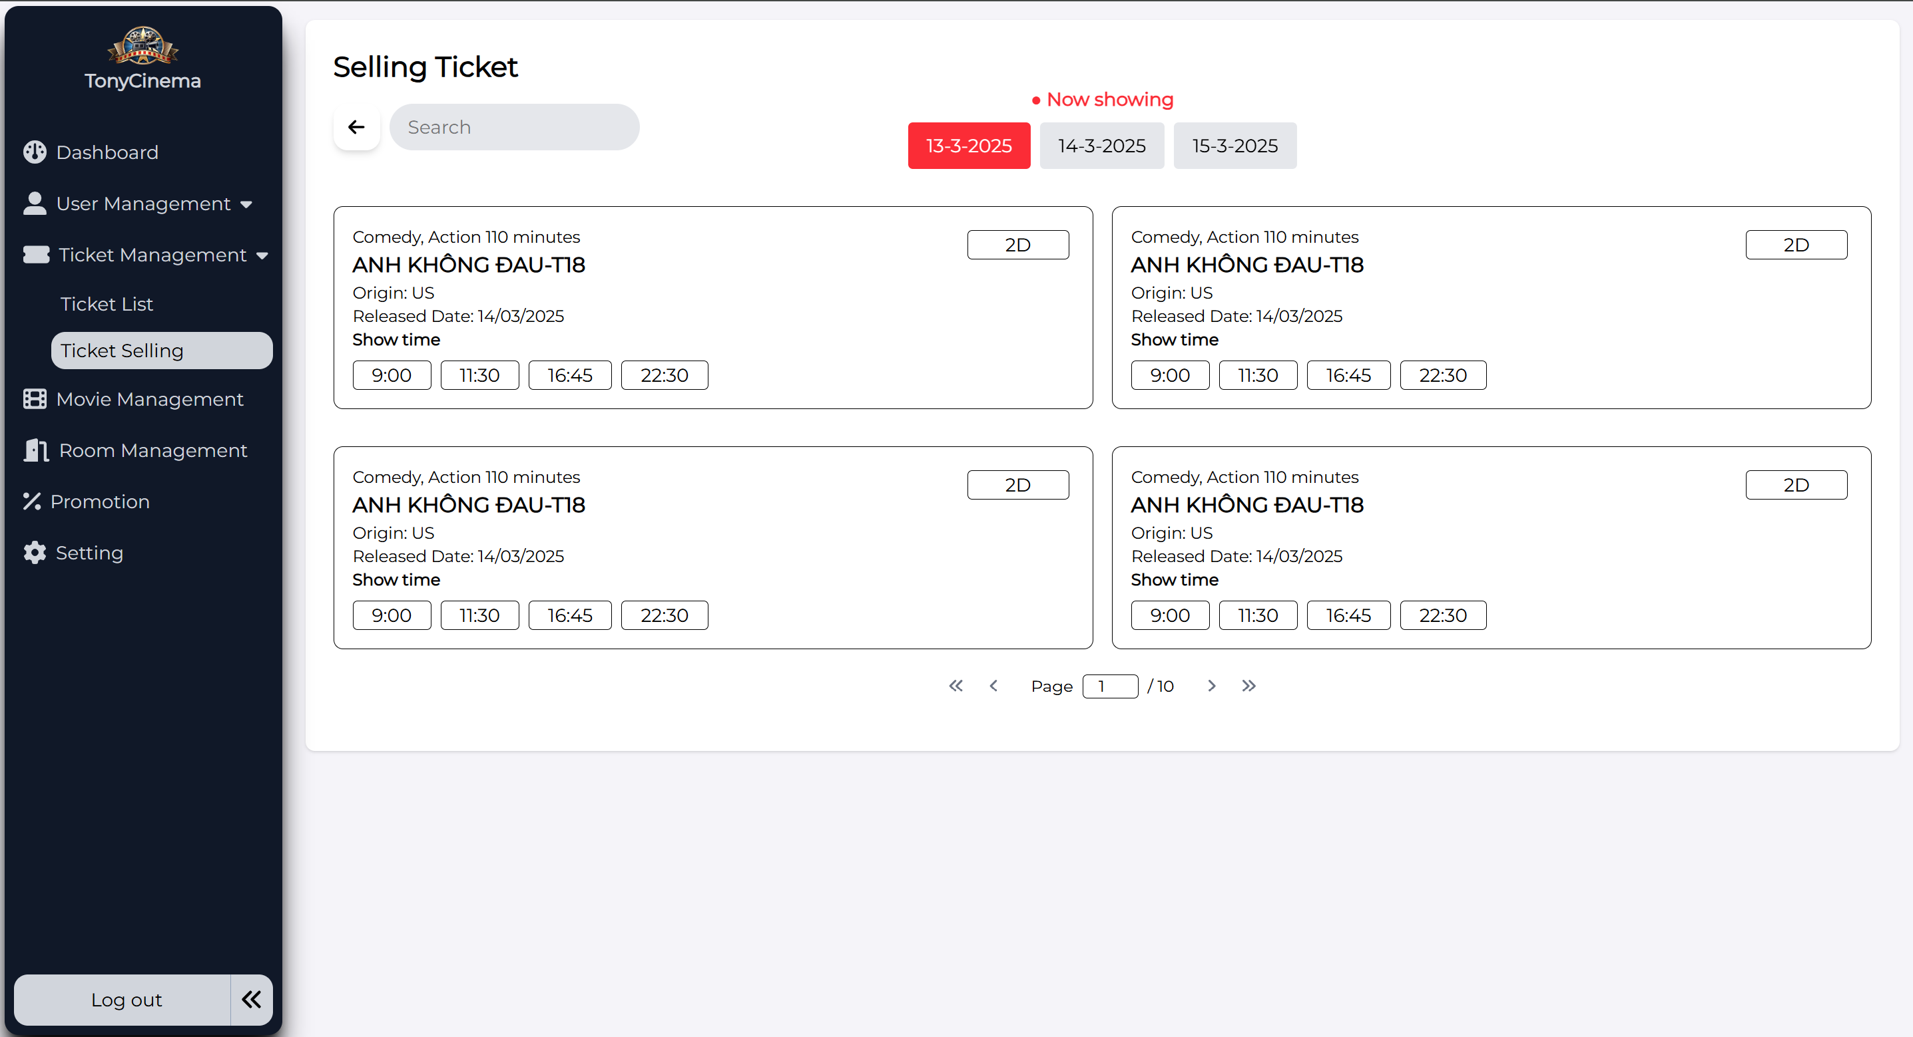

|  |  |  |  |  |
| --- | --- | --- | --- | --- |
| **Screen** | Booking ticket – Select movie and showtime | | | |
| **Description** | Display current movies and showtime | | | |
| **Screen**  **Access** | The user accesses Booking ticket | | | |
| **Screen Content** | | | | |
| **Item** | **Type** | **Data** | **Description** | |
| Date | Combobox | N/A |  | |
| Showtime | Button | N/A |  | |
| Movie name | Label | N/A |  | |
| Time | Link | N/A |  | |
| **Screen Action** | | | | |
| **Action name** | **Description** | | **Success** | **Failure** |
| View showtime | Display list of show dates for the user to select | | Display showtime list of current movies | If no showtime has been found, display message: “No  showtime” |
| Showtime | Display showtime of each movie | | Send information of movies and showtimes, display the Select seat  screen |  |

#### Ticket selling management – Selecting seat

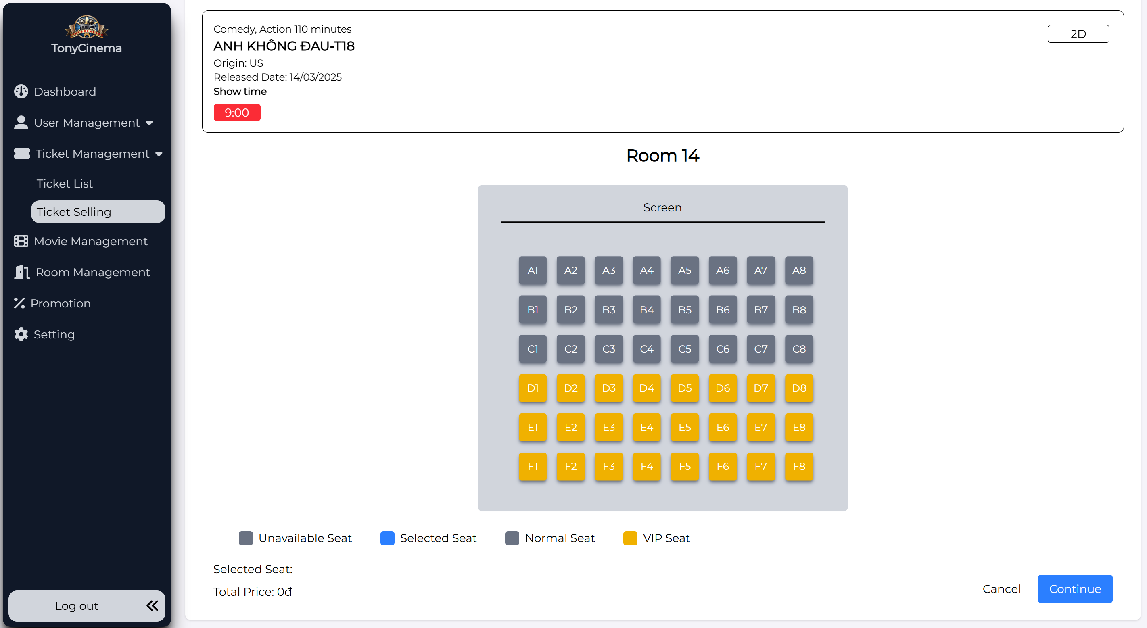

|  |  |  |  |  |
| --- | --- | --- | --- | --- |
| **Screen** | Booking ticket – Select seat | | | |
| **Description** | Display seat map of the movie and selected showtime | | | |
| **Screen**  **Access** | The user accesses after selecting movie and showtime | | | |
| **Screen Content** | | | | |
| **Item** | **Type** | **Data** | **Description** | |
| Select seat  quanity | Combobox | N/A | Display list of seat quantity for the  user to select | |
| Seat | CheckBox | N/A | Display seat map for the user to select | |
| Continue | Button | N/A | Send information of selecting seat and  display ticket booking information | |
| **Screen Action** | | | | |
| **Action name** | **Description** | | **Success** | **Failure** |

|  |  |  |  |
| --- | --- | --- | --- |
| Select seat  quantity | Display list of seat quantity that  customer needs (0, 1, 2, …8) | Display list of seat  quantity |  |
| Select seat | Display seat map, the employee chooses seat according to selected seat quantity at Combobox of Select seat quantity. | When selecting the seat number as the same as selected seat quantity in combobox of Select seat quantity | If selected seat number is less than the seat quantity at the combobox, display the message "Please selecte x seat more"  - If selected seat number is more than the seat quantity at the combo, display the message "Please select only x  seat" |
| Continue | Send ticket booking request, send seat  selection information and display booking information screen | Display Confirm  booking ticket screen |  |

#### Ticket selling management – Confirm ticket

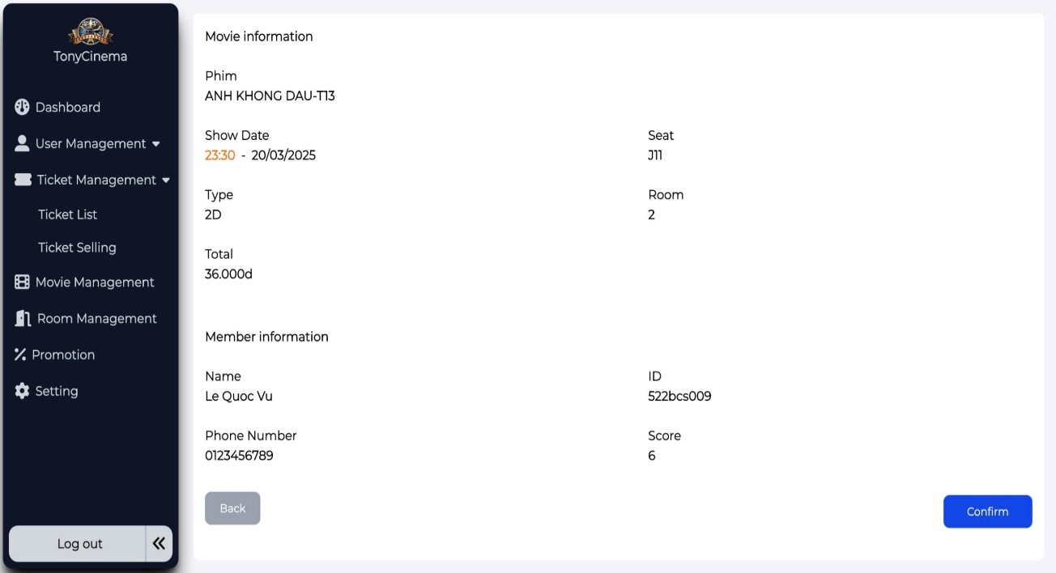

|  |  |  |  |
| --- | --- | --- | --- |
| **Screen** | Ticket selling management – Confirm ticket | | |
| **Description** | Display all ticket selling information | | |
| **Screen**  **Access** | The user accesses after selecting seat | | |
| **Screen Content** | | | |
| **Item** | **Type** | **Data** | **Description** |
| Movie name | Label | N/A |  |
| Type | Label | N/A |  |
| Date | Label | N/A |  |
| ShowDate | Label | N/A |  |
| Seat | Label | N/A |  |
| Room | Lable | N/A |  |
| Price | Label | N/A |  |
| Total | Label | N/A |  |
| Member | Textbox | N/A |  |
| Check | Button | N/A |  |
| Member ID | Label | N/A |  |

|  |  |  |  |  |
| --- | --- | --- | --- | --- |
| Name | Label |  |  | |
| Score | Label | N/A |  | |
| Phone  number | Label | N/A |  | |
| Back | Button | N/A |  | |
| Confirm | Button | N/A |  | |
| **Screen Action** | | | | |
| **Action name** | **Description** | | **Success** | **Failure** |
| Confirm | Select Confirm booking ticket to send all ticket booking information | | Send information of ticket selling, display screen of ticket booking information | If the member converts score into ticket, while score is not enough to convert, display message: “Member score is not enough to convert into  ticket” |
| Check member | Input member ID or identity card number to get information of member | | Display information of member | Display the message: “No member has  found!” |

#### Ticket selling management – Ticket information

|  |  |  |  |
| --- | --- | --- | --- |
| **Screen** | Ticket selling management – Ticket information | | |
| **Description** | Display all ticket information | | |
| **Screen**  **Access** | The user accesses after selecting seat | | |
| **Screen Content** | | | |
| **Item** | **Type** | **Data** | **Description** |
| Movie name | Label | N/A |  |
| Ticket  booking ID | Label | N/A |  |
| Screen | Label | N/A |  |
| Date | Label | N/A |  |
| ShowDate | Label | N/A |  |
| Seat | Label | N/A |  |
| Price | Label | N/A |  |
| Room | Label | N/A |  |

|  |  |  |  |
| --- | --- | --- | --- |
| Total | Label | N/A |  |
| Member ID | Label | N/A |  |
| Email | Label | N/A |  |
| Score | Label | N/A |  |
| Phone  number | Label | N/A |  |

### Ticket booking management

|  |  |
| --- | --- |
| Use Case  Name | Ticket booking management |
| Use Case ID |  |
| High Level  Requirement Ref |  |
| Actor | Admin/Employee |
| Description | Allows the users to manage ticket booking of members |
| Trigger | NA |
| Pre-condition | The user must log in the system |
| Post-  processing |  |

#### Ticket booking management – Search booking tickets

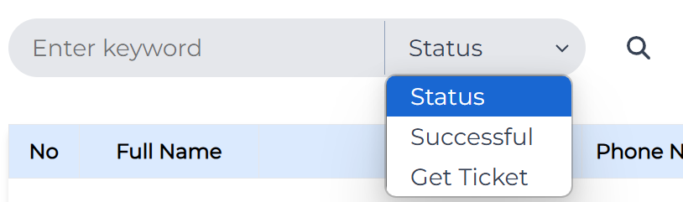

|  |  |
| --- | --- |
| **Screen** | Ticket booking management – Search with keywords/Status |
| **Description** | Manager can search for booked tickets of customers |
| **Screen**  **Access** | The user accesses Booking management |

|  |  |  |  |  |
| --- | --- | --- | --- | --- |
| **Screen Content** | | | | |
| **Item** | **Type** | **Data** | **Description** | |
| Search | Textbox | N/A | Input the keywords to search including Booking ID, account ID, phone number or identity card number of  booking account | |
| Status Filter | Dropdown Icon | N/A | Include 2 status types: successful & get ticket | |
| Search | Button | N/A | Select Search button | |
| **Screen Action** | | | | |
| **Action name** | **Description** | | **Success** | **Failure** |
| Search | Click the search button, the booking list will filter the data  Filtering data by keyword entered in the search textbox matches with the full name, email, phone number or movie name,  Also click to choose Status filter | | Display the list of booked tickets matching the input keywords as well as filter status | Enter wrong searching field, or search with unexisted keywords. The system will show the message "No data found!" |

#### Ticket booking management – View Booking tickets list and View ticket detail

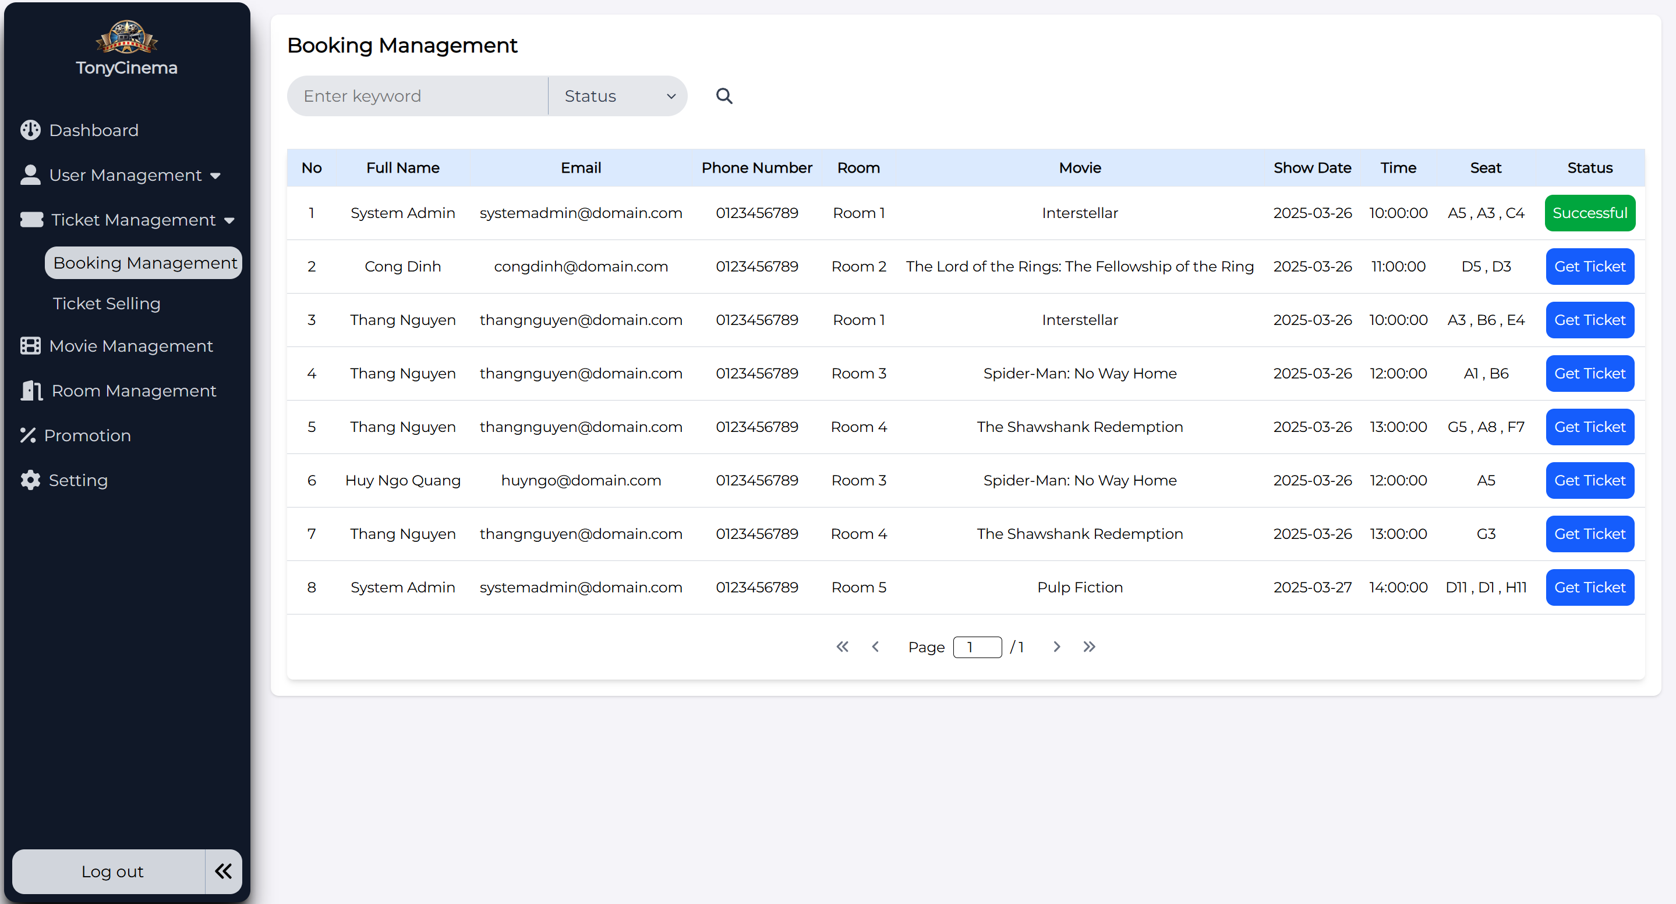

Managers press on “Successful” to view booked ticket information detail:

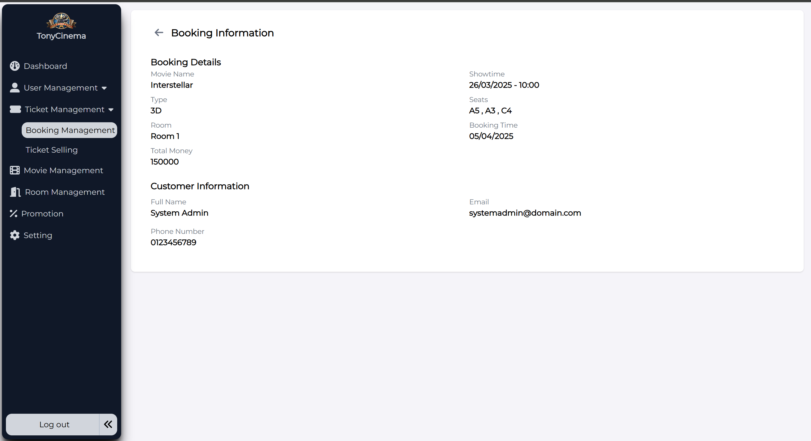

|  |  |
| --- | --- |
| **Screen** | Booking management – Booking tickets list |
| **Description** | Display all the booked tickets of customers with 2 status successful (paid) and get ticket (wait for payment) |
| **Screen**  **Access** | The user accesses Booking Management |

|  |  |  |  |  |
| --- | --- | --- | --- | --- |
| **Screen Content** | | | | |
| **Item** | **Type** | **Data** | **Description** | |
| No | Label | N/A | Order of records | |
| Full Name | Label | N/A |  | |
| Phone  number | Label | N/A |  | |
| Email | Label | N/A |  | |
| Movie | Label | N/A |  | |
| Room | Label | N/A |  | |
| Time | Label | N/A |  | |
| Seat | Label | N/A |  | |
| Showtime | Label | N/A |  | |
| Status | Button | N/A | 2 status types: Successful & Get Ticket | |
| **Screen Action** | | | | |
| **Action name** | **Description** | | **Success** | **Failure** |
| Successful | Click this button to view the booked ticket detail information | | The detail information of ticket will be shown with a Back button | N/A |

#### Ticket booking management – Confirm booking ticket

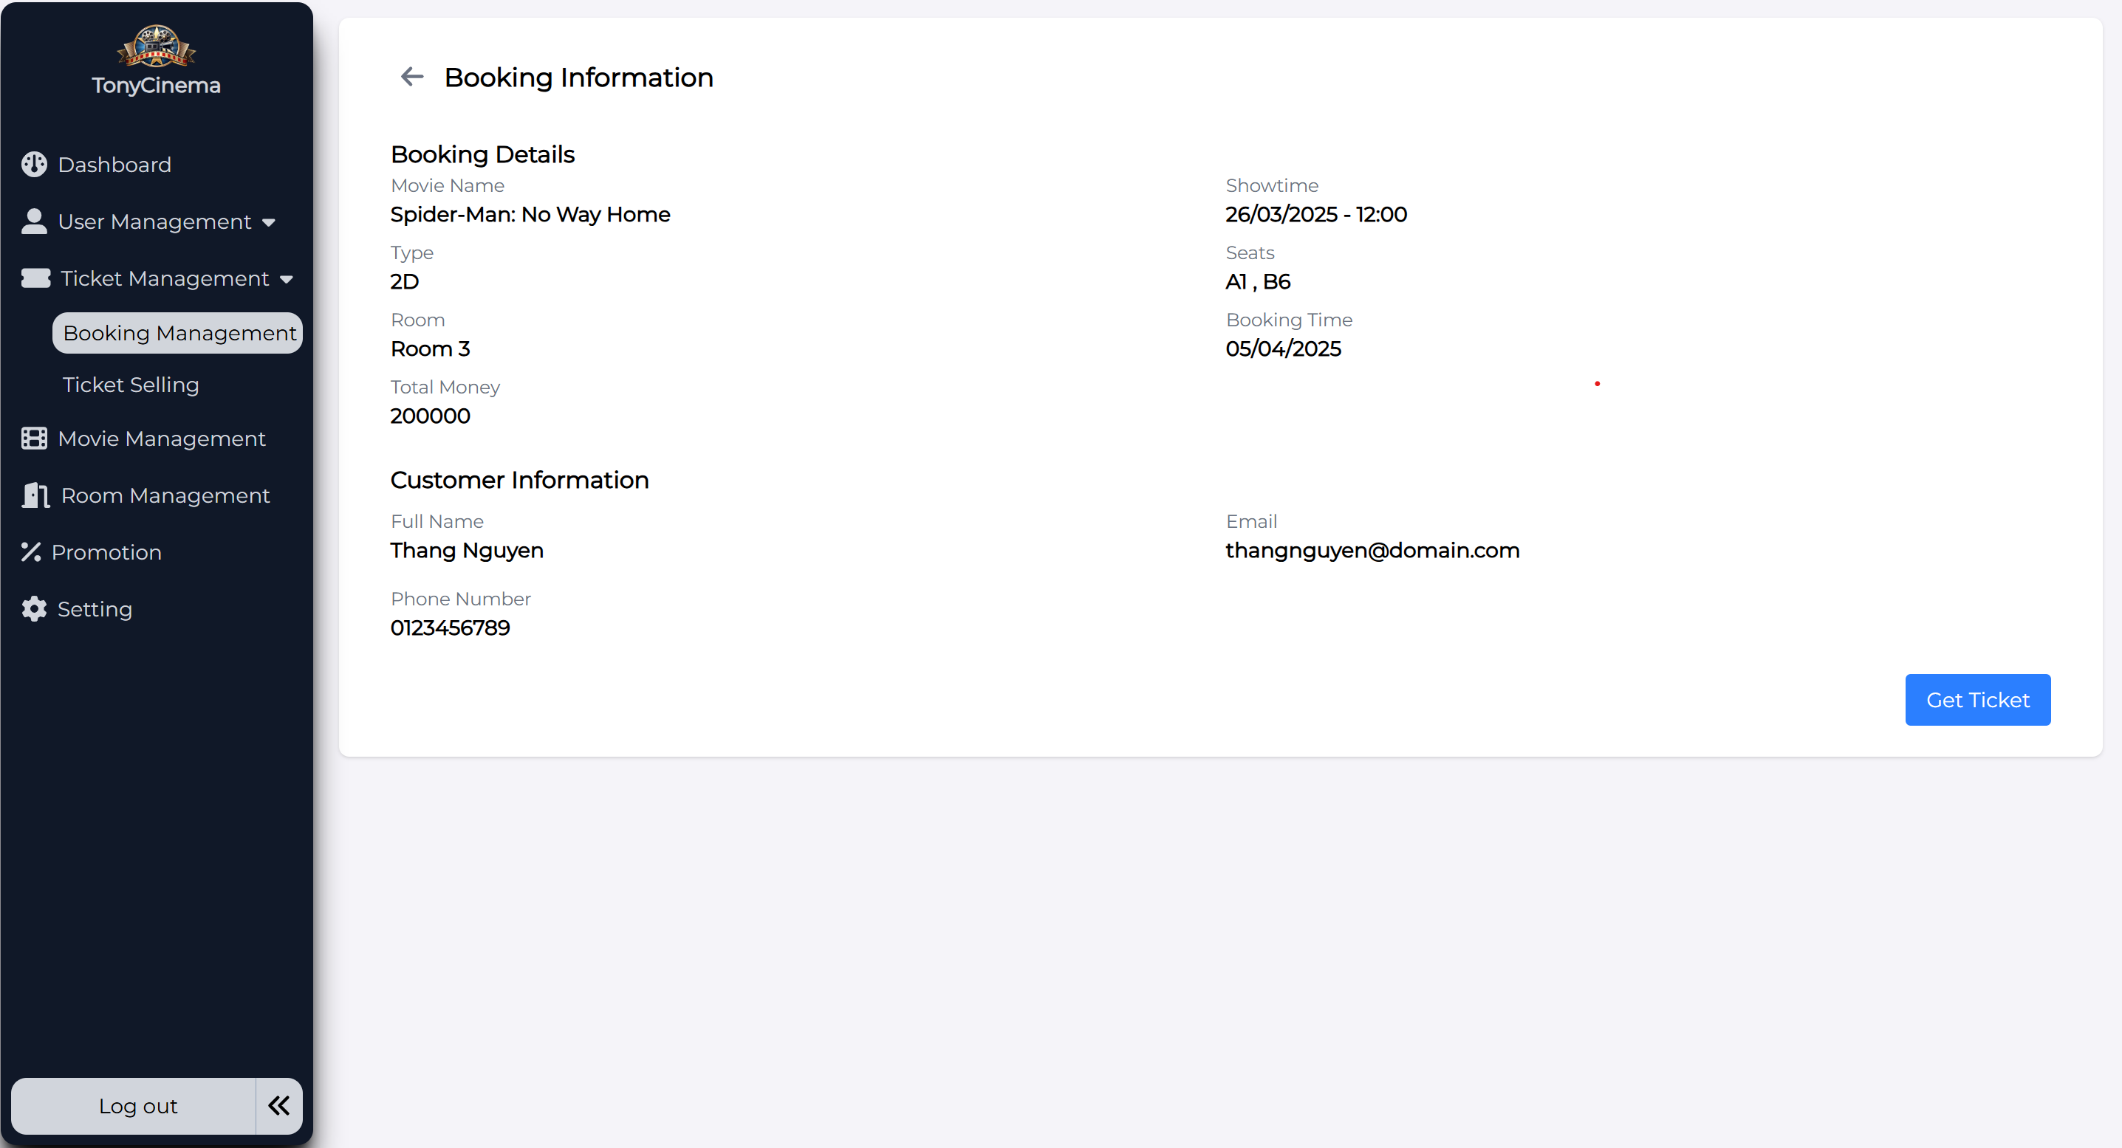

|  |  |  |  |
| --- | --- | --- | --- |
| **Screen Content** | | | |
| **Item** | **Type** | **Data** | **Description** |
| Booking Details | Label | N/A |  |
| Customer information | Label | N/A |  |
| Full Name | Label | N/A |  |
| Phone  number | Label | N/A |  |
| Email | Label | N/A |  |
| Movie Name | Label | N/A |  |
| Room | Label | N/A |  |
| Type | Label | N/A | 2D, 3D |
| Booking time |  |  |  |
| Total money | Label | N/A |  |
| Seat | Label | N/A |  |
| Showtime | Label | N/A |  |
| Get Ticket | Button | N/A |  |

|  |  |  |  |
| --- | --- | --- | --- |
| **Screen Action** | | | |
| **Action name** | **Description** | **Success** | **Failure** |
| Get Ticket | Click this button to view the ticket information again so as to confirm to get ticket | The system will direct back to the booking ticket list  The original status of the ticket will change from “Get ticket” to “Successful” | N/A |

### User Management

|  |  |
| --- | --- |
| Use Case Name | User management |
| Use Case ID |  |
| High Level Requirement  Ref | Admin |
| Actor | The function allows to view list, add, edit, delete, view detail, search of employee and view list, search, delete, view detail of customers |
| Description | N/A |
| Trigger | Only admin has right to implement functions |
| Pre-condition | Admin must login the system |
| Post-processing |  |

#### 3.1.6.1 Employee Management

##### **3.1.6.1.1 View employee list**

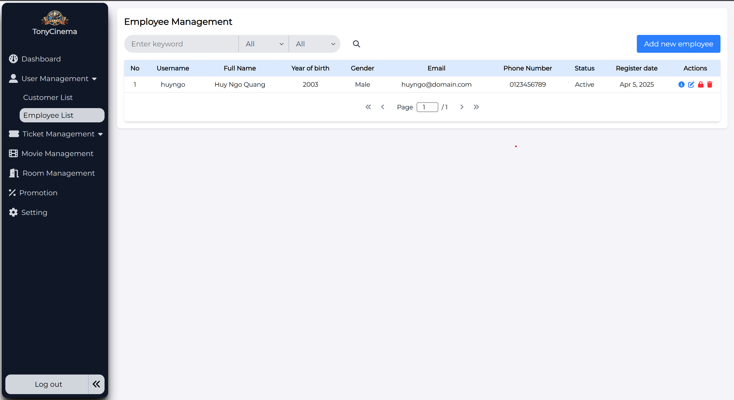

|  |  |  |  |
| --- | --- | --- | --- |
| **Screen** | Screen to display employee list | | |
| **Description** | Function of viewing information of movie theater employee  Allows to search, add, edit, delete employees | | |
| **Screen**  **Access** |  | | |
| **Screen Content** | | | |
| **Item** | **Type** | **Data** | **Description** |
| **User Name** | **Label** | **N/A** |  |
| **Full Name** | **Label** | **N/A** |  |
| **Year or Birth** | **Label** | **N/A** |  |
| **Email** | **Label** | **N/A** |  |
| **Phone**  **number** | **Label** | **N/A** |  |
| **Address** | **Label** | **N/A** |  |
| **Register Date** | **Label** | **N/A** |  |
| **Edit** | **Icon button** | **N/A** |  |
| **View Detail** | **Icon button** | **N/A** |  |
| **Delete** | **Icon button** | **N/A** |  |
| **Add** | **Button** | **N/A** |  |
| **All** | **Dropdown** | **N/A** |  |
| **Search** | **TextBox - nvarchar**  **(28)** | **N/A** |  |
| **Search** | **Button** | **N/A** |  |

##### 3.1.6.1.2 Add employee

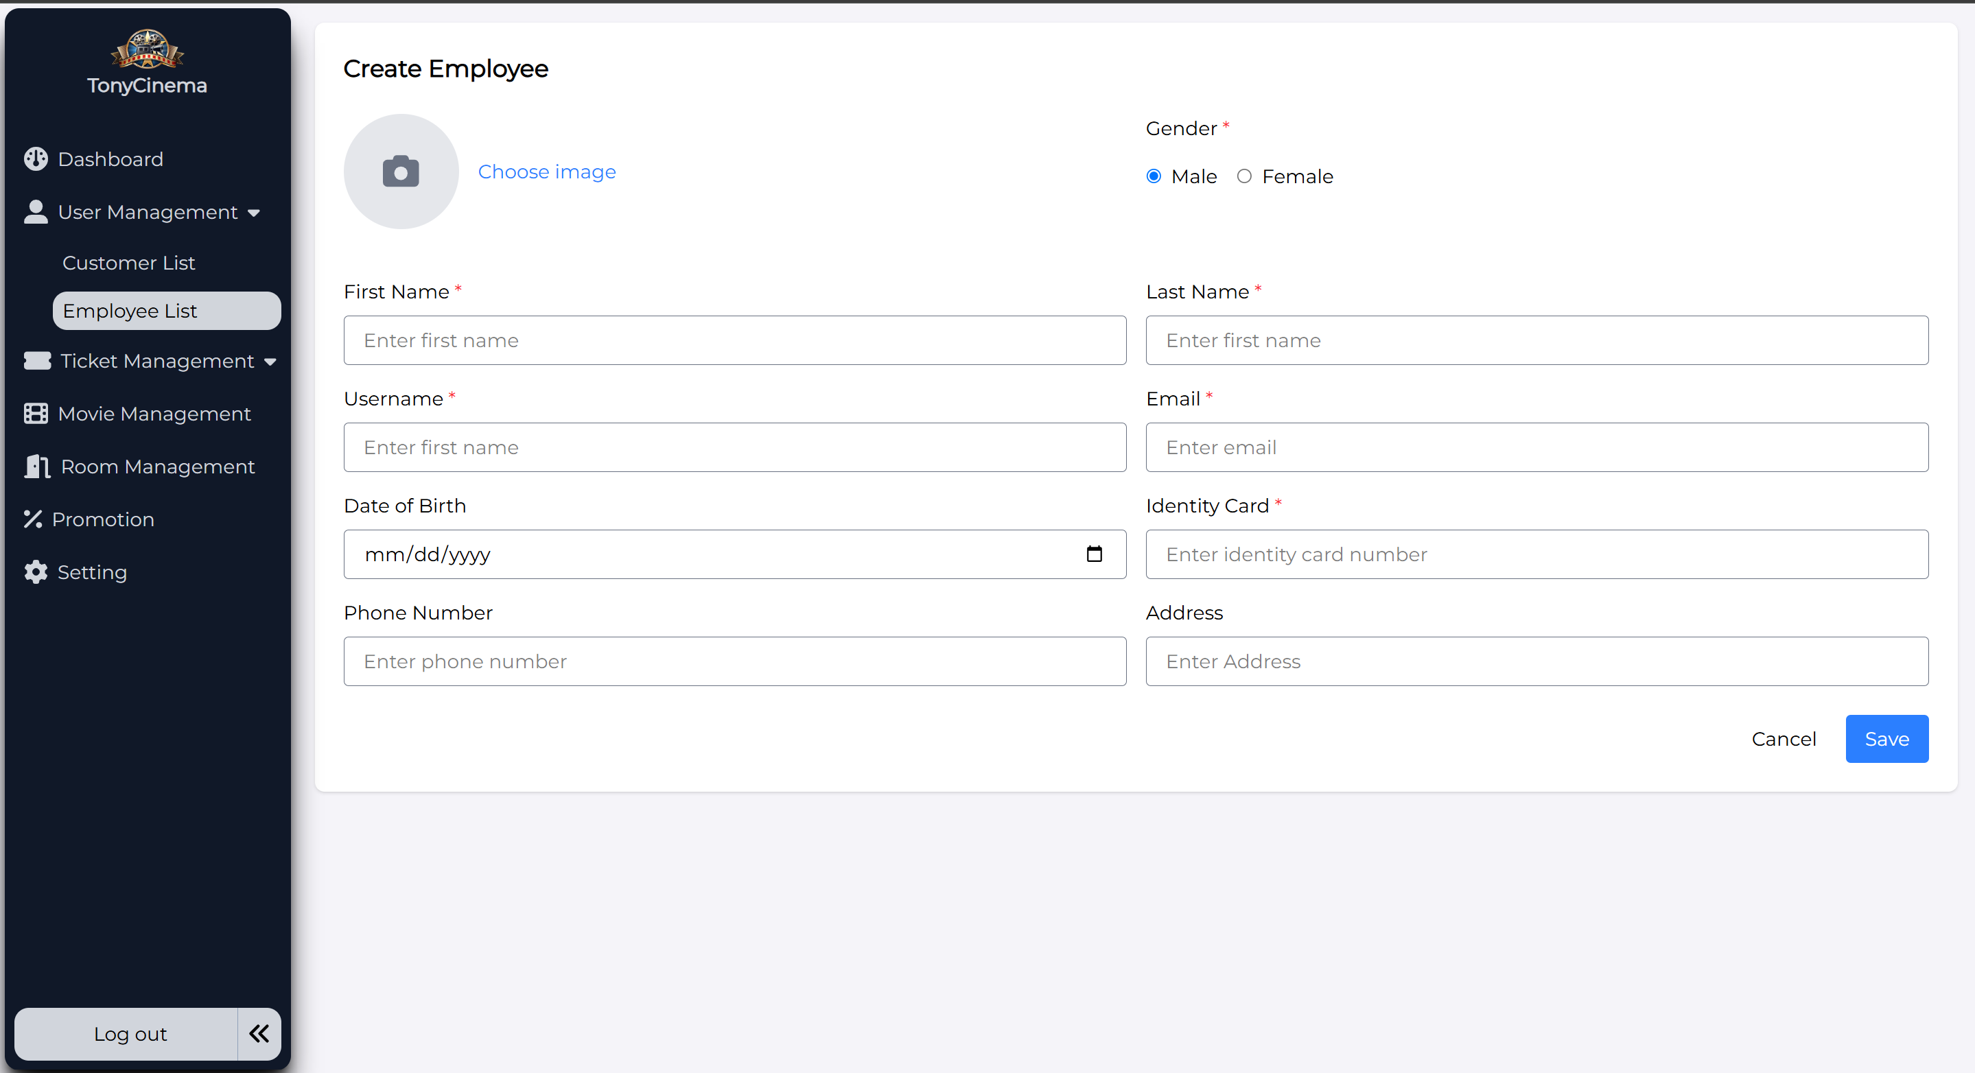

|  |  |  |  |
| --- | --- | --- | --- |
| **Screen** | Screen to add employee | | |
| **Description** | Function to add employee | | |
| **Screen**  **Access** | The admin enters the employee list and choose “Add new employee” | | |
| **Screen Content** | | | |
| **Item** | **Type** | **Data** | **Description** |
| Image | Button | N/A |  |
| First name | TextBox -  nvarchar (28) | N/A |  |
| Last name | TextBox -  nvarchar (28) | N/A |  |
| User name | TextBox -  nvarchar (28) | N/A |  |
| Date of birth | DataDatetime | N/A |  |
| Gender | checkbox | N/A |  |
| Email | TextBox -  nvarchar (28) | N/A |  |
| Identity card | TextBox -  nvarchar (28) | N/A |  |

|  |  |  |  |  |
| --- | --- | --- | --- | --- |
| Phone  number | TextBox -  nvarchar (28) | N/A |  | |
| Address | TextBox -  nvarchar (28) | N/A |  | |
| Save | Button | N/A |  | |
| Back | Button |  |  | |
| **Screen Action** | | | | |
| **Action name** | **Description** | | **Success** | **Failure** |
| Save | Add employee | | Add inputted employee information into database.  Forward to Employee management screen – View employee  list | Wrong input field criteria, the system will show specific error message |
| Cancel | Back to previous screen | | Back to previous  screen | N/A |

##### **3.1.6.1.3 Edit employee**

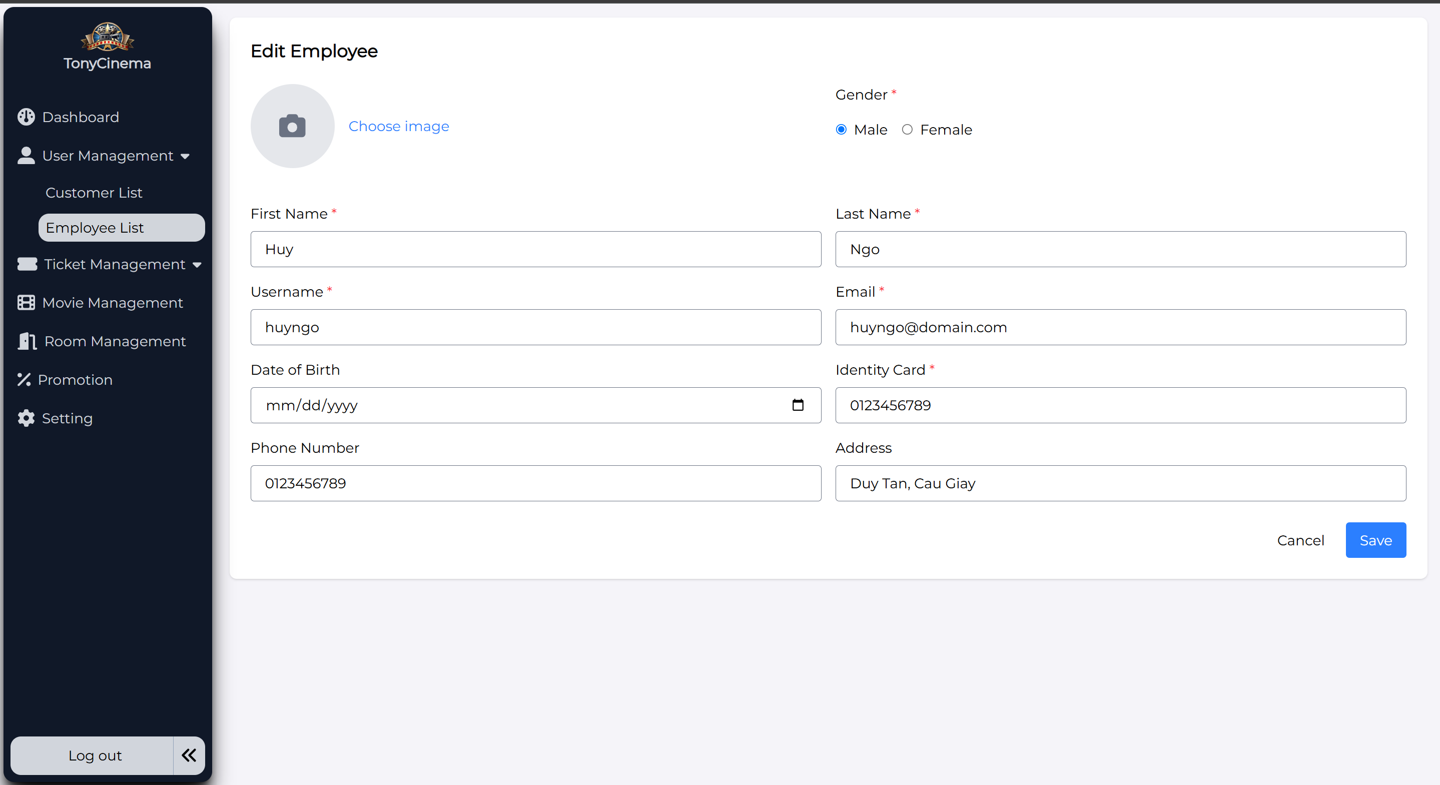

|  |  |  |  |
| --- | --- | --- | --- |
| **Screen** | Screen to edit employee | | |
| **Description** | Function to edit employee information | | |
| **Screen**  **Access** | The admin enters the employee list and choose “Edit” icon in Action column | | |
| **Screen Content** | | | |
| **Item** | **Type** | **Data** | **Description** |
| Image | Button | Display image of  the selected employee to edit |  |
| First name | TextBox - nvarchar (28) | N/A |  |
| Last name | TextBox -  nvarchar (28) | N/A |  |
| Username | TextBox -  nvarchar (28) | N/A |  |

|  |  |  |  |  |
| --- | --- | --- | --- | --- |
| Date of birth | DataDatetime | Display date of birth of selected  employee to edit |  | |
| Gender | chechbox | Display sex of selected employee  to edit |  | |
| Email | TextBox - nvarchar (28) | Display email of selected employee  to edit |  | |
| Identity card | TextBox - nvarchar (28) | Display identity card number of selected employee  to edit |  | |
| Phone number | TextBox - nvarchar (28) | Display phone number of selected employee  to edit |  | |
| Address | TextBox - nvarchar (28) | Display address of  selected employee to edit. |  | |
| Save | Button | N/A | Click to edit employee | |
| Cancel | Button | N/A | Back to the previous screen | |
| **Screen Action** | | | | |
| **Action name** | **Description** | | **Success** | **Failure** |
| Save | Edit information of an employee | | Edit successfully information of an employee. Edit information of employee in database. Forward to screen of employee management –  View employee list | N/A |
| Back | Back to the previous screen | | Back to the  previous screen | N/A |

##### **3.1.6.1.4 Delete employee**

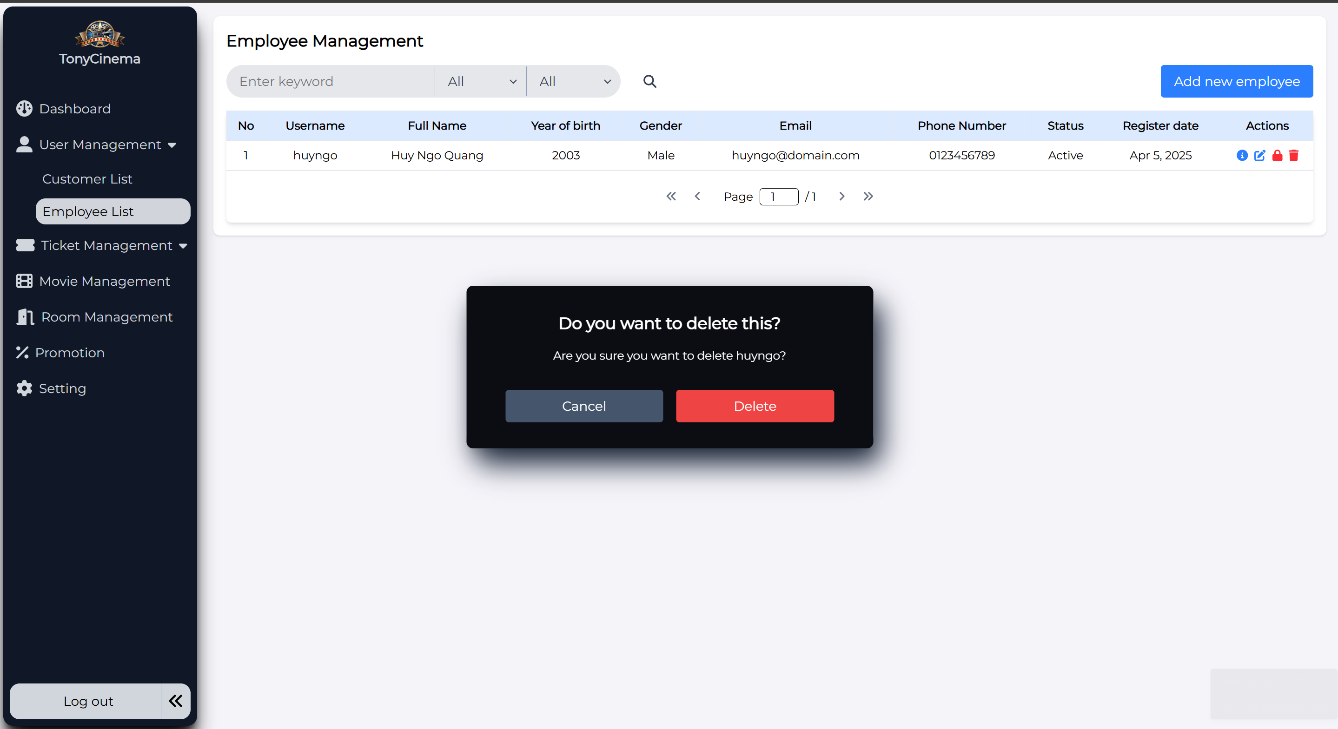

|  |  |  |  |
| --- | --- | --- | --- |
| **Screen** | Employee management – Delete employee | | |
| **Description** | Delete employee | | |
| **Screen Access** | Admin clicks icon “trash”-> Delete popup | | |
| **Screen Content** | | | |
| **Item** | **Type** | **Data** | |
| Cancel | Button |  | |
| Delete | Button |  | |
| **Screen Actions** | | | |
| **Action Name** | **Description** | | **Success** |
| Delete | Agree to delete employee | | Employee is deleted from database and display screen of employees list |
| Cancel | Close confirm pop-up | | Display screen of employee list |

##### **3.1.6.1.5 View employee’s detail**

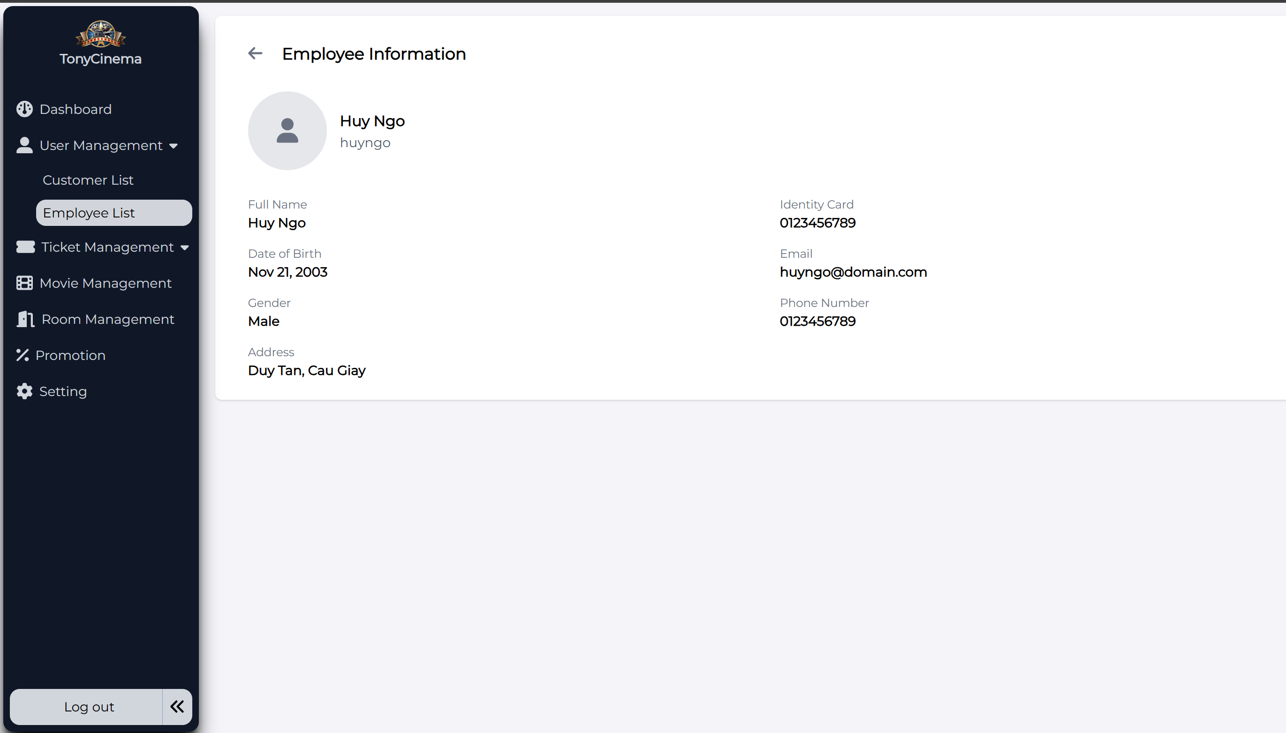

|  |  |  |  |
| --- | --- | --- | --- |
| **Screen** | Screen to display employee’s detail information | | |
| **Description** | Function of viewing information of employee | | |
| **Screen**  **Access** | The admin enters the employee list and choose “Detail” icon in Action column | | |
| **Screen Content** | | | |
| **Item** | **Type** | **Data** | **Description** |

|  |  |  |  |  |
| --- | --- | --- | --- | --- |
| Full Name | Label |  |  | |
| Identity Card | Label |  |  | |
| Date of Birth | Label |  |  | |
| Gender | Label |  |  | |
| Phone  number | Label |  |  | |
| Email | Label |  |  | |
| Address | Lable |  |  | |
| Arrow Back | Icon button | N/A |  | |
| **Screen Action** | | | | |
| **Action name** | **Description** | | **Success** | **Failure** |
| Arror Back | Back to previous screen | | Direct to the previous screen | N/A |

##### **3.1.6.1.6 Search employee**

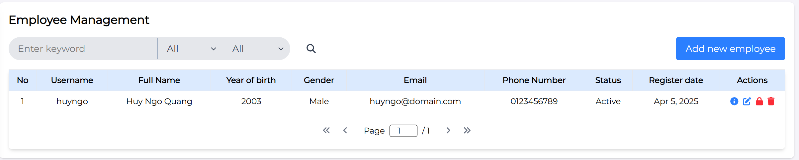

When the keyword is not matching, the system will show message: “No data found”

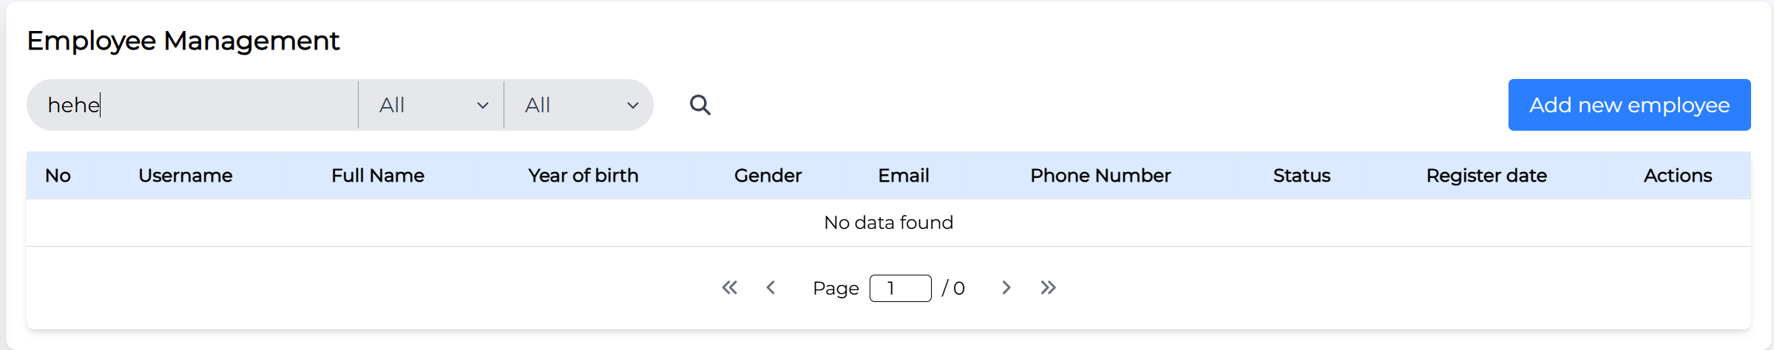

|  |  |  |  |
| --- | --- | --- | --- |
| **Screen** | Screen to search employee by keywords (all fields) and with genders, status | | |
| **Description** | Function of searching employee | | |
| **Screen**  **Access** | The admin enters the employee list input keyword into the search input field | | |
| **Screen Content** | | | |
| **Item** | **Type** | **Data** | **Description** |

|  |  |  |  |  |
| --- | --- | --- | --- | --- |
| Search input field | Input field |  |  | |
| Search | Icon button |  |  | |
| Filter | Dropdown |  | One filter is for Gender (Male, Female), and another is for Status (Active, Inactive) | |
| **Screen Action** | | | | |
| **Action name** | **Description** | | **Success** | **Failure** |
| Search | Search for the matched employees in the database with the input keyword | | A list of employees searched by keyword shown | When there is no data“No data found” |

##### **3.1.6.1.7 Inactive/Active Employee**

Lock employee:

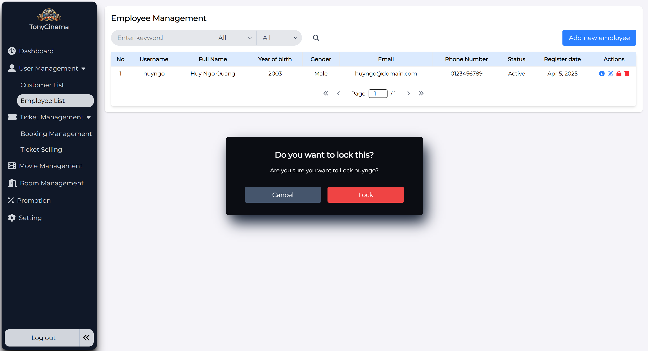

The icon changed: it means successfully locking the employee

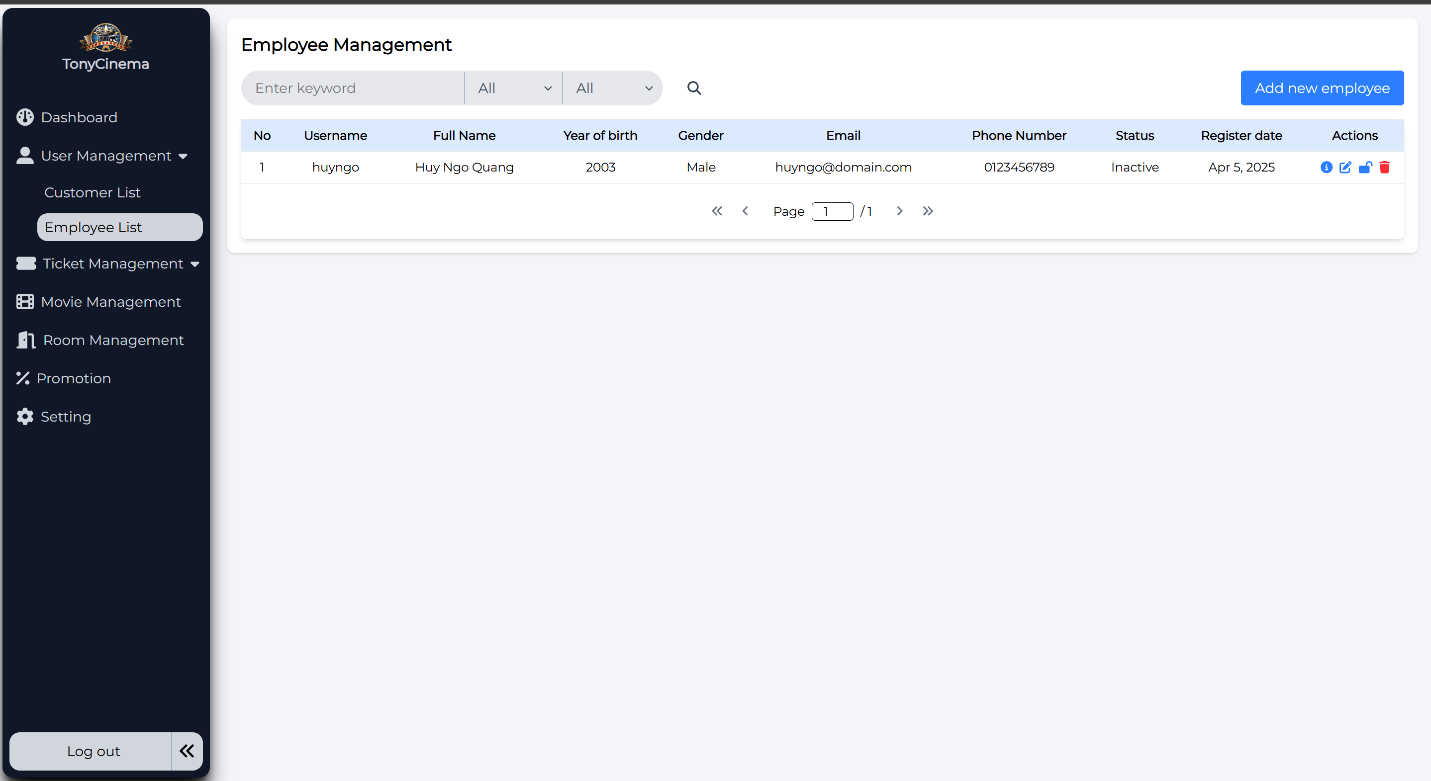

And press the “Unlock” icon, the pop-up unlock employee showed:

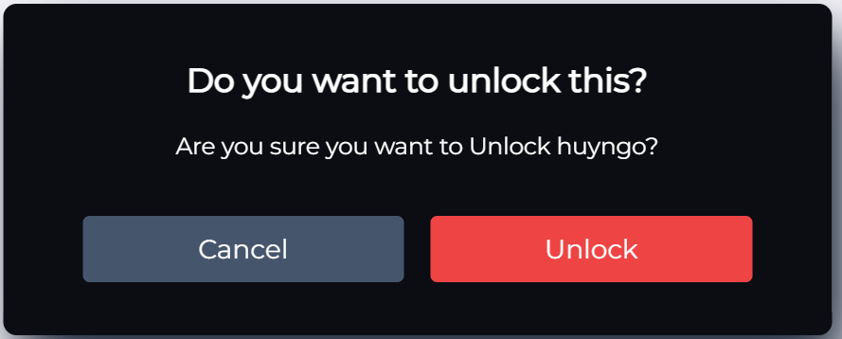

|  |  |  |  |
| --- | --- | --- | --- |
| **Screen** | Inactive/Active employee | | |
| **Description** | Function of forcing employee inactive (locked) – cannot access to the system | | |
| **Screen**  **Access** | The admin enters the Employee List and press on “Lock” icon action | | |
| **Screen Content** | | | |
| **Item** | **Type** | **Data** | **Description** |

|  |  |  |  |  |
| --- | --- | --- | --- | --- |
| Cancel | Button |  |  | |
| Lock/Unlock | Button |  |  | |
| **Screen Action** | | | | |
| **Action name** | **Description** | | **Success** | **Failure** |
| Cancel | Click this button to close the current pop-up | | Back to the employee list page | N/A |
| Lock | Click this button to make employee inactive (can not access to the system) | | The icon will change from “Lock” to “Unlock” icon  Then the employee cannot get access to the system, just wait until the admin unlock(active) the account again | N/A |
| Unlock | Click this button to make employee active again ( can access to the system) | | The icon will change from “Unlock” to “Lock” icon  Then the employee can get access to the system | N/A |

#### 3.1.6.2 Customer Management

##### **3.1.6.2.1 Search customers**

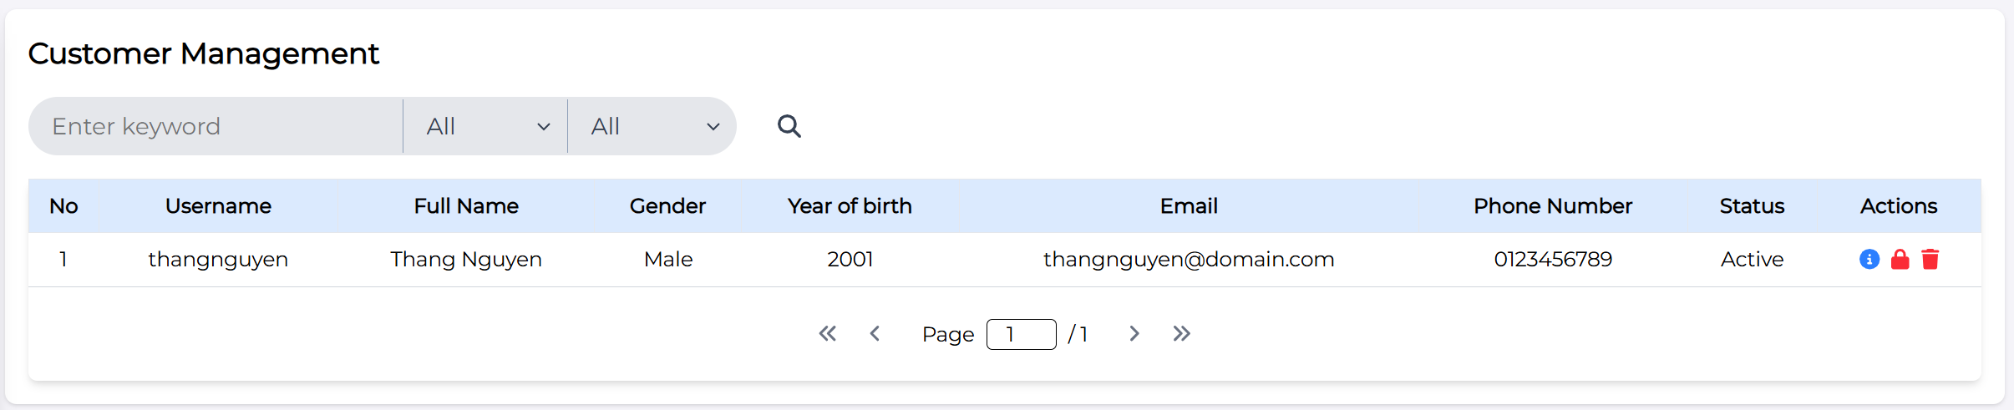

|  |  |  |  |
| --- | --- | --- | --- |
| **Screen** | Screen to search customer by keyword (all fields) and with genders and status | | |
| **Description** | Function of searching customer | | |
| **Screen**  **Access** | The admin enters the customer list input keyword into the search input field | | |
| **Screen Content** | | | |
| **Item** | **Type** | **Data** | **Description** |

|  |  |  |  |  |
| --- | --- | --- | --- | --- |
| Search input field | Input field |  |  | |
| Search | Icon button |  |  | |
| Filter | Dropdown |  | One filter is for Gender (Male, Female), and another is for Status (Active, Inactive) | |
| **Screen Action** | | | | |
| **Action name** | **Description** | | **Success** | **Failure** |
| Search | Search for the matched customer in the database with the input keyword | | A list of customers searched by keyword shown | When there is no data“No data found” |

##### **3.1.6.2.2 View customer’s detail**

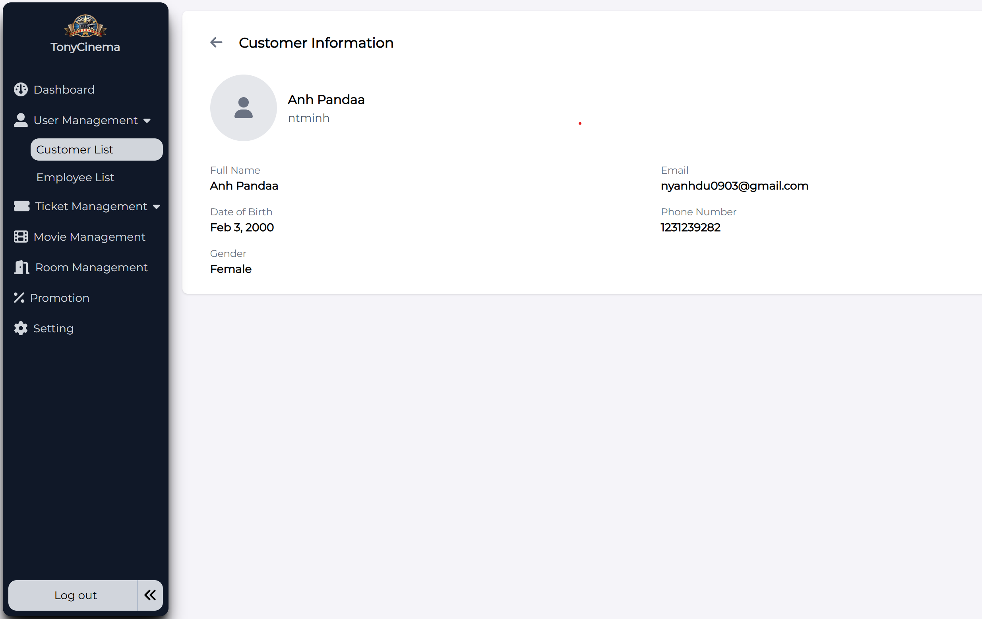

|  |  |  |  |
| --- | --- | --- | --- |
| **Screen** | Screen to display customer detail information | | |
| **Description** | Function of viewing information of customer | | |
| **Screen**  **Access** | The admin enters the customer list and choose “Detail” icon in Action column | | |
| **Screen Content** | | | |
| **Item** | **Type** | **Data** | **Description** |

|  |  |  |  |  |
| --- | --- | --- | --- | --- |
| Full Name | Label |  |  | |
| Date of Birth | Label |  |  | |
| Gender | Label |  |  | |
| Phone  number | Label |  |  | |
| Email | Label |  |  | |
| Arrow Back | Icon button | N/A |  | |
| **Screen Action** | | | | |
| **Action name** | **Description** | | **Success** | **Failure** |
| Arror Back | Back to previous screen | | Direct to the previous screen | N/A |

##### **3.1.6.2.3 Delete customer**

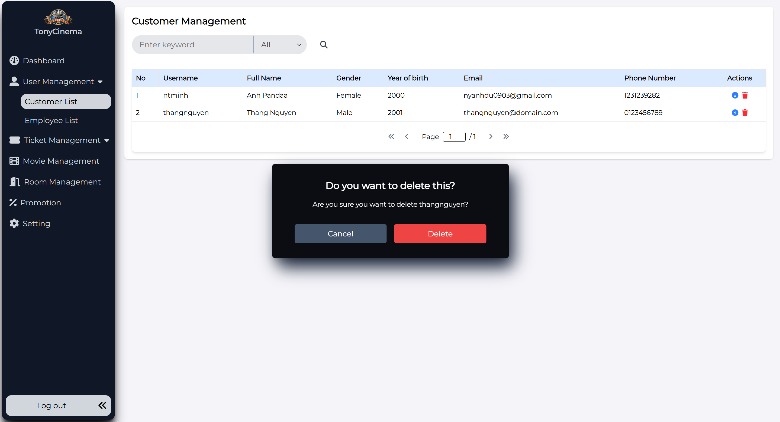

|  |  |  |  |
| --- | --- | --- | --- |
| **Screen** | Customer management – Delete customer | | |
| **Description** | Delete customer | | |
| **Screen Access** | Admin clicks icon “trash”-> Delete popup | | |
| **Screen Content** | | | |
| **Item** | **Type** | **Data** | |
| Cancel | Button |  | |
| Delete | Button |  | |
| **Screen Actions** | | | |
| **Action Name** | **Description** | | **Success** |
| Delete | Agree to delete customer | | Employee is deleted from database and display screen of customers list |
| Cancel | Close confirm pop-up | | Display screen of customers list |

##### **3.1.6.2.3 Inactive/Active Customer**

Lock customer:

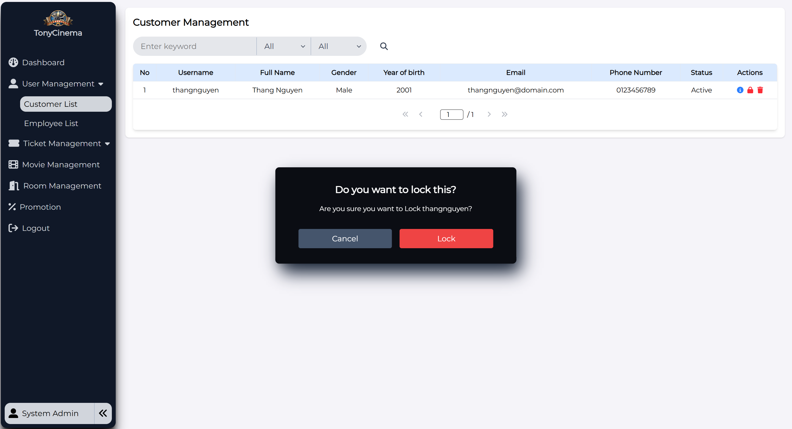

The icon changed: it means successfully locking the customer

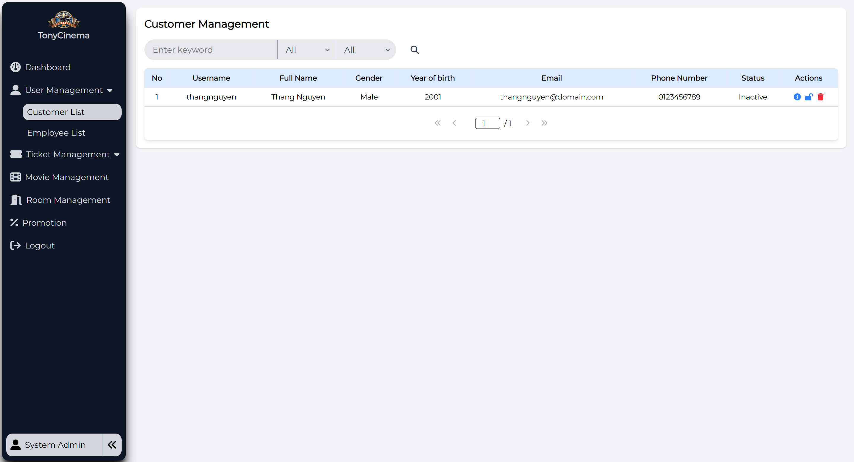

And press the “Unlock” icon, the pop-up unlock customer showed:

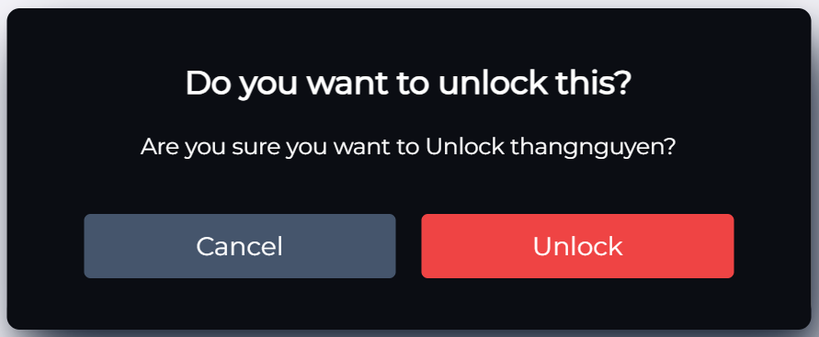

|  |  |  |  |
| --- | --- | --- | --- |
| **Screen** | Inactive/Active employee | | |
| **Description** | Function of forcing employee inactive (locked) – cannot access to the system | | |
| **Screen**  **Access** | The admin enters the Employee List and press on “Lock” icon action | | |
| **Screen Content** | | | |
| **Item** | **Type** | **Data** | **Description** |

|  |  |  |  |  |
| --- | --- | --- | --- | --- |
| Cancel | Button |  |  | |
| Lock/Unlock | Button |  |  | |
| **Screen Action** | | | | |
| **Action name** | **Description** | | **Success** | **Failure** |
| Cancel | Click this button to close the current pop-up | | Back to the customer list page | N/A |
| Lock | Click this button to make customer inactive (cannot access to the system) | | The icon will change from “Lock” to “Unlock” icon  Then the customer cannot get access to the system, just wait until the admin unlock(active) the account again | N/A |
| Unlock | Click this button to make customer active again (can access to the system) | | The icon will change from “Unlock” to “Lock” icon  Then the customer can get access to the system | N/A |

### Cinema room management

|  |  |
| --- | --- |
| Use Case Name | Cinema room management |
| Use Case ID |  |
| High Level Requirement  Ref | Admin |
| Actor | Allows to view list or detail of cinema room, edit room seat types and search/search with filters (min – max seat capacity) |
| Description | NA |
| Trigger | Only admin has right to implement functions |
| Pre-condition | Admin must login the system |

#### Display list of cinema rooms

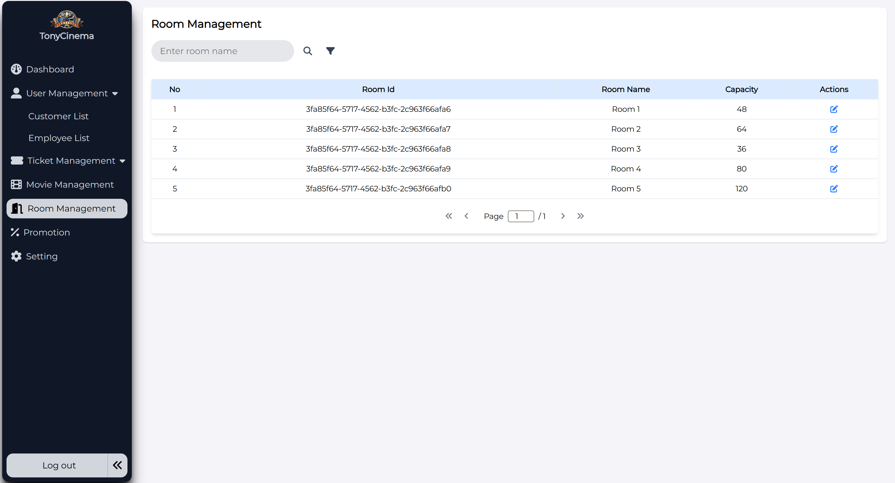

|  |  |  |  |
| --- | --- | --- | --- |
| **Screen** | Screen to display cinema room list | | |
| **Description** | Function to view list of cinema room information and search for keyword, or with filter  Allows to edit cinema room seat types | | |
| **Screen**  **Access** |  | | |
| **Screen Content** | | | |
| **Item** | **Type** | **Data** | **Description** |
| Room ID | Label | N/A |  |

|  |  |  |  |  |
| --- | --- | --- | --- | --- |
| Room Name | Label | N/A |  | |
| Capacity | Label | N/A | Seat capacity | |
| Seat detail | Button | N/A |  | |
| Edit | Icon button | N/A |  | |
| Search | TextBox - nvarchar  (28) | N/A |  | |
| Search | Button | N/A |  | |
| Filter | Icon button | N/A | Which includes min – max seat capacity as a criteria for search | |
| **Screen Actions** | | | | |
| **Action name** | **Description** | | **Success** | **Failure** |
| Search | 1. Input keyword into Input_Text Search with room name 2. Click Search button | | Updated Cinema room list is list of cinema room according to search  keyword. | N/A |
| Back | Back to previous screen | | Back to previous  screen | N/A |

#### Search cinema room

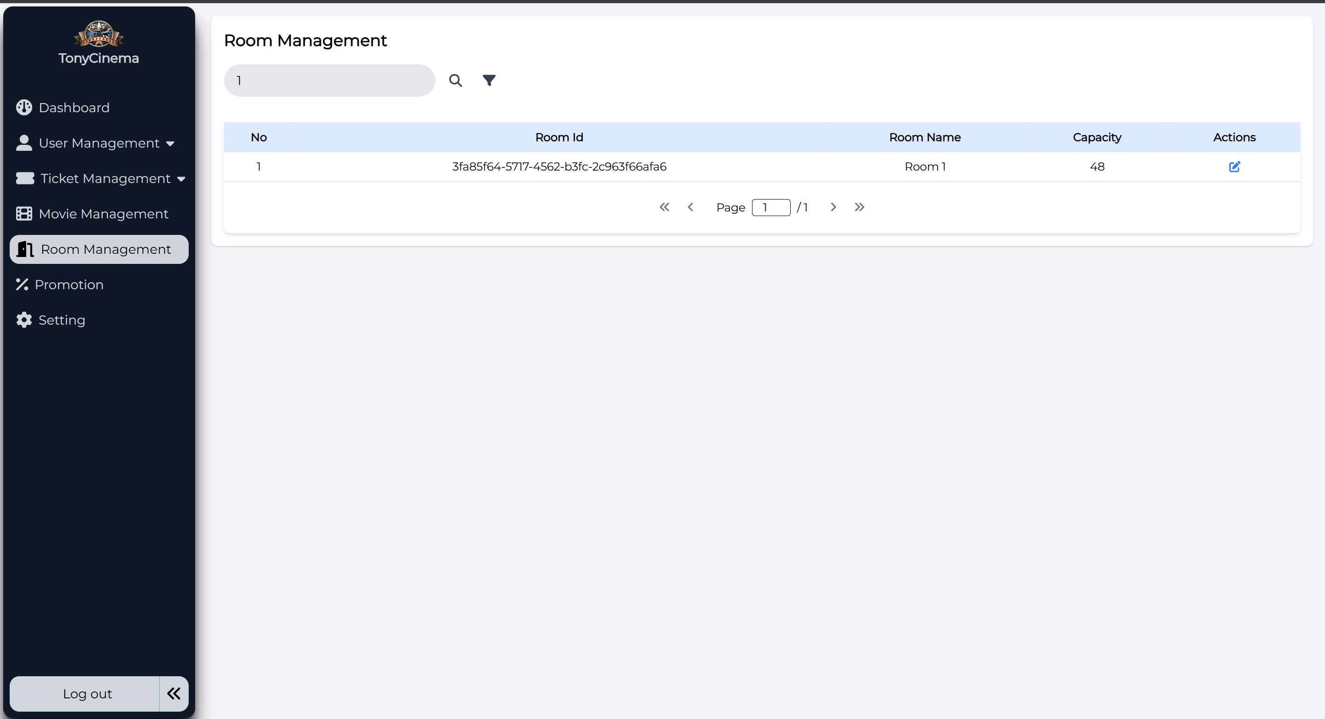

The admin can search by room name

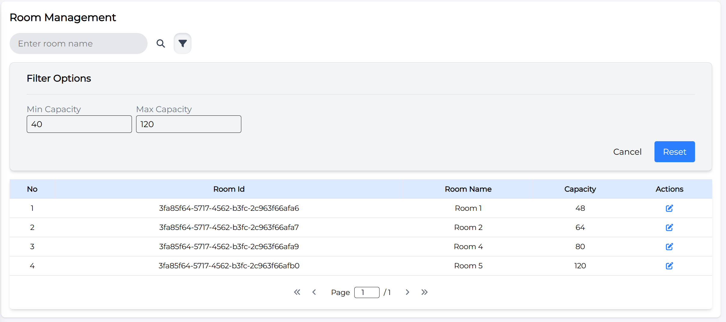

The admin can also search by room name with min – max capacity

|  |  |  |  |
| --- | --- | --- | --- |
| **Screen** | Screen to display cinema room list | | |
| **Description** | Function to view list of cinema room information and search for keyword, or with filter  Allows to edit cinema room seat types | | |
| **Screen**  **Access** |  | | |
| **Screen Content** | | | |
| **Item** | **Type** | **Data** | **Description** |
| Room ID | Label | N/A |  |

|  |  |  |  |  |
| --- | --- | --- | --- | --- |
| Room Name | Label | N/A |  | |
| Capacity | Label | N/A | Seat capacity | |
| Seat detail | Button | N/A |  | |
| Edit | Icon button | N/A |  | |
| Search | TextBox - nvarchar  (28) | N/A |  | |
| Search | Button | N/A |  | |
| Filter | Icon button | N/A | Which includes min – max seat capacity as a criteria for search | |
| Reset | Button | N/A | Reset all searching criteria | |
| Cancel | Button | N/A | Back to the previous screen | |
| **Screen Actions** | | | | |
| **Action name** | **Description** | | **Success** | **Failure** |
| Search | 1. Input keyword into Input_Text Search with room name 2. Click Search button | | Updated Cinema room list is list of cinema room according to search  keyword. | N/A |
| Cancel | Back to previous screen | | Back to previous  screen | N/A |

#### Cinema room detail

|  |  |  |  |  |
| --- | --- | --- | --- | --- |
| **Screen** | Detail screen of cinema room | | | |
| **Description** | Function to view information and edit seat type in selected cinema room | | | |
| **Screen**  **Access** |  | | | |
| **Screen Content** | | | | |
| **Item** | **Type** | **Data** | **Description** | |
| Cinema room | Label |  |  | |
| Seat | Checkbox |  |  | |
| Save | Button | N/A |  | |
| Back | Button | N/A |  | |
| **Screen Action** | | | | |
| **Action name** | **Description** | | **Success** | **Failure** |
| Select seat | Select seat to change status of the seat from this status into another status  (Normal seat – VIP seat) | | Selected seat color is changed into  green color | N/a |
| Save | Click to save change in database | | Edit successfully in database. Change status of selected  seats. Return screen | Re-display the screen of this function. |

|  |  |  |  |
| --- | --- | --- | --- |
|  |  | of cinema room management |  |

### Movie management

|  |  |
| --- | --- |
| Use Case  Name | Movie management |
| Use Case ID |  |
| High Level Requirement  Ref |  |
| Actor | Admin/Manager |
| Description | Allows admin to view, add, edit movie information |
| Trigger | The user must log in the system as admin right |
| Pre-condition |  |

#### Movie management – View movie list

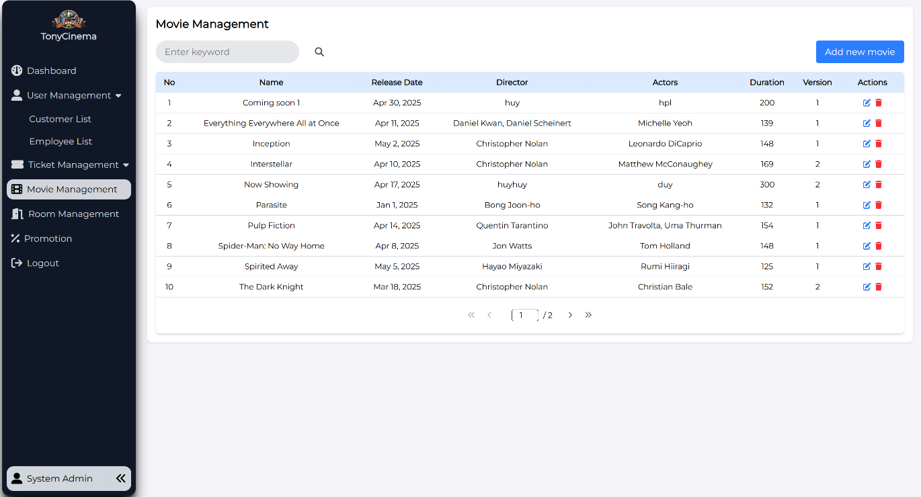

|  |  |  |  |
| --- | --- | --- | --- |
| **Screen** | View movie list | | |
| **Description** | Display movie list | | |
| **Screen Access** | The user clicks **Movie management** | | |
| **Screen Content** | | | |
| **Item** | **Type** | **Data** | **Description** |
| Movie | Lable –  String | N/A |  |
| Release date | Lable –  String | N/A |  |

|  |  |  |  |  |  |  |
| --- | --- | --- | --- | --- | --- | --- |
| Movie production  company | | Lable –  String | N/A | |  | |
| Movie running  time | | Lable –  Number | N/A | |  | |
| Version | | Lable –  String | N/A | |  | |
| Edit | | Button | N/A | |  | |
| Add movie | | Button | N/A | |  | |
| **Screen Action** | | | | | | |
| **Action name** | **Description** | | | **Success** | | **Failure** |
| Add movie | Forward to page of adding movie | | | Display page of  adding movie | |  |
| Edit | Forward to page of editing movie | | | Display page of  editing movie | |  |

#### Movie management – Add movie

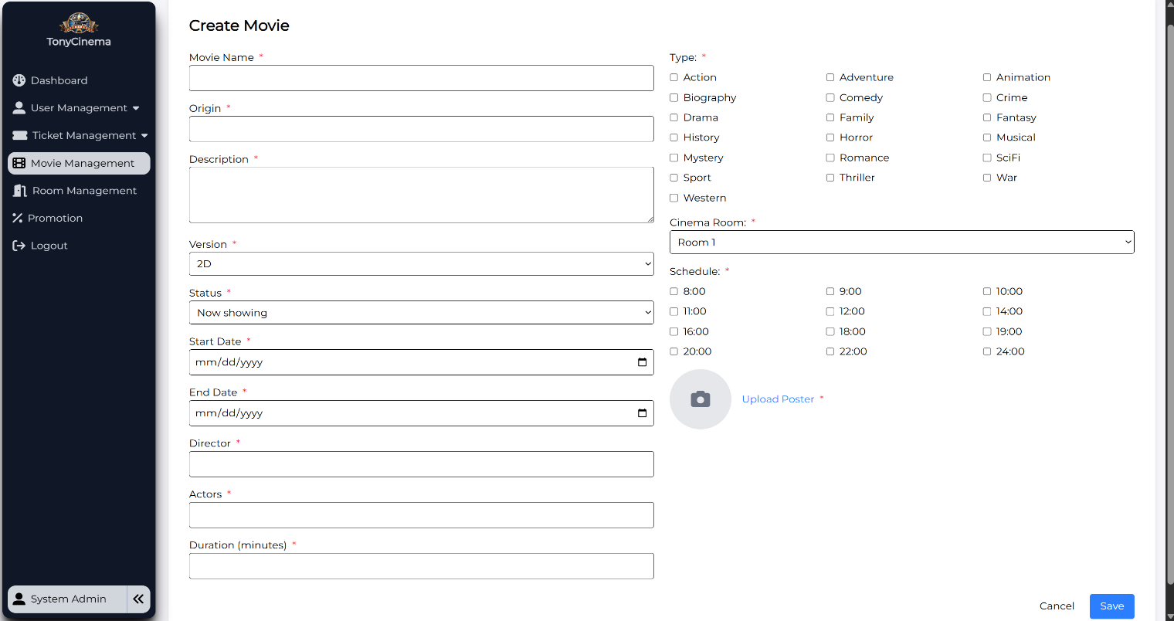

|  |  |  |  |
| --- | --- | --- | --- |
| **Screen** | Add movie | | |
| **Description** | Add 1 movie into database | | |
| **Screen Access** | The user clicks **Movie management -> Add movie** | | |
| **Screen Content** | | | |
| **Item** | **Type** | **Data** | **Description** |
| Movie name | TextBox –  String | N/A |  |
| From date | Date | N/A |  |
| To date | Date | N/A |  |

|  |  |  |  |  |  |  |
| --- | --- | --- | --- | --- | --- | --- |
| Actor | | TextBox –  String | N/A | |  | |
| Movie  production company | | TextBox –  String | N/A | |  | |
| Director | | TextBox –  String | N/A | |  | |
| Running time | | TextBox –  Number | N/A | |  | |
| Version | | RadioBox | N/A | |  | |
| Trailer | | TextBox –  Number | N/A | |  | |
| Type | | CheckBox | N/A | |  | |
| Cinema room | | ComboBox | N/A | |  | |
| Showtime | | TextBox –  String | N/A | |  | |
| Content | | TextBox –  String | N/A | |  | |
| Add cinema  time | | Button | N/A | |  | |
| Choose file | | Button | N/A | |  | |
| Submit | | Button | N/A | |  | |
| **Screen Action** | | | | | | |
| **Action name** | **Description** | | | **Success** | | **Failure** |
| Add movie | Add movie into database, after admin inputs all information, then click Add  movie to add movie. | | | Back to page of Movie management | | Display the error message |

#### Movie management – Edit movie information

|  |  |  |  |
| --- | --- | --- | --- |
| **Screen** | Update movie information | | |
| **Description** | Update information of the movie | | |
| **Screen Access** | The user clicks **Movie management -> Edit** | | |
| **Screen Content** | | | |
| **Item** | **Type** | **Data** | **Description** |

|  |  |  |  |  |  |  |
| --- | --- | --- | --- | --- | --- | --- |
| Movie name | | TextBox –  String | N/A | |  | |
| From date | | Date | N/A | |  | |
| To date | | Date | N/A | |  | |
| Actor | | TextBox –  String | N/A | |  | |
| Movie  production company | | TextBox –  String | N/A | |  | |
| Director | | TextBox –  String | N/A | |  | |
| Running time | | TextBox –  Number | N/A | |  | |
| Version | | RadioBox | N/A | |  | |
| Trailer | | TextBox -  String | N/A | |  | |
| Type | | CheckBox | N/A | |  | |
| Ciname room | | ComboBox | N/A | |  | |
| Showtime | | TextBox –  String | N/A | |  | |
| Content | | TextBox –  String | N/A | |  | |
| Add movie time | | Button | N/A | |  | |
| Choose file | | Button | N/A | |  | |
| Submit | | Button | N/A | |  | |
| Back | | Button | N/A | |  | |
| **Screen Action** | | | | | | |
| **Action name** | **Description** | | | **Success** | | **Failure** |
| Edit | Edit information of movie. After admin edits information, then click Submit to update all information of the  movie. | | | Back to movie management | | Display error messages |

#### Movie management – Delete movie

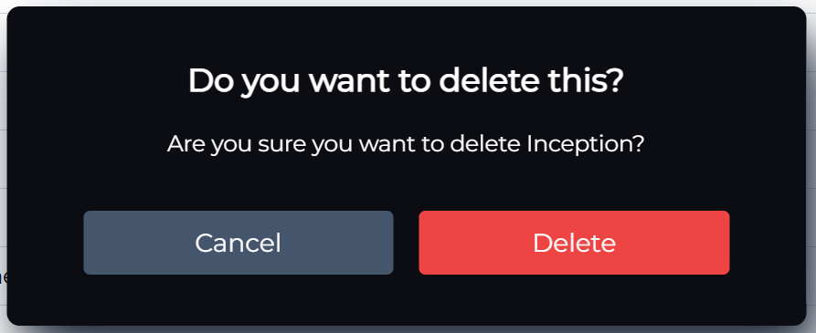

|  |  |  |  |
| --- | --- | --- | --- |
| **Screen** | Movie management – Delete movie | | |
| **Description** | Delete information of the movie | | |
| **Screen Access** | Admin clicks menu **Movie management -> Delete** | | |
| **Screen Content** | | | |
| **Item** | **Type** | **Data** | |
| Delete | Button |  | |
| Cancel | Button |  | |
| **Screen Actions** | | | |
| **Action Name** | **Description** | | **Success** |
| Delete | Agree to delete  movies | | The movie is deleted from database and display  Movie list screen |
| Cancel | Close confirm screen | | Display Movie list screen |

#### Search movie

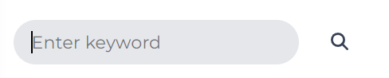

### Promotion management

|  |  |
| --- | --- |
| Use Case  Name | Promotion management |
| Use Case ID |  |
| High Level Requirement  Ref |  |
| Actor | Admin |
| Description | Allows users to manage promotion programs of the movie theater |
| Trigger |  |
| Pre-condition | The user must log in the system |
| Post-  processing |  |

#### Promotion management – View promotion list

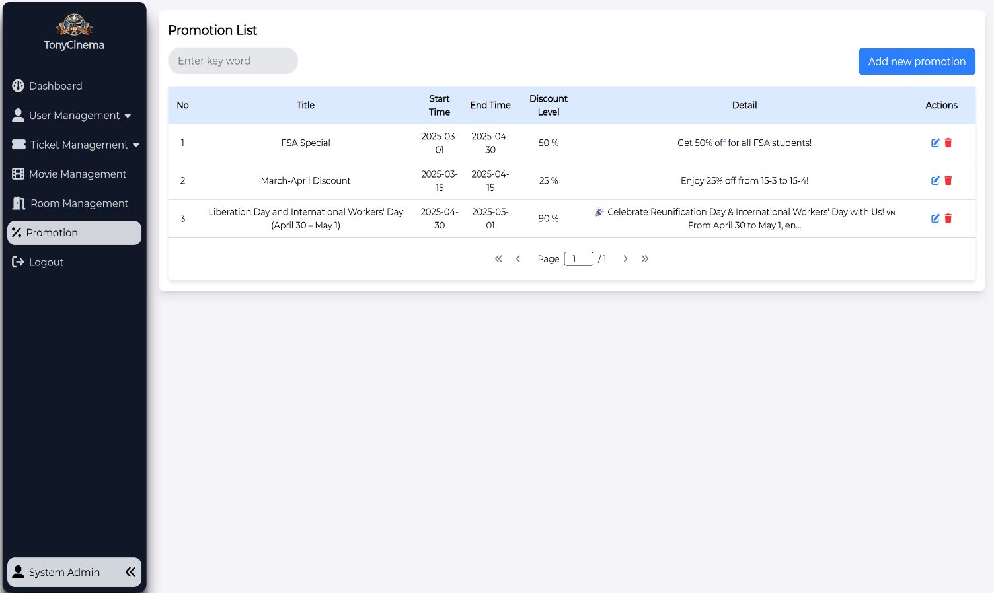

|  |  |  |  |  |
| --- | --- | --- | --- | --- |
| **Screen** | View promotion list of system | | | |
| **Description** | Allows to search, add, edit, delete promotions | | | |
| **Screen**  **Access** | Admin clicks menu **Promotion management** | | | |
| **Screen Content** | | | | |
| **Item** | **Type** | **Data** | **Description** | |
| Title | Lable –  String | N/A |  | |
| Start time | Date | N/A |  | |
| End time | Lable –  String | N/A |  | |
| DiscountLevel | string | N/A |  | |
| Detail | Lable –  String | N/A |  | |
| Edit | Icon Button | N/A |  | |
| Add | Icon Button | N/A |  | |
| Delete | Button | N/A |  | |
| Search | TextBox | N/A |  | |
| Search | Button | N/A |  | |
| **Screen Action** | | | | |
| **Action name** | **Description** | | **Success** | **Failure** |

|  |  |  |  |
| --- | --- | --- | --- |
| Add | Click Add promotion button to add a  promotion | Forward to Add  promotion function | N/A |
| Edit | Click Edit promotion button to edit  information of a promotion | Forward to Edit  promotion function | N/A |
| Delete | Click Delete promotion button to delete information of a promotion | Forward to Delete  promotion function | N/A |
| Search | 1. Input keyword into Input_Text Search 2. Click Search button | Updated promotion list is list of promotion according to search  keyword. | N/A |

#### Promotion management – Add promotion

When filling all the required input field and “Save”, a notification will be shown:

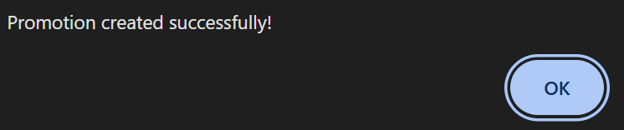

|  |  |  |  |
| --- | --- | --- | --- |
| **Screen** | Add promotion | | |
| **Description** | Add promotion | | |
| **Screen Access** | Admin clicks menu **Promotion management -> Add promotion** | | |
| **Screen Content** | | | |
| **Item** | **Type** | **Data** | **Description** |
| Title | TextBox –  String | N/A |  |
| Start time | DateOnly | N/A |  |
| End time | DateOnly | N/A |  |

|  |  |  |  |  |  |  |
| --- | --- | --- | --- | --- | --- | --- |
| Discoutn | | TextBox –  Number | N/A | |  | |
| Description | | TextBox –  String | N/A | |  | |
| Save | | Button | N/A | |  | |
| Cancel | | Button | N/A | |  | |
| **Screen action** | | | | | | |
| **Action name** | **Description** | | | **Success** | | **Failure** |
| Save | After admin inputs all of required fields, then click Save, the system will add a promotion into database | | | Add inputted promotion information into database.  A notification will be shown.  Direct back to Promotion management screen – View promotion  list | | Display the message: “Failed to create promotion. Please try again.”. Display Add promotion screen. |
| Cancel | Back to previous screen | | | Back to previous  screen | | N/A |

#### Promotion management – Edit promotion

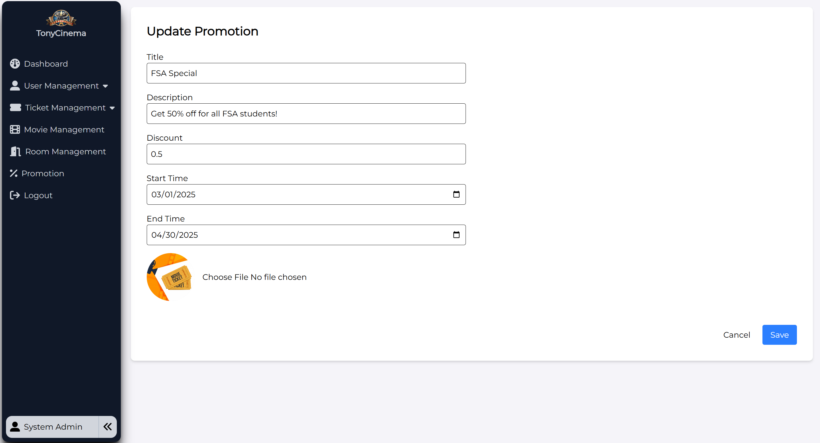

|  |  |  |  |
| --- | --- | --- | --- |
| **Screen** | Edit promotion | | |
| **Description** | Edit information of promotion | | |
| **Screen Access** | Admin clicks menu **Promotion management -> Edit** | | |
| **Screen Content** | | | |
| **Item** | **Type** | **Data** | **Description** |
| Title | TextBox –  String | Display title of the  selected promotion to edit |  |
| Start time | DateOnly | Display start time of the selected  promotion to edit |  |
| End time | DateOnly | Display end time of the selected  promotion to edit |  |
| Discount | TextBox –  Number | Display sales off detail of the selected  promotion to edit |  |

|  |  |  |  |  |  |  |
| --- | --- | --- | --- | --- | --- | --- |
| Description | | TextBox –  String | Display detail of the selected promotion to  edit | |  | |
| Upload Image | | Button | Get access to the device storage to choose image | |  | |
| Save | | Button | N/A | |  | |
| Back | | Button | N/A | |  | |
| **Screen Action** | | | | | | |
| **Action name** | **Description** | | | **Success** | | **Failure** |
| Save | After admin edits some fields, then click Save, the system will save changes a new promotion into database | | | Update inputted promotion information into database.  A notification will be shown.  Direct back to Promotion management screen – View promotion  list | | Display the message: “Failed to update promotion. Please try again.”. Display Add promotion screen. |
| Back | Back to previous screen | | | Back to previous  screen | | N/A |

#### Promotion management – Delete promotion

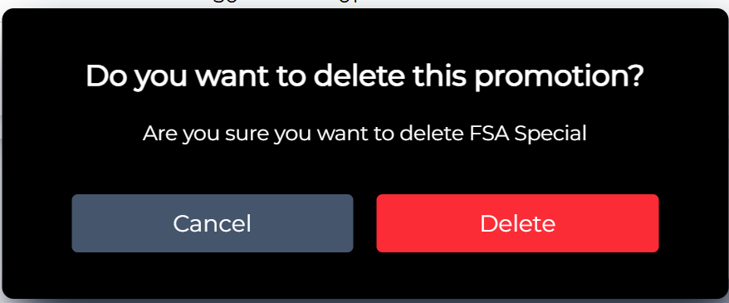

|  |  |  |  |
| --- | --- | --- | --- |
| **Screen** | Delete promotion | | |
| **Description** | Delete information of the promotion | | |
| **Screen Access** | Admin clicks menu **Promotion management -> Delete Icon** | | |
| **Screen Content** | | | |
| **Item** | **Type** | **Data** | |
| Delete | Button |  | |
| Cancel | Button |  | |
| **Screen Actions** | | | |
| **Action Name** | **Description** | | **Success** |

|  |  |  |
| --- | --- | --- |
| Delete | Agree to delete  promotion | Promotion is deleted from database and display  screen of promotion list |
| Cancel | Close confirm screen | Display screen promotion list |

#### Search promotion



|  |  |  |  |  |
| --- | --- | --- | --- | --- |
| **Screen** | Search promotion | | | |
| **Description** | Allows to search promotion by keyword (title, detail | | | |
| **Screen**  **Access** | Admin clicks menu **Promotion** | | | |
| **Screen Content** | | | | |
| **Item** | **Type** | **Data** | **Description** | |
| Search | Placeholder | N/A |  | |
| Search | Button | N/A |  | |
| **Screen Action** | | | | |
| **Action name** | **Description** | | **Success** | **Failure** |

|  |  |  |  |
| --- | --- | --- | --- |
| Search | Click Search to look for specific promotions that have similar input keywords | A list of specific promotions found by inputted keywords will be shown | If there are no promotions found, a message will be shown: “No data found” |

## Detailed Non-Functional Requirements

### Logical Structure of the Data

The logical structure of the data to be stored on the system is given below:

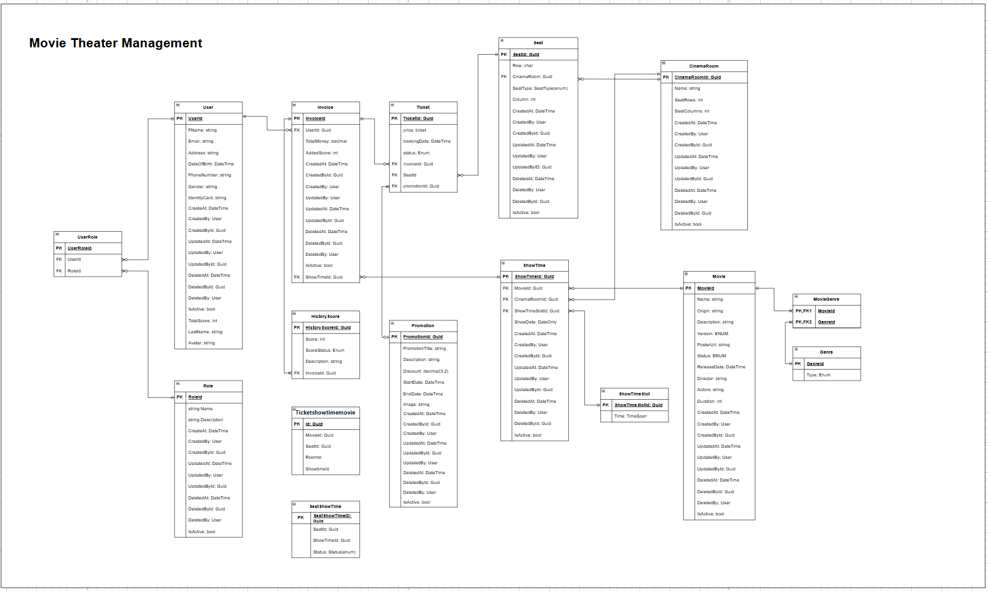

### Security

TBD

### Performance

TBD